**HEALTH STREETH HOSPITAL**

**HOSPITAL MANAGEMENT SYSTEM**

Diploma In Software Engineering 20.1 Full Time

Bishan Kanthana - MA-DSE-201-F-007

Chalitha Basula - MA-DSE-201-F-009

Hasindu Nimsara - MA-DSE-201-F-010

Hansaka Tharanga -MA-DSE-201-F-041

National Institute Of Business Management

**Declaration**

“I certify that this project does not incorporate without acknowledgement, any material previously submitted for a Diploma in any institution and to the best of my knowledge and belief ,it does not contain any material previously published or written by another person or myself except where due reference is made in the text. I also hereby give consent for my project report, if accepted, to be made available for photocopying and for interlibrary loans, and for the title and summary to be made available to outside organizations”

Index no Name Signature

MA-DSE-201-F-007 Bishan Kanthana .…………………

MA-DSE-201-F-009 Chalitha Basula .…………………

MA-DSE-201-F-010 Hasindu Nimsara .…………………

MA-DSE-201-F-041 Hansaka Tharanga .…………………

………………. …………………………

Submission Date Mrs. Nadeeshani Gunasekara

Course Director

**Acknowledgement**

It is indeed with a great pleasure and immense sense of gratitude that we acknowledge the help of these individuals. We are highly indebted to our Course Director Mrs Nadishani Gunasekara for the facilities provided to accomplish this DSE final project. she has been a constant source of inspiration for us and we are very deeply thankful to her for her support and valuable advice. We extremely grateful to our National School of Business Management staff members, Lab technicians and Non-teaching staff members for their extreme help throughout our project. Finally we express our heart full thanks to all of our friends who helped us in successful completion of this project.

**Table of Content**

**Chapter1-introduction**

Introduction…………………….………………………………………......Page 01

* 1. Background…………………………………………………....……….Page 02
  2. Statement to problem…………………………………………....………Page 04
  3. Aim and Objectives…………………………………………...……….Page 05
  4. Scope of Study…………………………………………………………Page 06
  5. Gantt Chart……………………………….…………….………….……Page 08

**Chapter 2-Analysis**

2.1 Existing System…….……………………….………………….…….… Page 09

2.2 Major Activities and Functions……………………...……………….…...Page 11

2.3 Drawbacks of Existing System ………………...…………...…...………Page 11

2.4 UML Diagrams……….……...…………………………………...…....

2.4.1 Use Case Diagram………………………………………page 12

2.4.2 Activity Diagram………………………………………..page 13

2.4.3 Class Diagram…………………………………………..page 23

2.4.4 ER Diagram…………………….....................................page 30

**Chapter 3-Design**

3.1 Proposed System……………………………………………………………page 31

3.1.1 System Requirements……………………………………………………page 31

3.2 Database Design……………………………………………………………page 32

3.3 Interface Design……………………………………………………………..page 51

**Chapter 4**

Conclusion……………………………………………………………….page 108

**CHAPTER 1**

**Introduction**

Information technology is made people’s lives easier.Thats’s why With the birth of information technology, new machines and new technologies are introduced to the world. Today, Information technology is became the turning point of the world. Most of countries used many concepts related with information technology to do their day-to-day activities.

In Sri Lanka, both government sector and private sector institutes like banks and universities used new technologies to make their day to day works. What we are particularly considering here is a unique way of systematically entering and storing information in a hospital. The hospital is an essential place for every person living in the world, so the information of the hospital staff as well as the people who come to work in the hospital should be stored in a very secure and systematic system.

But To keep the information related with all other hospital related activities, they used paper documents. There are so many drawbacks of using paper documents to store important data. The one of main drawback is loss of security. The paper documents can be damage or destroy by animals, fires, natural disasters and so on. And, these documents can be stolen by someone. Sometimes paper documents can be lost or misplaced. Lack of paper storage is another drawback. Paper documents take a significant amount of space, therefore, to store large amount of data, many papers must be used. Transporting documents in a paper-based system is taking complicated, slow and inefficient. It is another drawback. If someone wants to make changes in a paper document, he or she will need to write all the content again. This will need to be repeated every time that someone wants to make more corrections. The person who makes correction should make a copy of the original document to distinguish all the amendments that have be done. High cost is another main drawback. To store data, the tones of paper documents must be used with pens, printers, photocopies etc. So, it makes a high cost. Environmental damage is another drawback.

**1.1 Background**

Our developers decided to introduce a hospital management system as a solution to these problems which can be seen as inefficient in the hospital sector due to the above reasons. It consists of the following subsystems.

* Admit Patient Management System
* Admit Patients dashboard
* Add New Patient
* add Guardians
* Guardians’ dashboard
* Admission officers
* X-ray outpatients
* X-ray in patients
* Change password
* Doctor dashboard
* Patients lab sample
* Officer
* Organization
* Add pharmacy Medicines
* Suppliers
* Scan patients samples
* Scan patients
* Room dashboard
* Add customer

The hospital management system consisting of these subdivisions provides a high quality, safe and quality service to the people free from the aforementioned unsafe practices.

We also hope to create a website parallel to this hospital management system. The hospital management system provides a detailed description of the hospital that owns the hospital management system belongs, even though all activities in the hospital are carried out systematically.

The user of this website can get a better understanding of the hospital. For example, the history of the hospital, the details of the doctors treating the hospital as well as the diseases treated by the hospital can be give This website also allows anyone to make an online book apology so that the person who comes to get the service from the hospital can get the service they need on time without any wastage or hassle

**1.2 Problem Statement**

Here we see that the main problem is that all the activities in the hospital system are going on without any management. There are many disadvantages to this method

Paper documents take up considerable space. So a lot of paper should be used to store information on a daily basis. So there are millions of papers every month and at the end of the year. Therefore a large area is required to store all paper documents.

This paper writing system is expensive. To store a lot of information, the hospital needs to spend a lot of money to buy paper, books, pens, printers, photocopies, and so on.

Furthermore, Paper documents cannot provide a proper security for the data. Because paper documents can be easily damaged by animals, fires, natural disasters and many of other harmful activities. And also these papers can be lost or misplaced. So it is unable to find the papers quickly. It is time wastage. Sometimes any one can steal any information because of the lack of security.

This system is consisted with many disadvantages. So it makes hospital works inefficient. So we can clearly understand this paper document system is not suitable for school in the modern society. Because present society is developed with new technological concepts.

* + 1. **Aim and Objectives**
       1. **Aim**
* goal is to facilitate to make the work of the hospital more efficient and patients to be able to channel the doctor they want without having to go to the hospital. This way patients are not rascals. You can come in time and channel the doctor. It saves them time and effort.
  + - 1. **Objectives**

To reach for our aim, we have several objectives to complete.

* Clearly identify the drawbacks of current system.
* Find the best solutions for each identified draw backs
* Design a system for better patient care.
* Reduce hospital operating costs.
* Provide Management Information System report on demand to management for better decision making.
* Better co-ordination among the different departments.
* Provide top management a single point of control

**1.4 Scope of Study**

**HEALTH STREETH HOSPITAL Management System**

We know that many rural hospitals do not have a proper system to manage day-to-day hospitals and other administrative matters. Our main hope is to establish this system in hospitals throughout the island.

Paper sheets are usually used to store information here. It is an unsafe method that increases the risk of data loss and causes inconvenience to patients as well as hospital staff. This is because it takes up a lot of space and it fails because it is difficult to transport

Through our system, we hope to manage all activities using new technological concepts. Patients and their caregivers use the patient's medical reports, staff and database of physicians, officers, suppliers, and pharmacies currently available at the hospital pharmacy.

We hope to manage everything in this section, including category information. Therefore, anyone can take the time to see a doctor without going to the hospital, which is very convenient for patients as well as hospital staff.

We hope to set up an “IT room” with the authorized person who manages the above system. So anyone can take any report of patients in a matter of seconds.

We also hope to keep the unit up to date with all the information about the doctors when they arrive. Under this we can easily know the doctor we want according to the need or what disease that doctor is special for.

Under this system we can see how many patients are currently being treated in the hospital, how many patients are coming in a day and the number of doctors in the hospital at that time and also the information of the staff working in the hospital which is very important for the administration of the hospital. Patients can also find out which treatments they received at the hospital and which doctor they saw.

Our hospital management system is able to manage all hospital activities with the help of new technologies. We look forward to the successful completion of the system and to establish our "Hospital Management System" in hospitals to make all hospital activities and all other activities a single computer-based platform for the smooth management of all hospital operations. Technology by providing an efficient and optimal medical environment by minimizing the problems of the current paper writing system Finally, we have a dream to introduce this system to hospitals across the island.

**1.5 Gantt Chart**

|  |  |  |  |  |
| --- | --- | --- | --- | --- |
| **Task** | **June** | **July** | **August** | **September** |
| Requirement gathering |  |  |  |  |
| Design |  |  |  |  |
| Coding |  |  |  |  |
| Testing |  |  |  |  |
| Maintenances |  |  |  |  |

**CHAPTER 2**

**2.1Existing System**

Existing System Hospitals currently use a manual system for the management and maintenance of critical information In Hospital Management System, presently all Patients and staff

Management operations are being done manually. Various Books and Regressive and time consuming, as even for a single Record, several books must be referred, in all immediate updating, validation, and reporting is just too large.

If someone wants to make changes in a paper document, he or she will need to write all the content again. This will need to be repeated every time that someone wants to make more corrections. The person who make correction should make a copy of the original document to distinguish all the amendments that have be done. And also, to make the old document correction, it is unable to find the document quickly. Because there are lot of documents. It is a trouble with time wastage.

To transporting documents in a paper-based system is taking complicated, slow and inefficient.

The current system requires numerous paper forms, with data stores spread throughout the hospital management infrastructure. Often information (on forms) is incomplete or does not follow management standards. Forms are often lost in transit between departments requiring a comprehensive auditing process to ensure that no vital information is lost. Multiple copies of the same information exist in the hospital and may lead to inconsistencies in data in various data stores. Objective of the System Hospitals currently use a manual system for the management and maintenance of critical information. The current system requires numerous paper forms, with data stores spread throughout the hospital management infrastructure. Often information (on forms) is incomplete or does not follow management standards. Forms are often lost in transit between departments requiring a comprehensive auditing process to ensure that no vital information is lost. Multiple copies of the same information exist in the hospital and may lead to inconsistencies in data in various data stores. A significant part of the operation of any hospital involves the acquisition, management and timely retrieval of great volumes of information. This information typically involves; patient personal information and medical history, staff information, room and ward scheduling, staff scheduling, operating theater scheduling and various facilities waiting lists. All this information must be managed in an efficient and cost wise fashion so that an institution's resources may be effectively utilized HMS will automate the management of the hospital making it more efficient and error free. It aims at standardizing data, consolidating data ensuring data integrity and reducing inconsistencies.

This result in unnecessary delay in various operation of organization and cloisters are maintained for entries about patients and staff enquiry, registration and fees submission. Final report preparation is very combed be detrimental to the progress. This result in unnecessary delay in various operation.

Paper documents take a significant amount of space. So, to store day to day information many papers must be used. So, at the end of each month and year, there are millions of papers. So, it wants the large area to store all paper documents.

This paper document system makes a high cost. Because to store much information, hospital must want to buy papers, books, pens, printer machines, photocopies and so on by expensing lot of money.

**2.2 Major Activities and Functions**

To give a solution for the drawbacks of current paper-based hospital management system, we will hope to introduce the new system called “health Streeth hospital Management System” which is consisted with many useful digital technological concepts. By using this system, we hope to take all activities of the hospital to a one computer-based platform to manage hospital works with more efficiently.

We divided our system into many sub parts. So, we can give a suitable solution for each section of the hospital easily.

**2.3 Drawbacks of Existing System**

To keep the information related with all ther hospital related activities, they used paper documents. There are so many drawbacks of using paper documents to store important data. The one of main drawback is loss of security. The paper documents can be damage or destroy by animals, fires, natural disasters and so on. And also these documents can be stolen by someone. Sometimes paper documents can be lost or misplaced. Lack of paper storage is another drawback. Paper documents take a significant amount of space, therefore to store large amount of data, many papers must be used. Transporting documents in a paper based system is taking complicated, slow and inefficient. It is another drawback. If someone wants to make changes in a paper document, he or she will need to write all the content again. This will need to be repeated every time that someone wants to make more corrections. The person who make correction should make a copy of the original document to distinguish all the amendments that have be done. High cost is another main drawback. To store data, the tones of paper documents must be used with pens, printers, photocopies and etc. So it makes a high cost. Environmental damage is another drawback.

**2.4 UML Diagram**

**2.4.1Use Case Diagram**

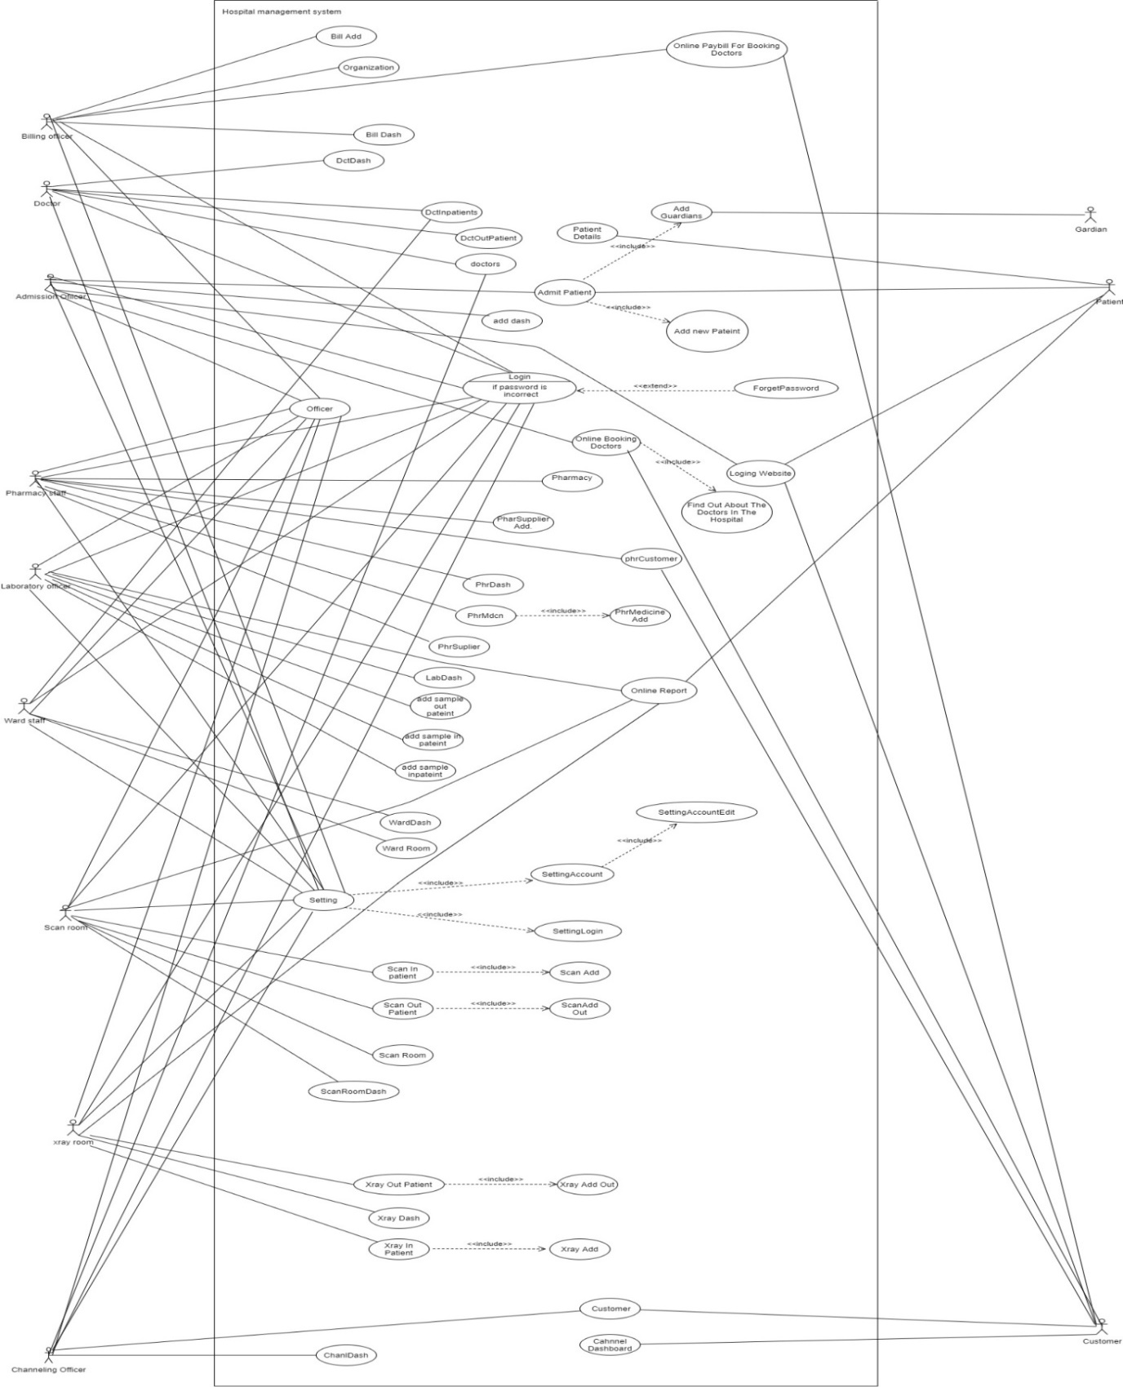

**2.4.2Activity Diagram**

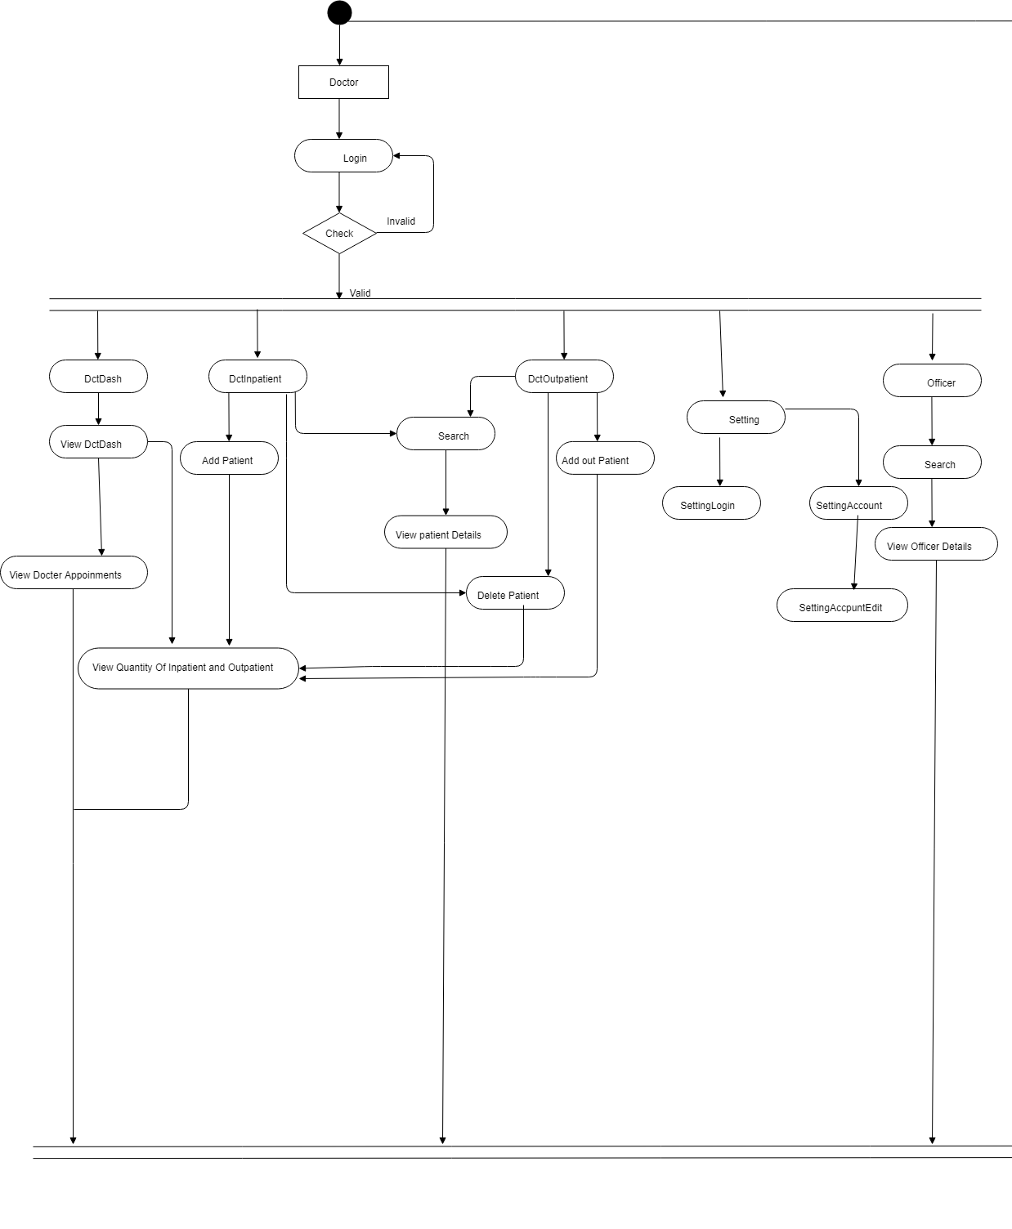

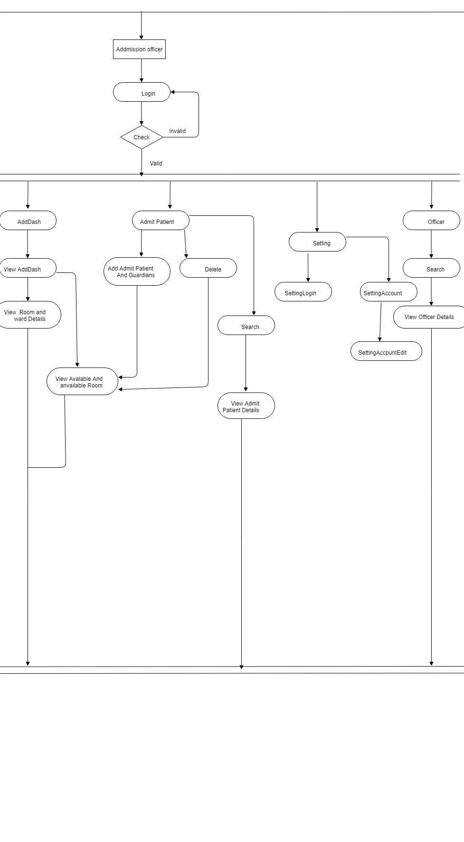

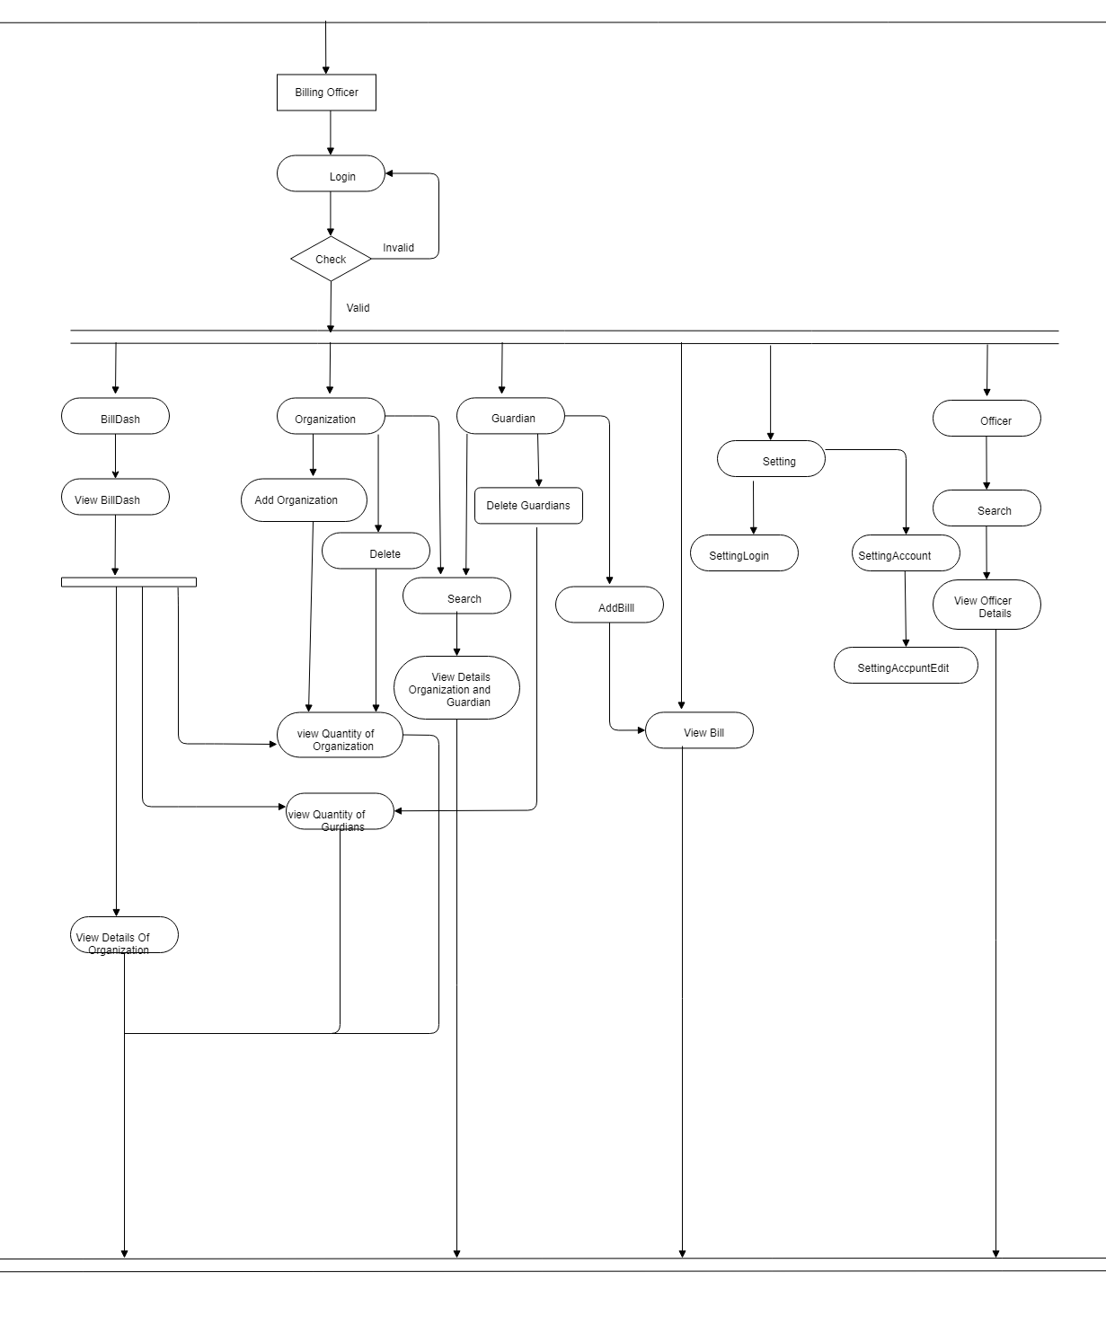

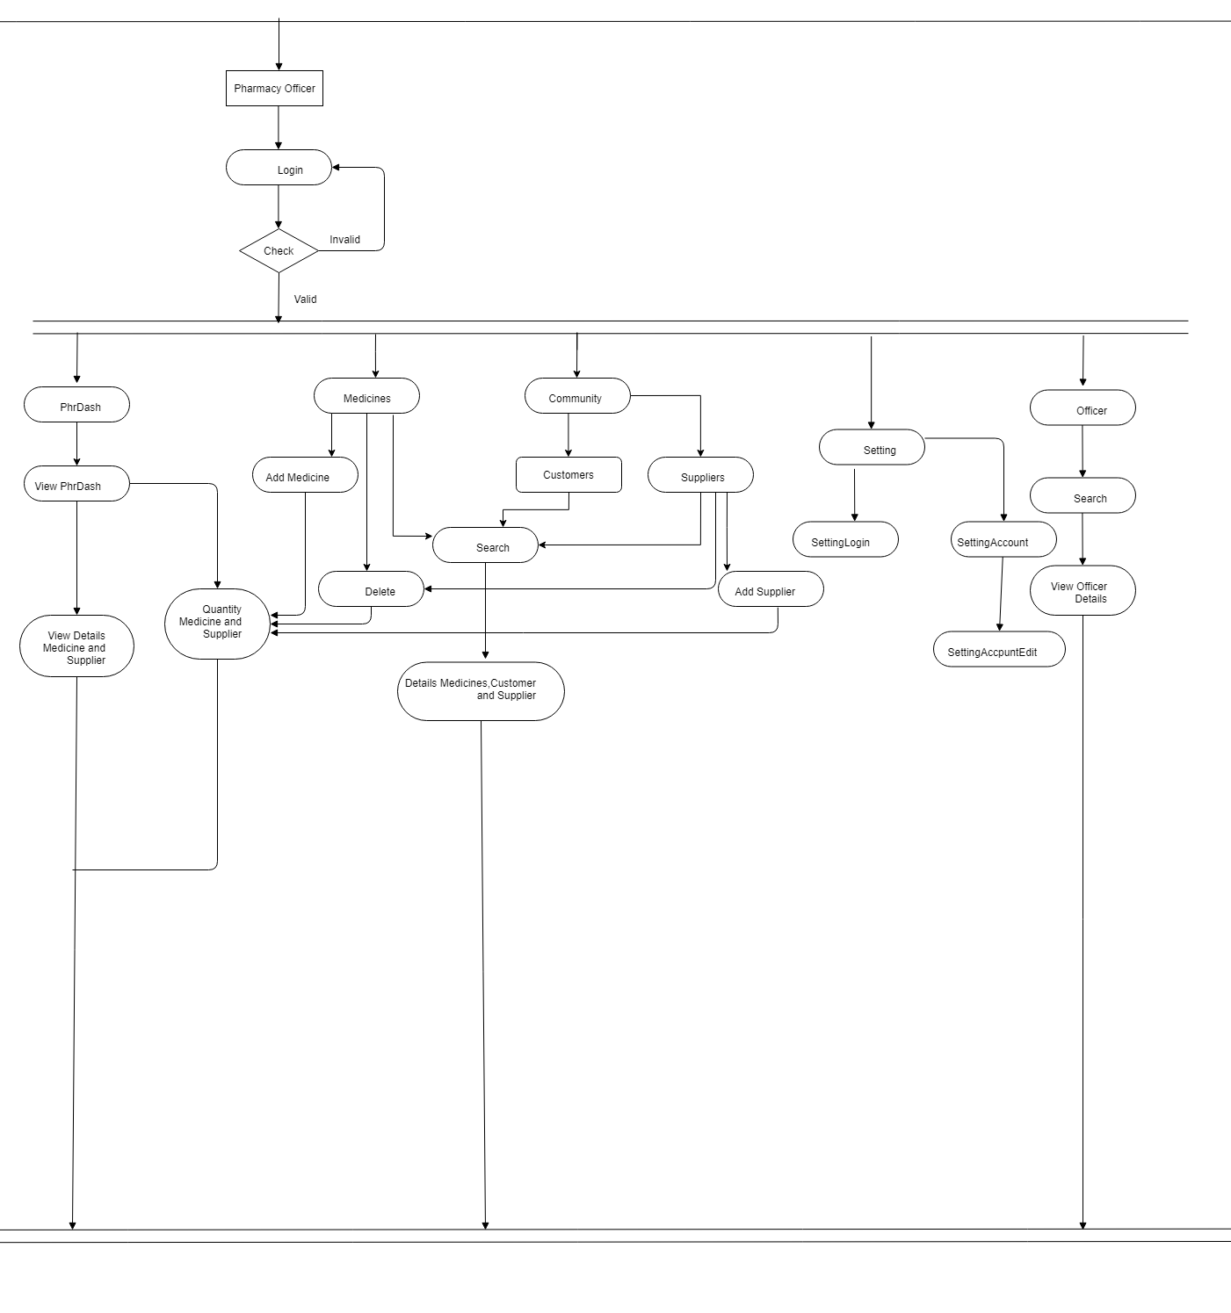

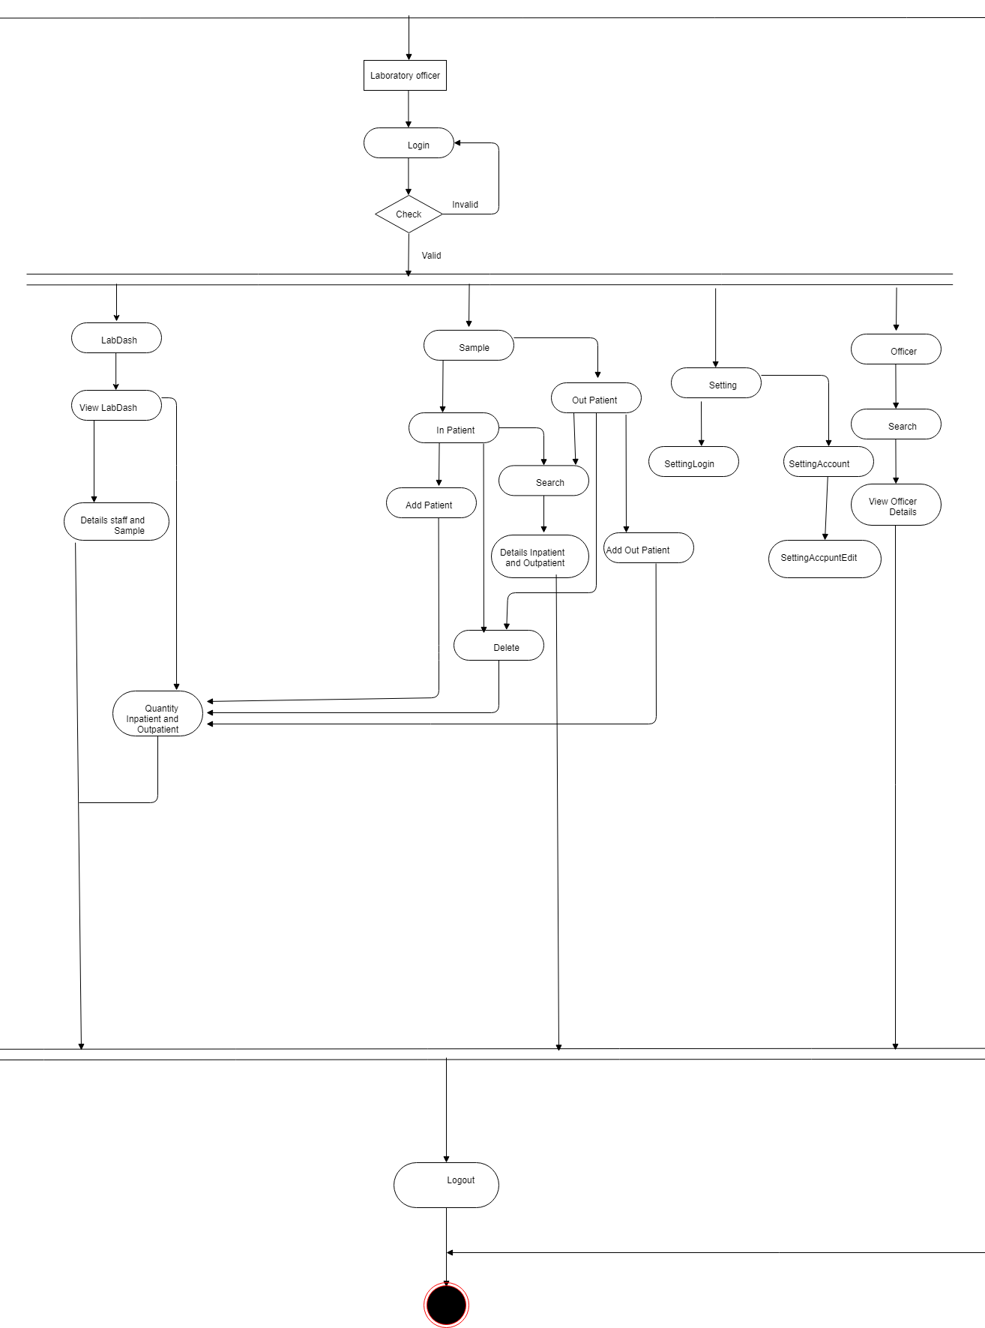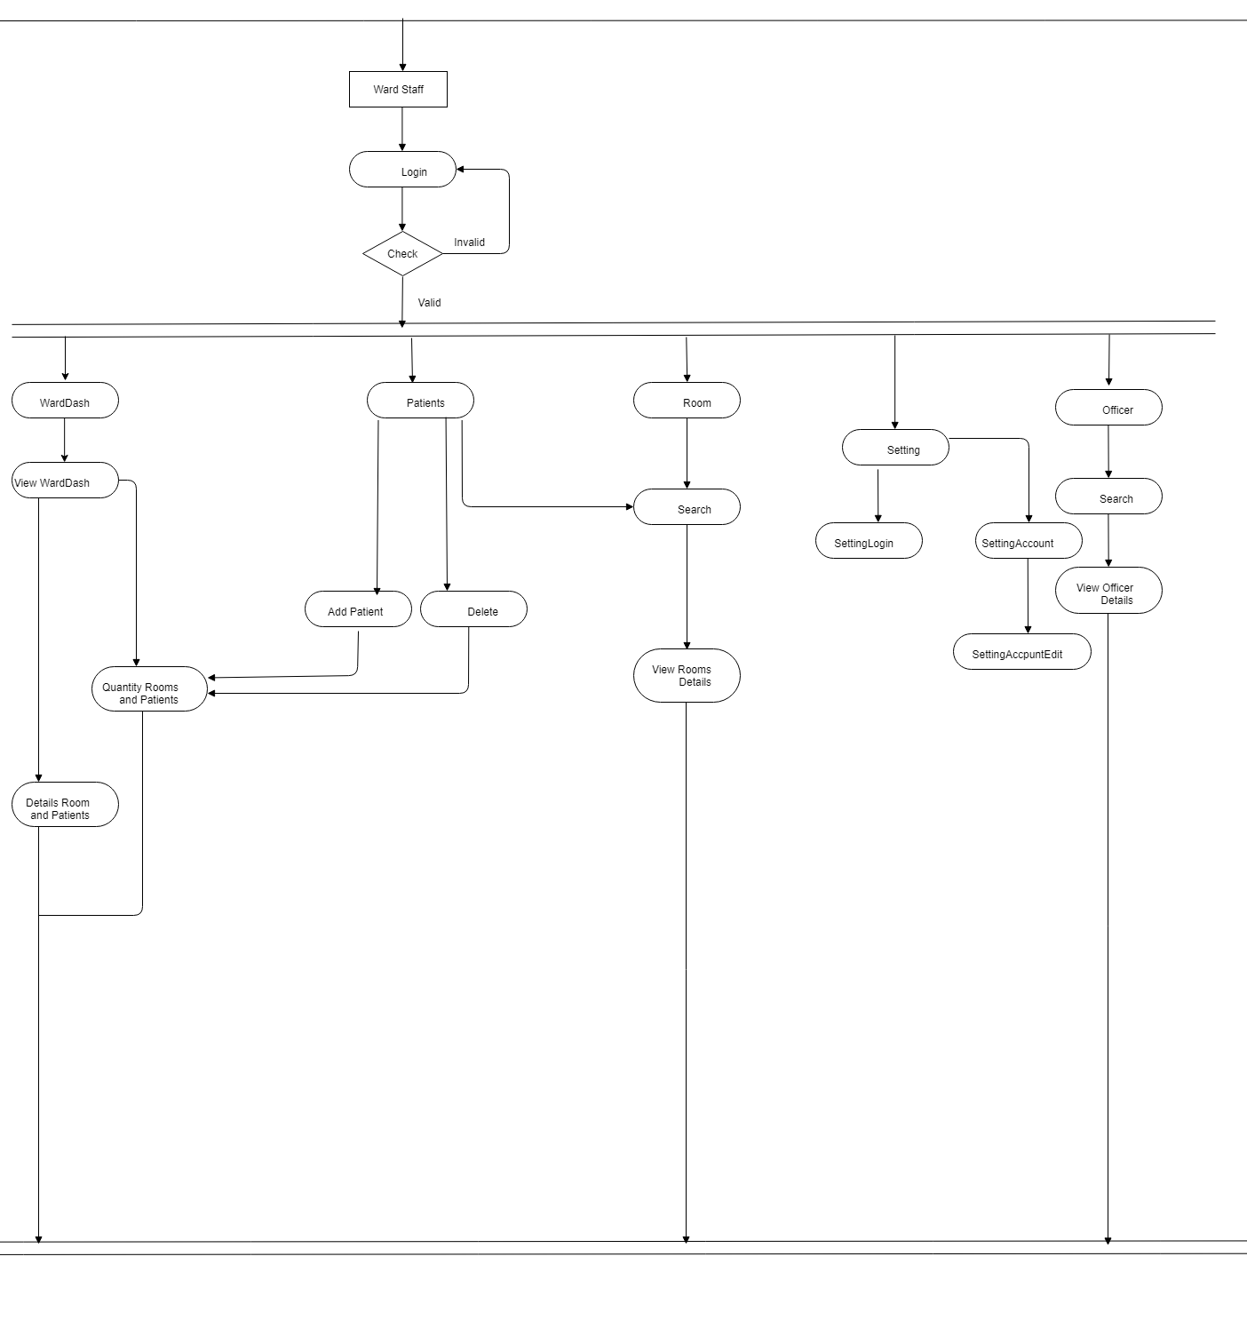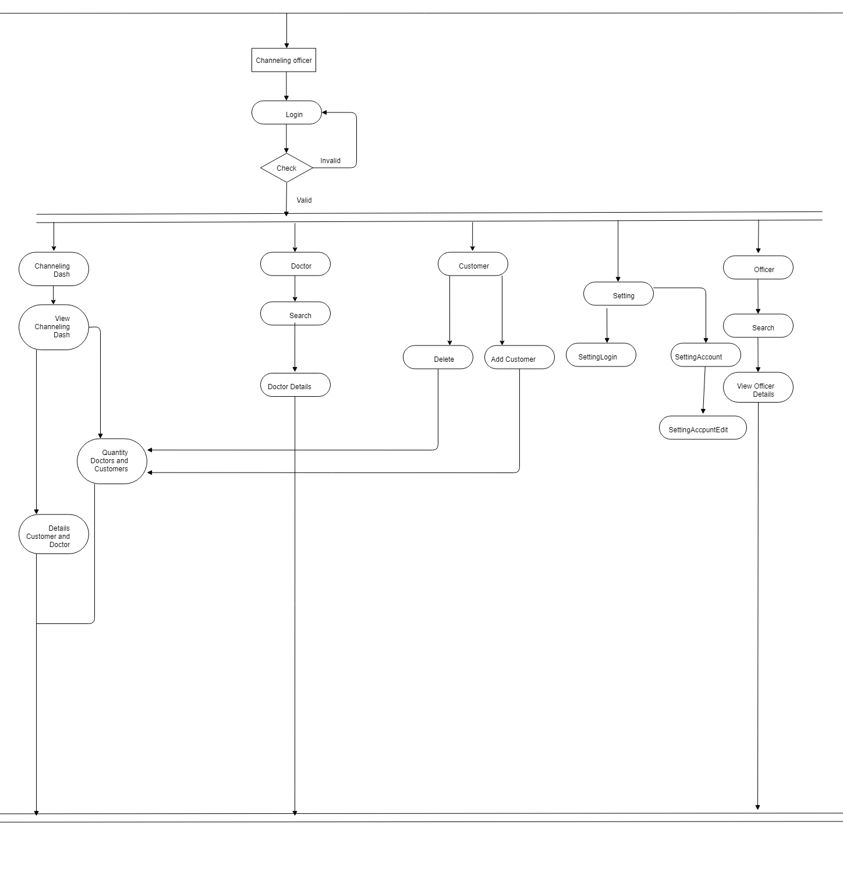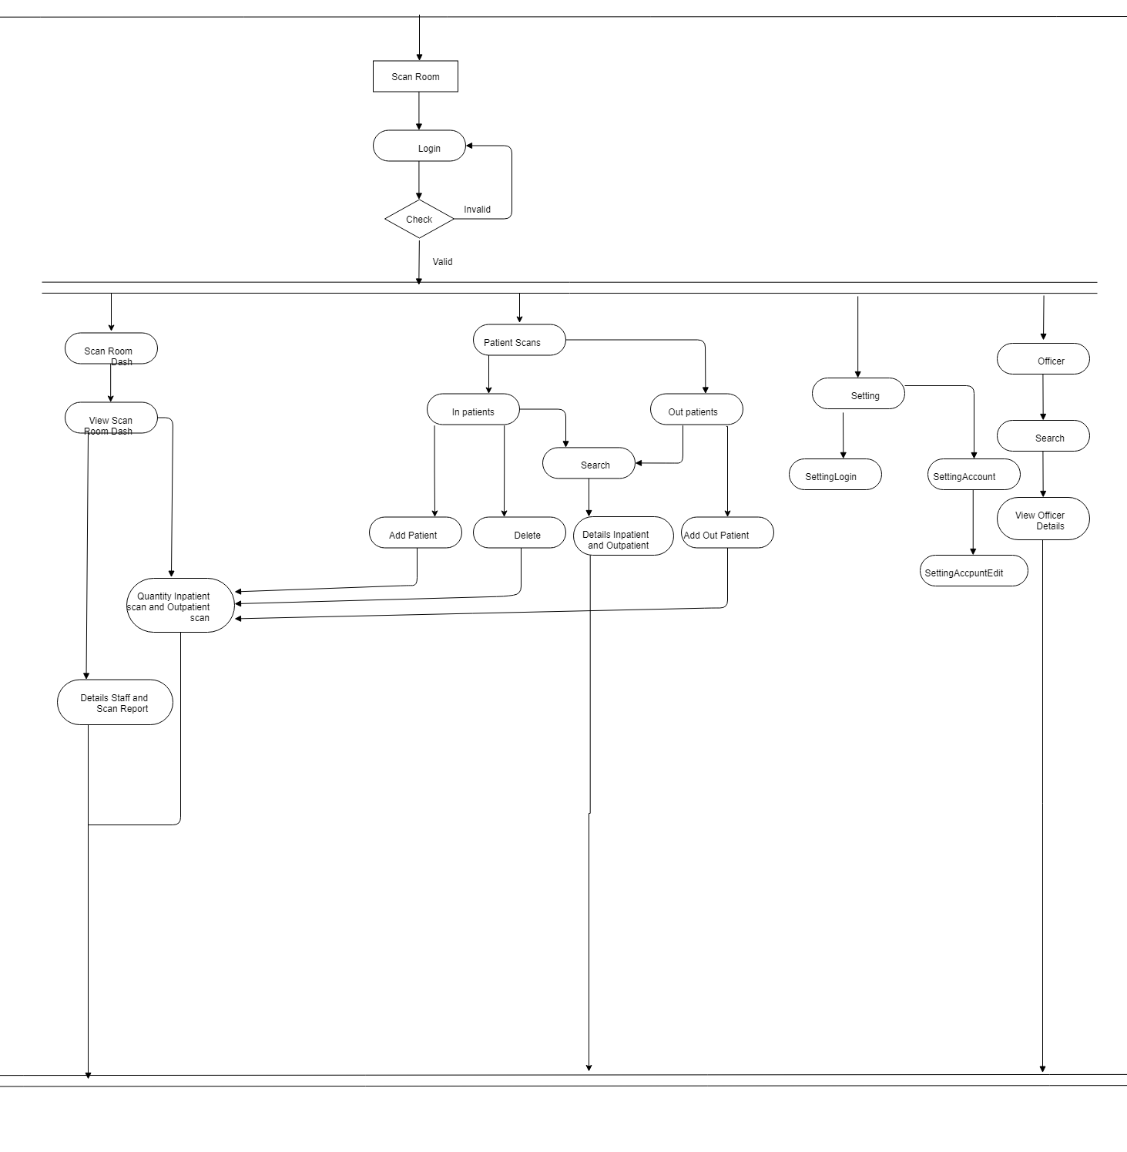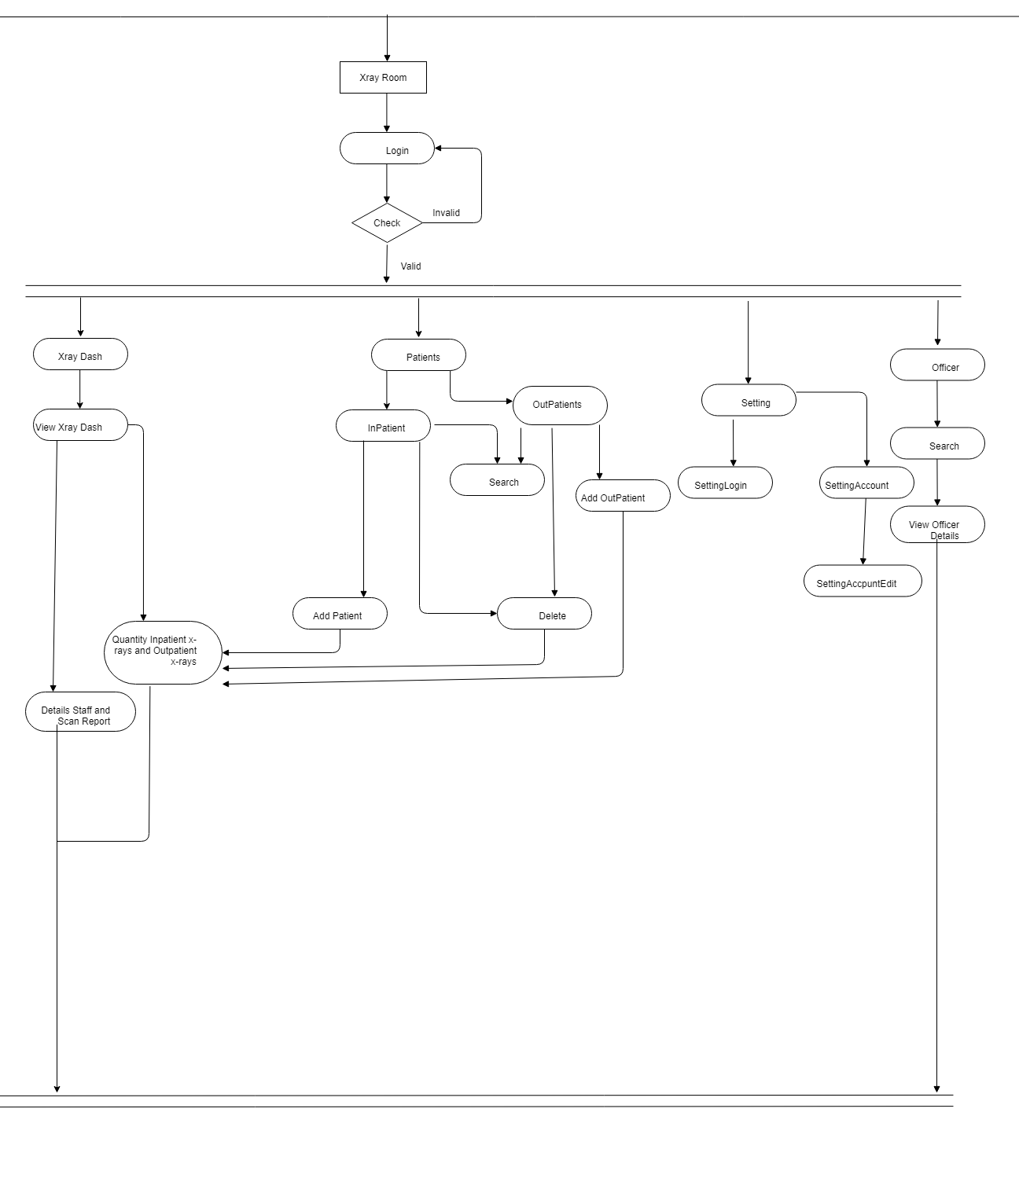

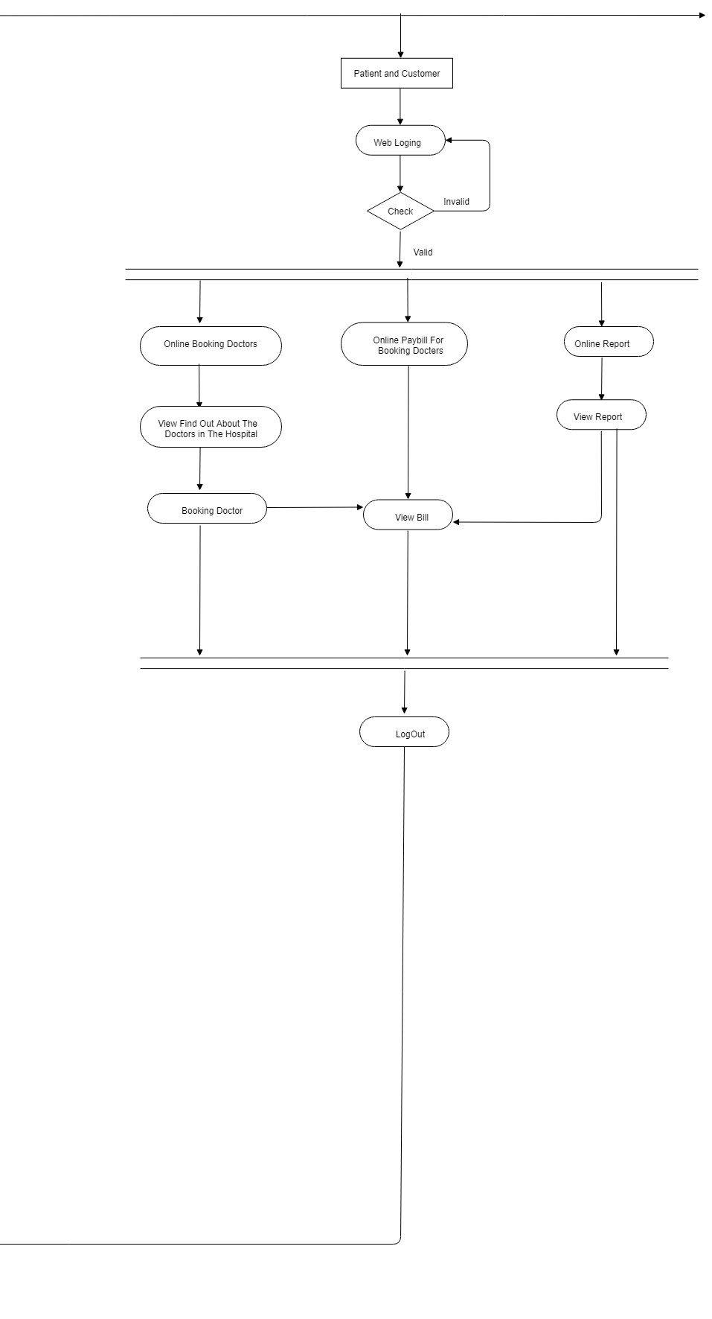

**2.4.3. Class Diagram**

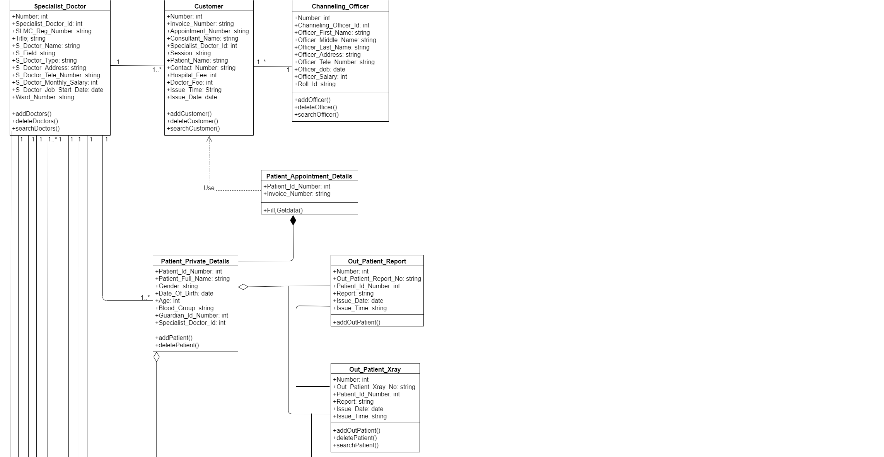

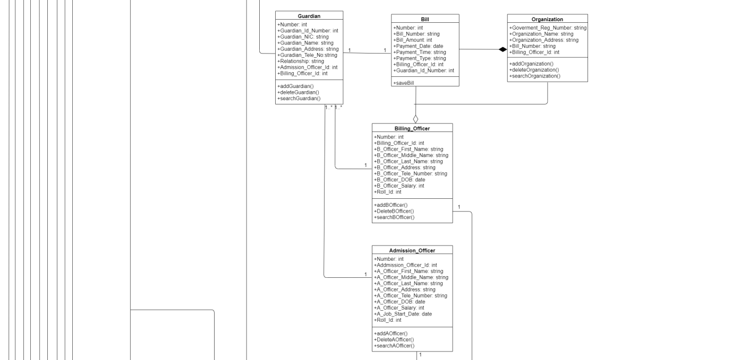

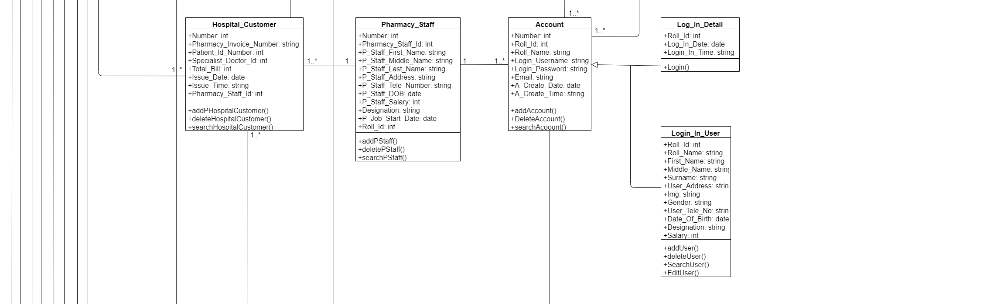

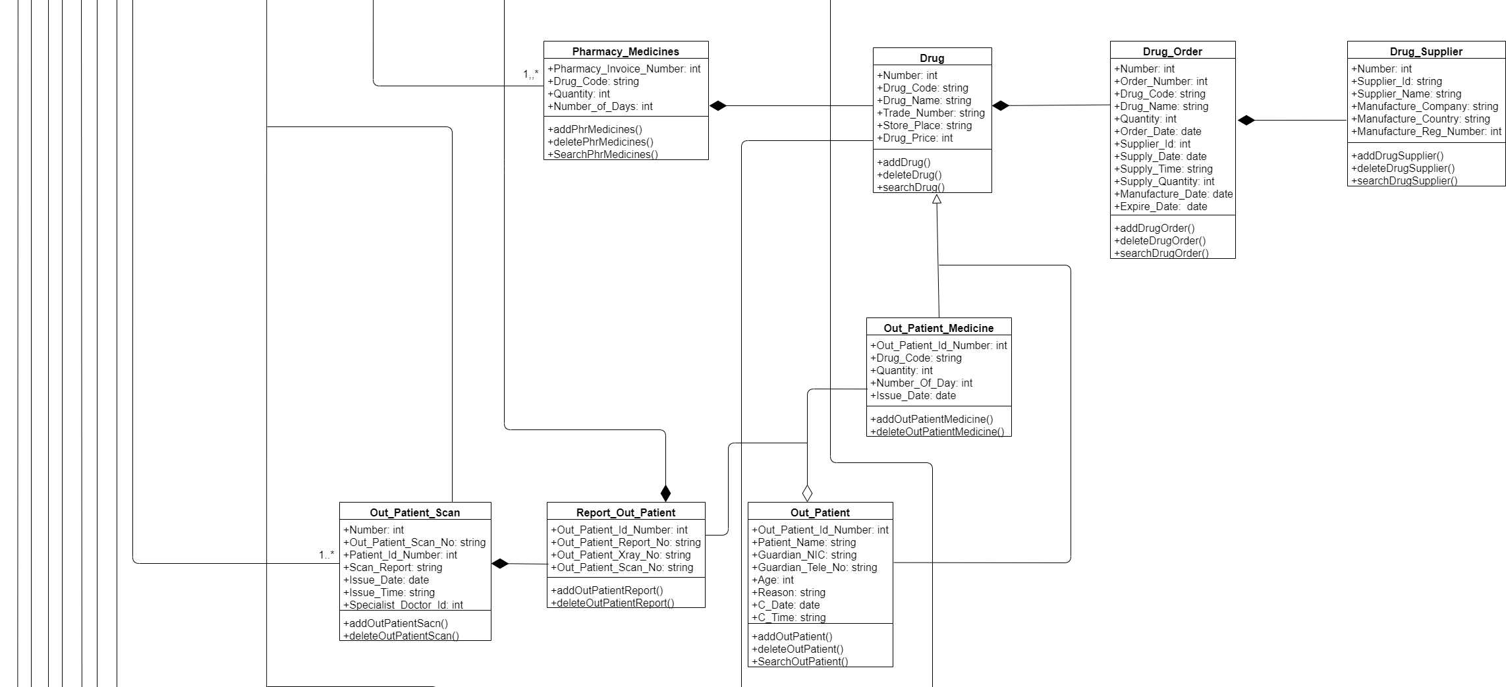

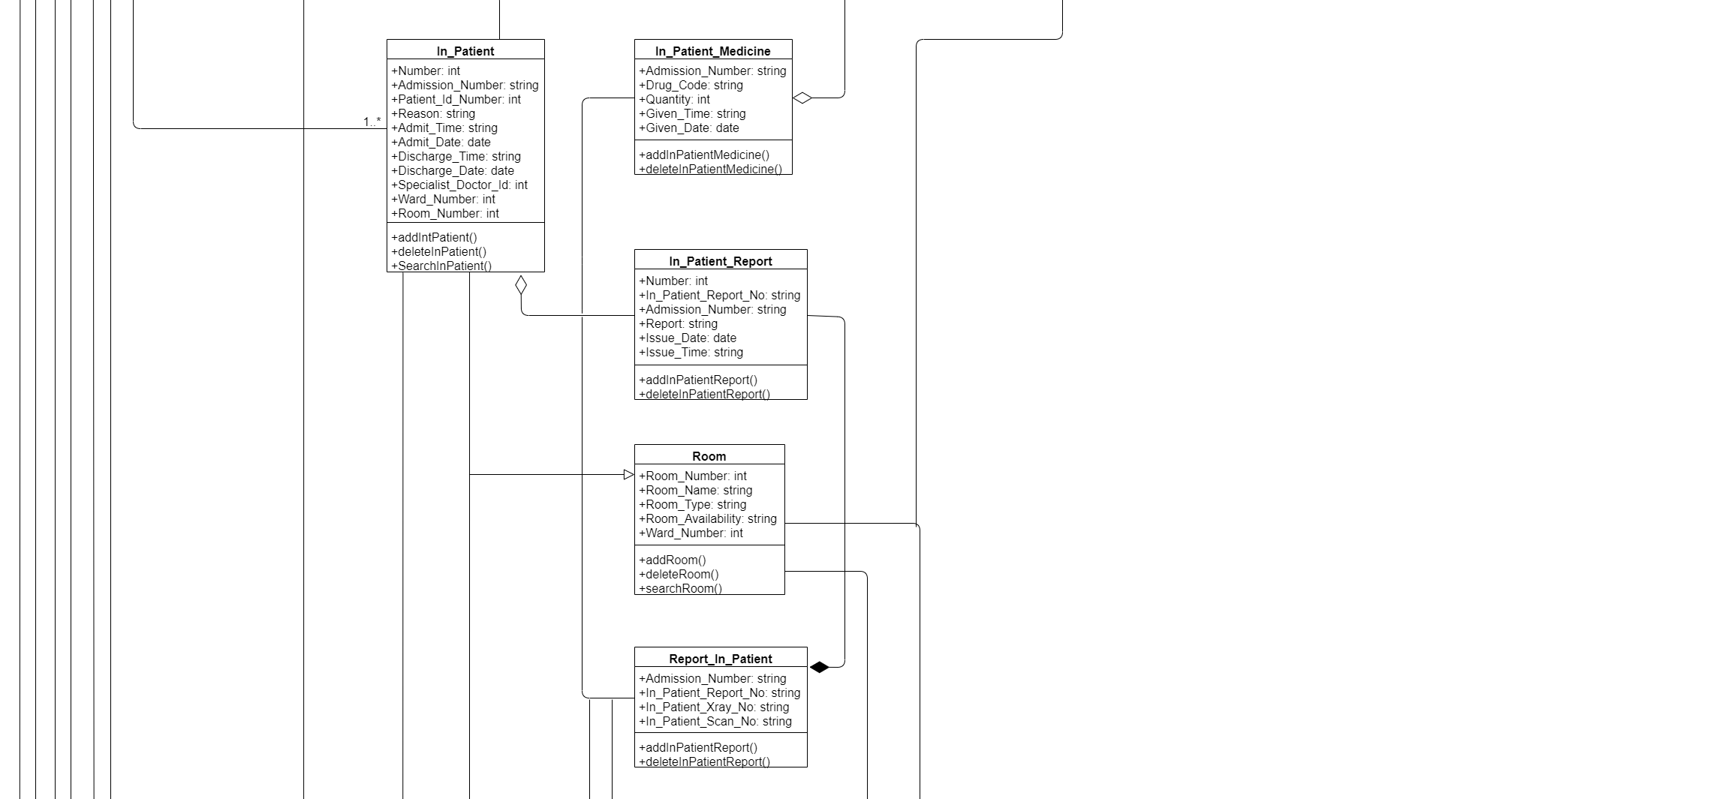

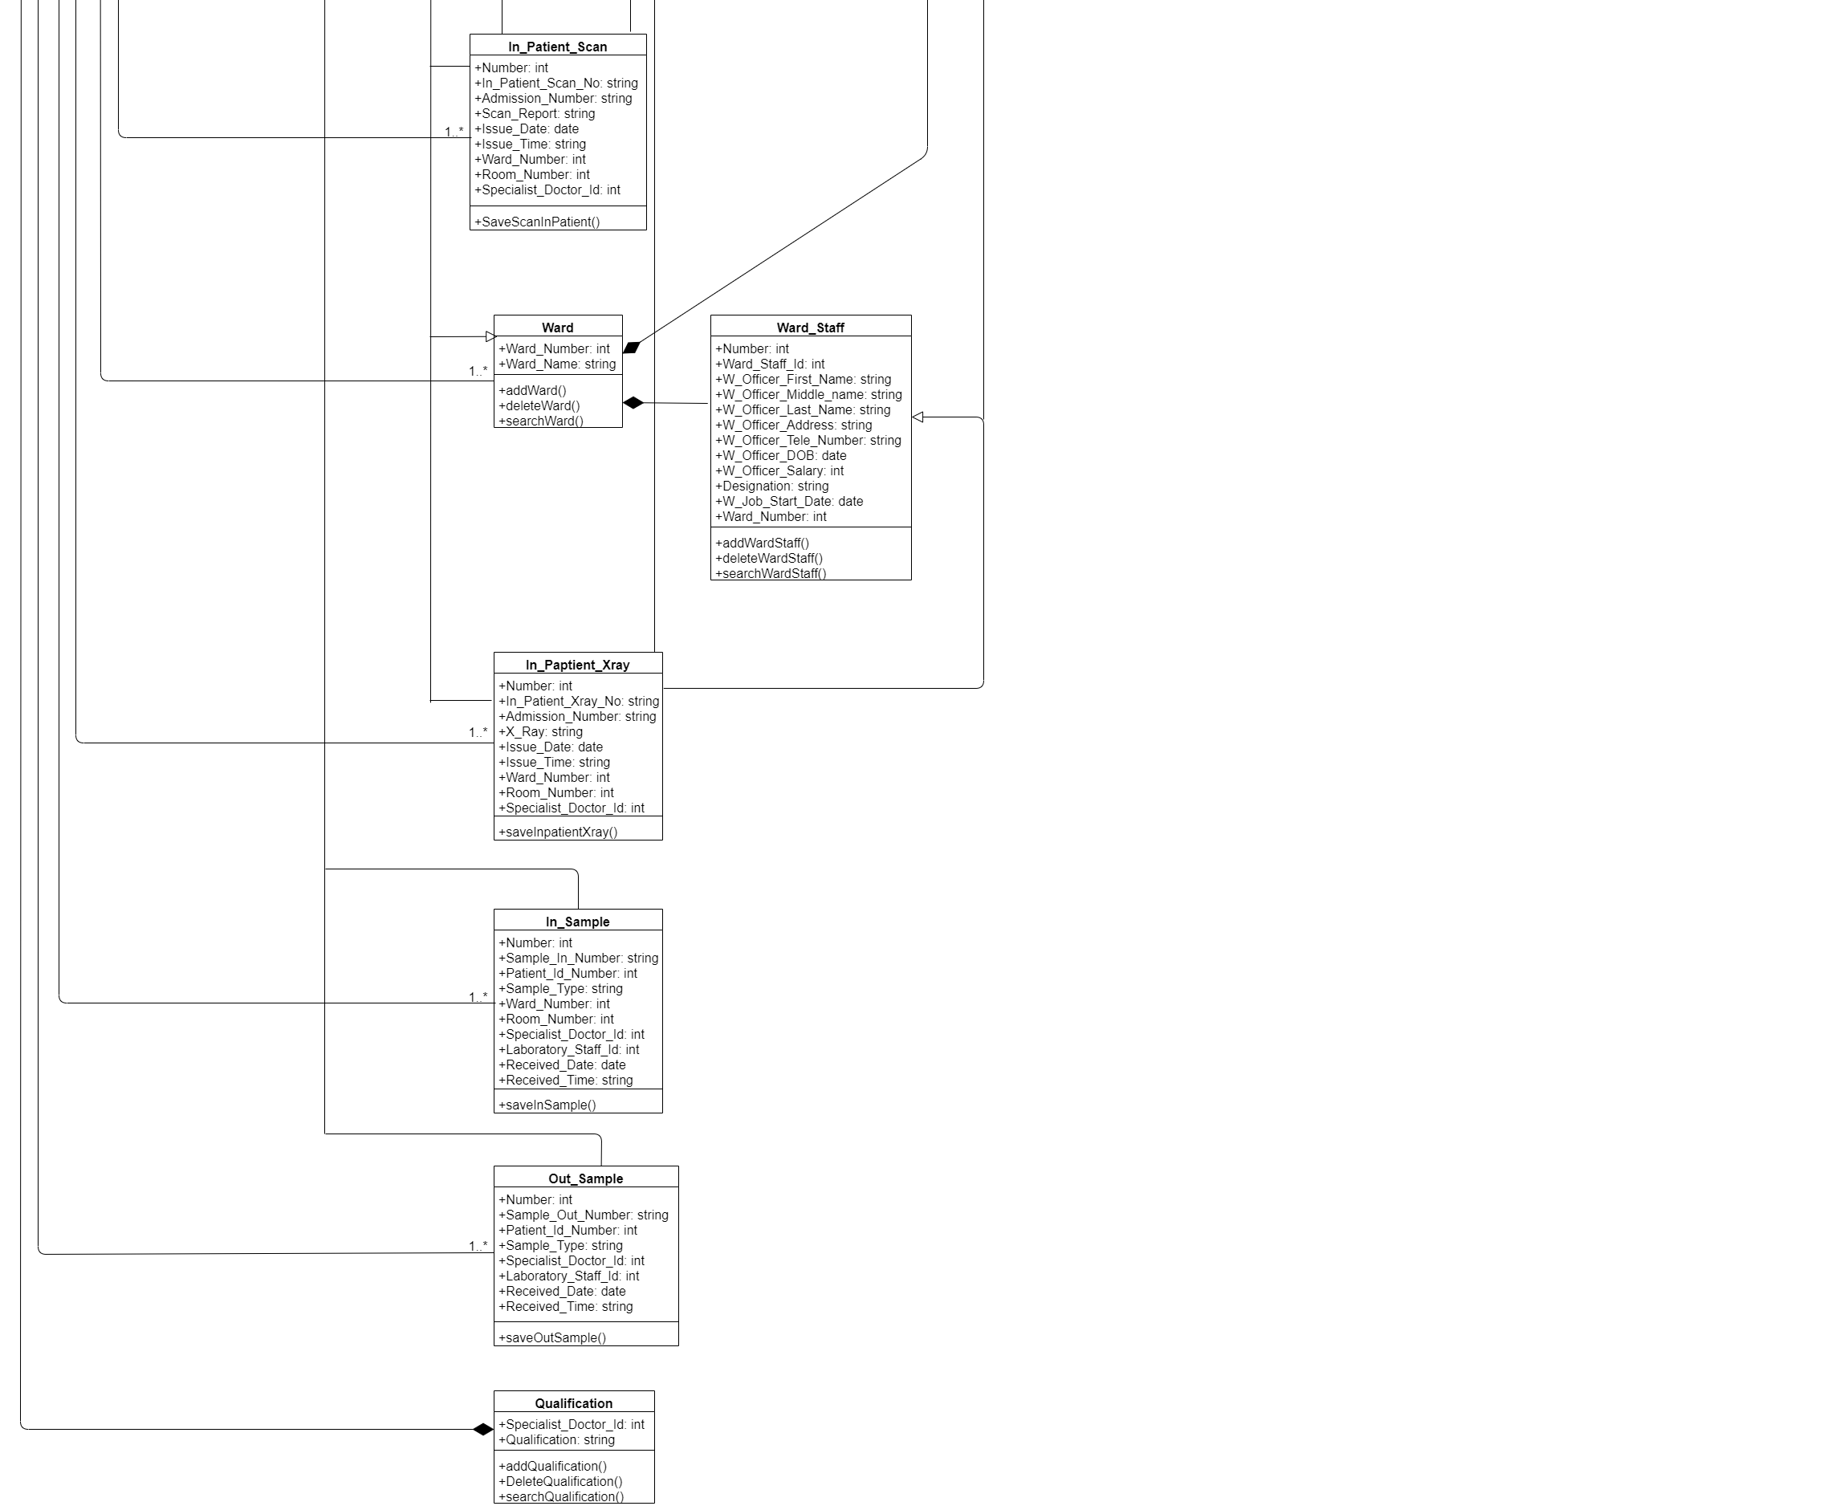

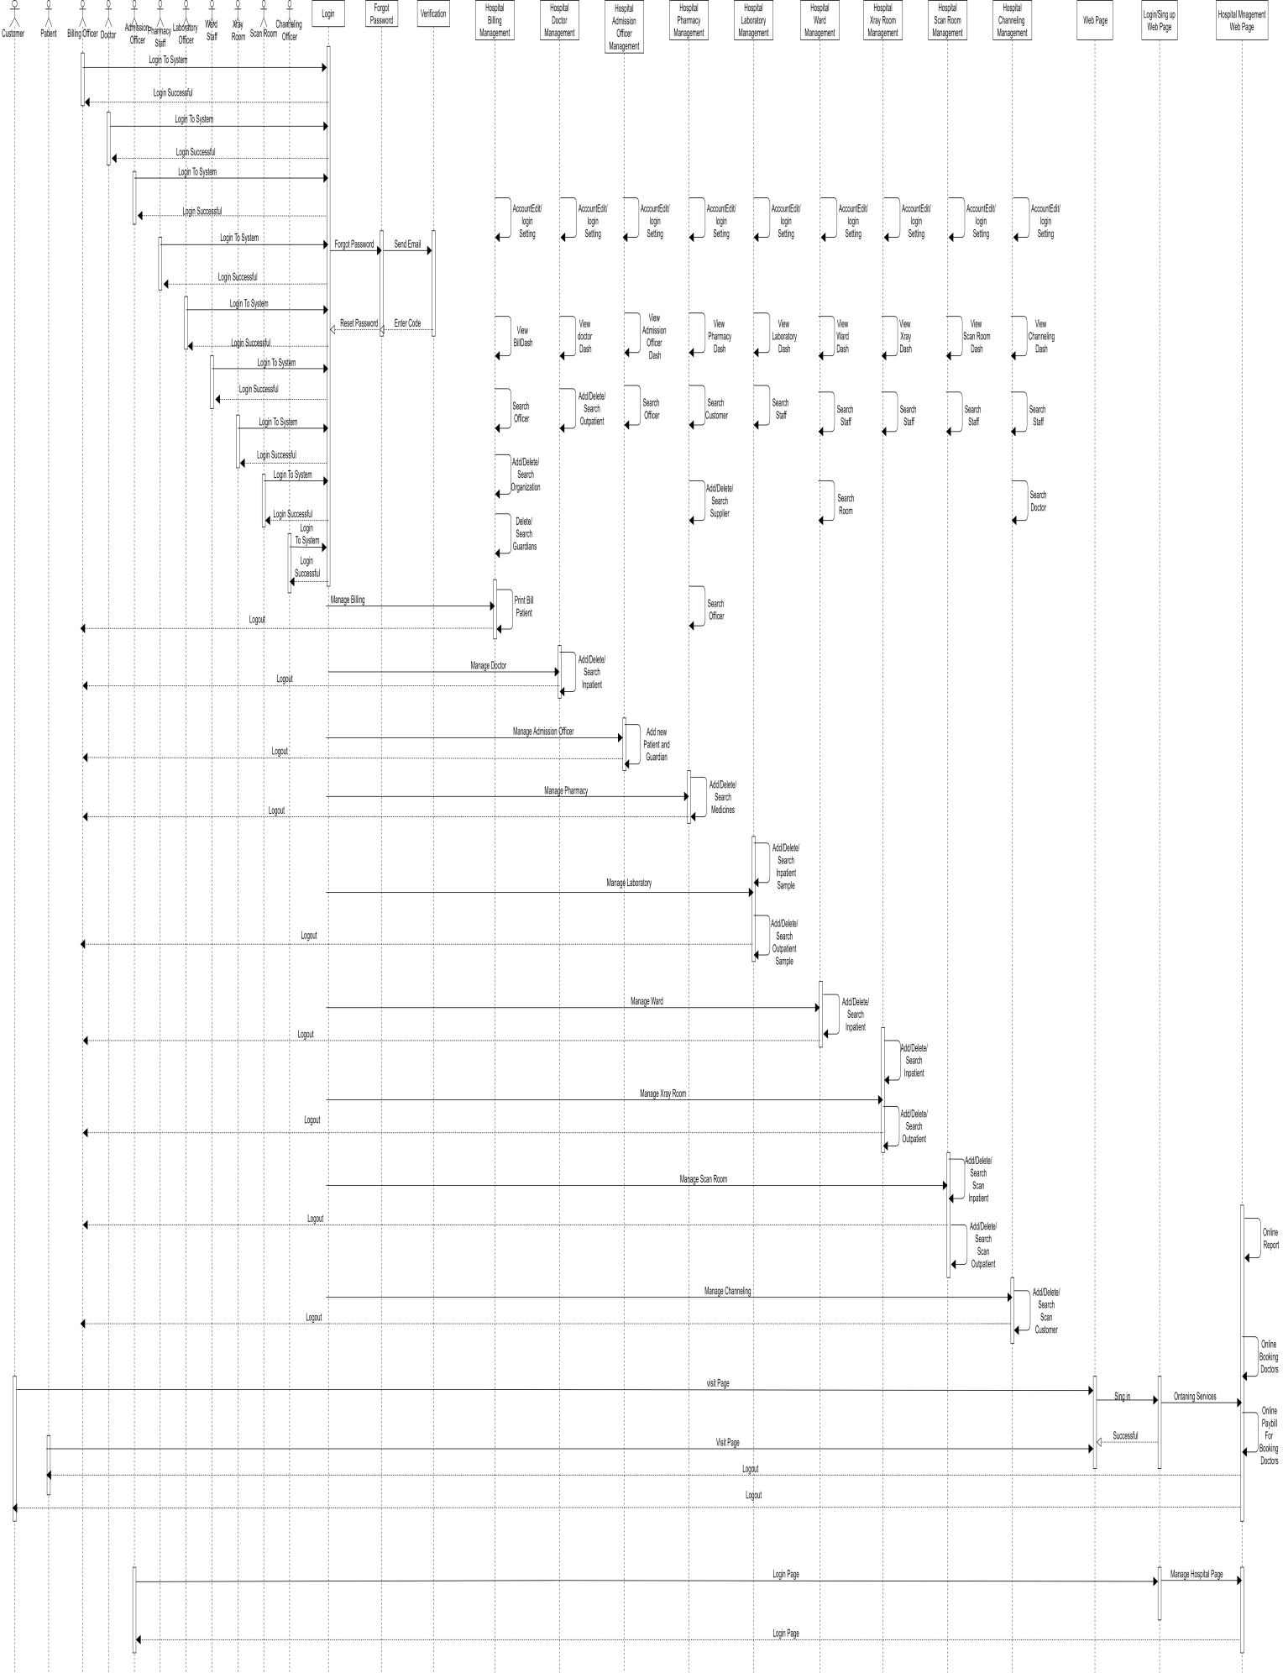**2.4.4 Sequence Diagrams**

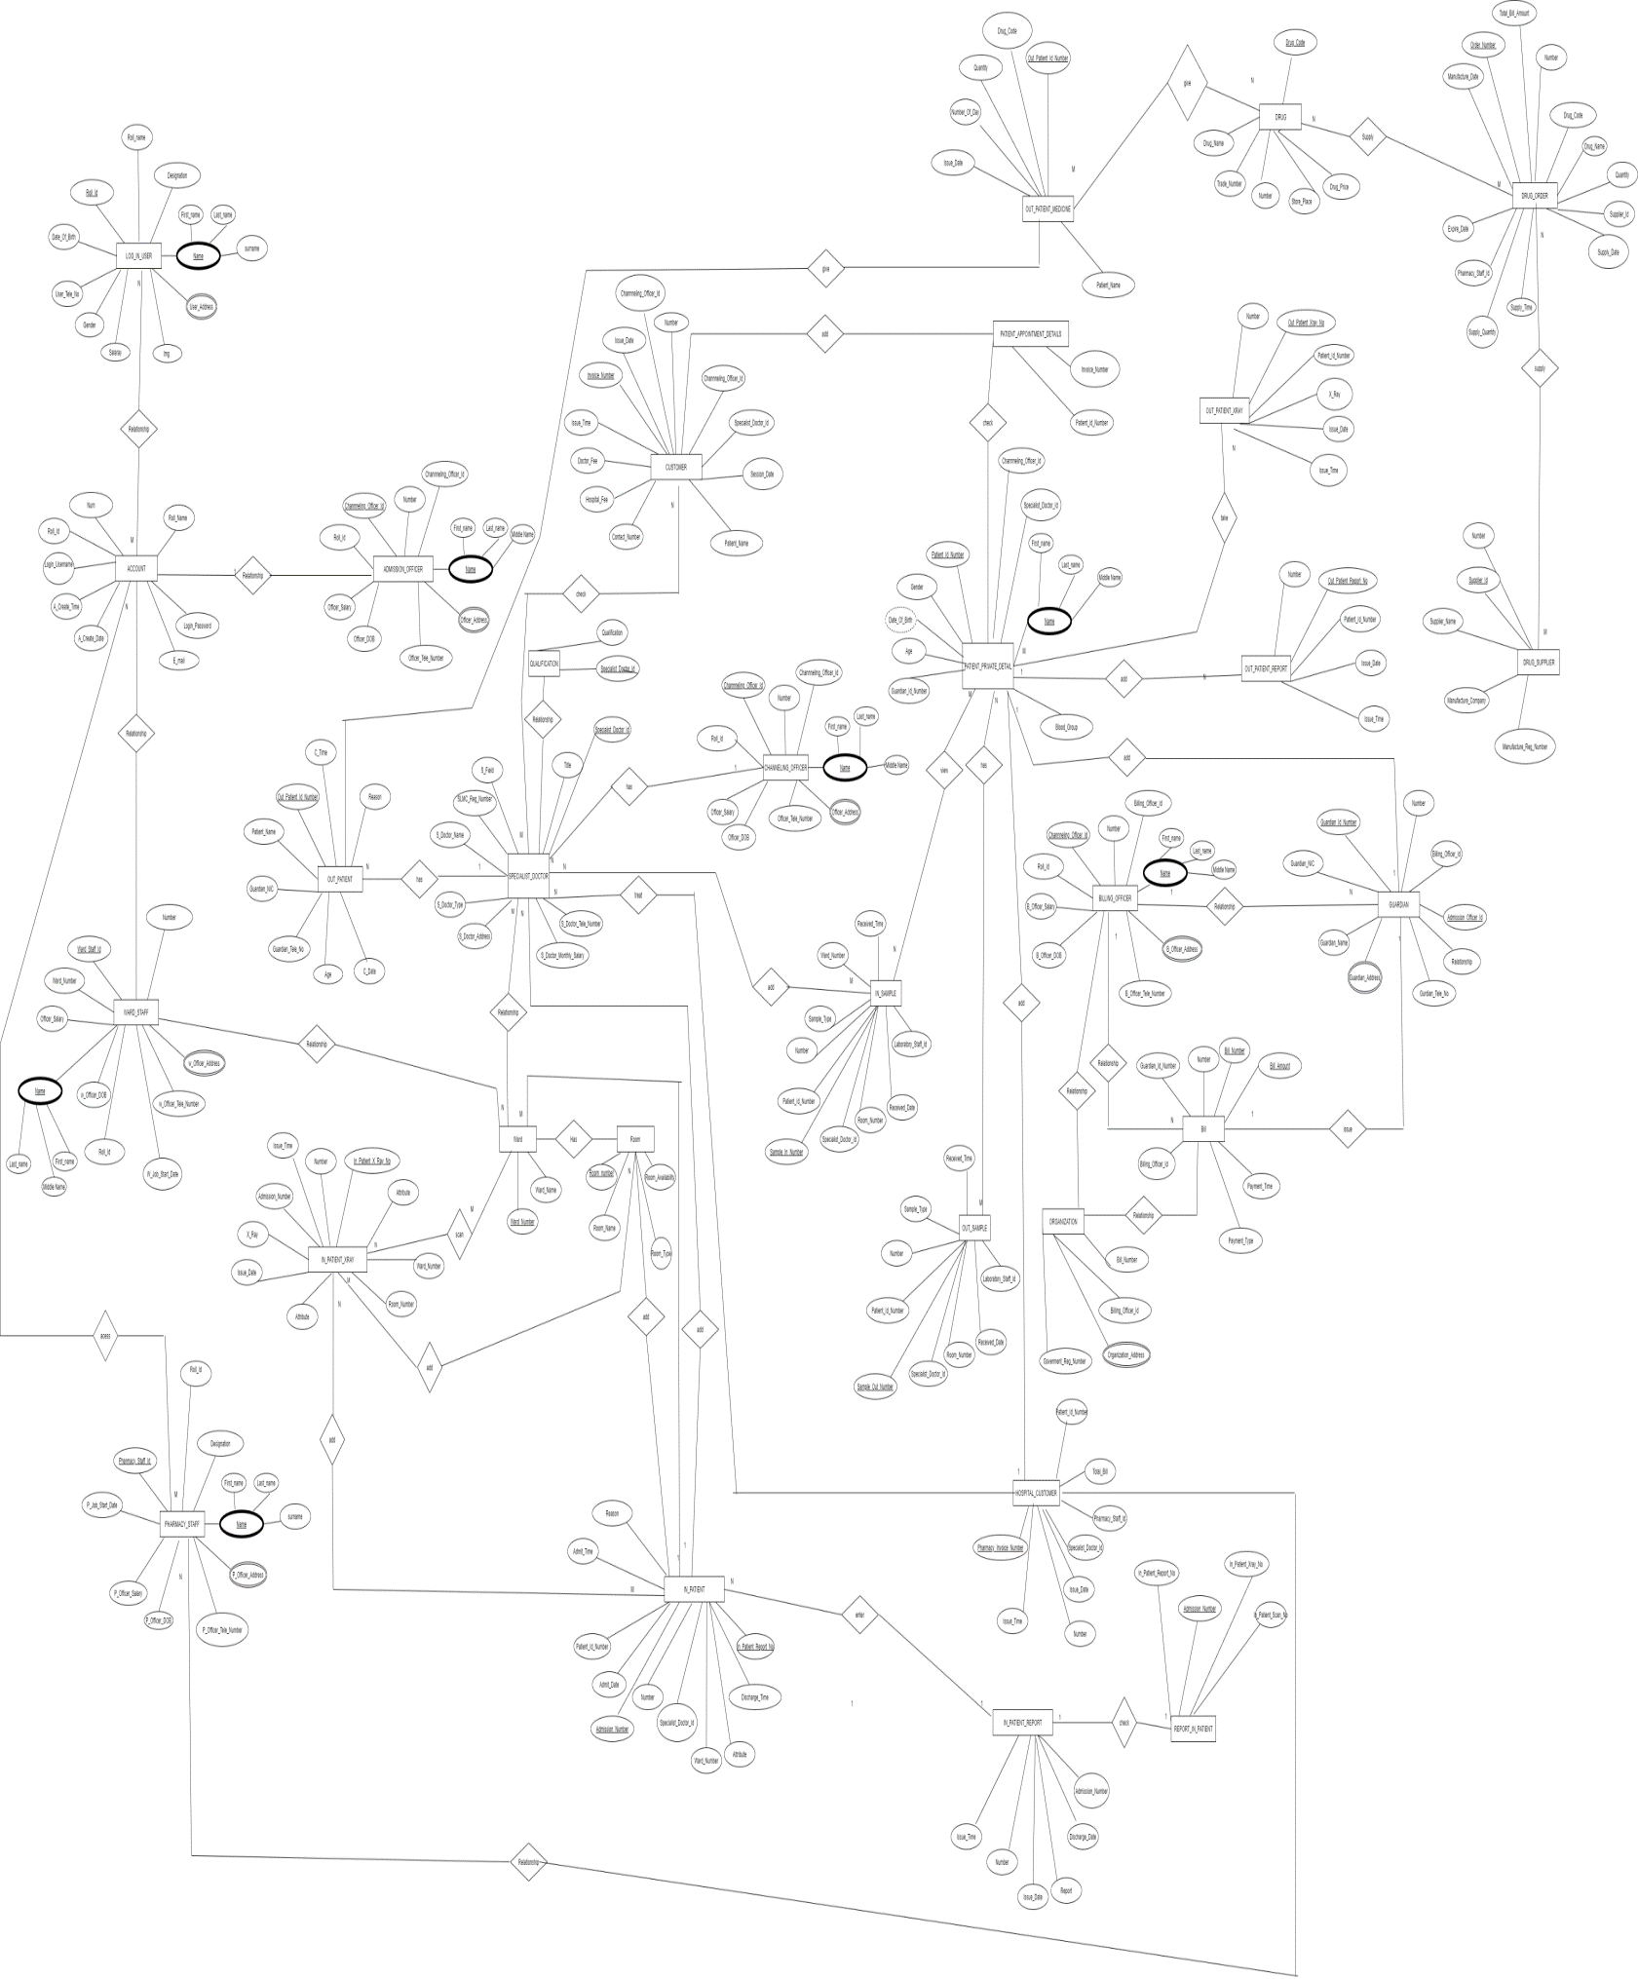**2.4.5 ER Diagram**

**Chapter 3**

**3.1 Design of proposed system**

**3.1.1 System Requirements**

Health Street Hospital Management system is web-based application and standalone application which handle the Hospital Management and administrative activities. Standalone application is implemented for Add patient, admit Patient, bill create, bill dashboard, change password, add channel customer, dashboard channel customer, channeling officer dashboard, add doctor, doctor dashboard, forgot Password, add guardians, add lab sample, dashboard lab sample, add pharmacy medicine, dashboard pharmacy details, add pharmacy suppliers, suppliers details, add scan room, scan room dashboard, add ward, ward dashboard, all account setting, add patient x-ray details, display x-ray details.

**3.2 Database Design**

Table number : 01

Table name : Account

Primary key : ROLL_ID

|  |  |  |  |
| --- | --- | --- | --- |
| **Field Name** | **Data Type** | **Field Size** | **Constraints** |
| NUM | INT |  | NOT NULL |
| ROLL_NAME | VARCHAR | 20 | NOT NULL |
| ROLL_NAME | VARCHAR | 80 | NOT NULL |
| LOGIN_USERNAME | VARCHAR | 50 | NOT NULL |
| LOGIN_PASSWORD | VARCHAR | 20 | NOT NULL |
| E_MAIL | VARCHAR | 90 |  |
| A_CREATE_DATE | DATE |  |  |
| A_CREATE_TIME | TIME |  |  |

Table number : 02

Table name : Addmission_Officer

Primary key : ADDMISSION_OFFICER_ID

|  |  |  |  |
| --- | --- | --- | --- |
| **Field Name** | **Data Type** | **Field Size** | **Constraints** |
| NUMBER | INT |  | NOT NULL |
| ADDMISSION_OFFICER_ID | VARCHAR | 100 | NOT NULL |
| A_OFFICER_FIRST_NAME | VARCHAR | 200 | NOT NULL |
| A_OFFICER_MIDDLE_NAME | VARCHAR | 200 |  |
| A_OFFICER_LAST_NAME | VARCHAR | 200 | NOT NULL |
| A_OFFICER_ADDRESS | VARCHAR | 150 | NOT NULL |
| A_OFFICER_TELE_NUMBER | INT |  | NOT NULL |
| A_OFFICER_DOB | DATE |  | NOT NULL |
| A_OFFICER_SALARY | DECIMAL |  | NOT NULL |
| A_JOB_START_DATE | DATE |  | NOT NULL |
| ROLL_ID | VARCHAR | 8 | NOT NULL |

Table number : 03

Table name : Bill

Primary key : BILL_NUMBER

|  |  |  |  |
| --- | --- | --- | --- |
| **Field Name** | **Data Type** | **Field Size** | **Constraints** |
| NUMBER | INT |  | NOT NULL |
| BILL_NUMBER | VARCHAR | 10 | NOT NULL |
| BILL_AMOUNT | FLOAT |  | NOT NULL |
| PAYMENT_DATE | DATE |  | NOT NULL |
| PAYMENT_TIME | TIME |  | NOT NULL |
| PAYMENT_TYPE | VARCHAR | 20 | NOT NULL |
| BILLING_OFFICER_ID | VARCHAR | 8 | NOT NULL |

Table number : 04

Table name : Billing_Officer

Primary key :BILLING_OFFICER_ID

|  |  |  |  |
| --- | --- | --- | --- |
| **Field Name** | **Data Type** | **Field Size** | **Constraints** |
| NUMBER | INT |  | NOT NULL |
| BILLING_OFFICER_ID | VARCHAR | 10 | NOT NULL |
| B_OFFICER_FIRST_NAME | VARCHAR | 200 | NOT NULL |
| B_OFFICER_MIDDLE_NAME | VARCHAR | 200 |  |
| B_OFFICER_LAST_NAME | VARCHAR | 200 | NOT NULL |
| B_OFFICER_ADDRESS | VARCHAR | 150 | NOT NULL |
| B_OFFICER_TELE_NUMBER | INT |  | NOT NULL |
| B_OFFICER_DOB | DATE |  | NOT NULL |
| B_OFFICER_SALARY | DECIMAL |  | NOT NULL |
| ROLL_ID | VARCHAR | 8 |  |

Table number : 05

Table name : Channeling_Officer

Primary key :CHANNELING_OFFICER_ID

|  |  |  |  |
| --- | --- | --- | --- |
| **Field Name** | **Data Type** | **Field Size** | **Constraints** |
| NUMBER | INT |  | NOT NULL |
| CHANNELING_OFFICER_ID | VARCHAR | 10 | NOT NULL |
| OFFICER_FIRST_NAME | VARCHAR | 200 | NOT NULL |
| OFFICER_MIDDLE_NAME | VARCHAR | 200 |  |
| OFFICER_LAST_NAME | VARCHAR | 200 | NOT NULL |
| OFFICER_ADDRESS | VARCHAR | 150 | NOT NULL |
| OFFICER_TELE_NUMBER | INT |  | NOT NULL |
| OFFICER_DOB | DATE |  | NOT NULL |
| OFFICER_SALARY | DECIMAL |  | NOT NULL |
| ROLL_ID | VARCHAR | 8 |  |

Table number : 06

Table name : Customer

Primary key :INVOICE_NUMBER

|  |  |  |  |
| --- | --- | --- | --- |
| **Field Name** | **Data Type** | **Field Size** | **Constraints** |
| NUMBER | INT |  | NOT NULL |
| INVOICE_NUMBER | VARCHAR | 10 | NOT NULL |
| APPOINTMENT_NUMBER | INT |  | NOT NULL |
| CONSULTANT_NAME | VARCHAR | 50 | NOT NULL |
| SPECIALIST_DOCTOR_ID | VARCHAR | 9 | NOT NULL |
| SESSION_DATE | VARCHAR | 10 | NOT NULL |
| PATIENT_NAME | VARCHAR | 90 | NOT NULL |
| CONTACT_NUMBER | INT |  | NOT NULL |
| HOSPITAL_FEE | INT |  | NOT NULL |
| DOCTOR_FEE | INT |  | NOT NULL |
| ISSUE_TIME | TIME |  | NOT NULL |
| ISSUE_DATE | DATE |  | NOT NULL |
| CHANNELING_OFFICER_ID | VARCHAR | 8 | NOT NULL |

Table number : 07

Table name : Drug

Primary key :DRUG_CODE

|  |  |  |  |
| --- | --- | --- | --- |
| **Field Name** | **Data Type** | **Field Size** | **Constraints** |
| NUMBER | INT |  | NOT NULL |
| DRUG_CODE | VARCHAR | 10 | NOT NULL |
| DRUG_NAME | VARCHAR | 30 | NOT NULL |
| TARDE_NUMBER | VARCHAR | 10 | NOT NULL |
| STORE_PLACE | VARCHAR | 30 | NOT NULL |
| DRUG_PRICE | FLOAT |  | NOT NULL |

Table number : 08

Table name : Drug_Order

Primary key :ORDER_NUMBER

|  |  |  |  |
| --- | --- | --- | --- |
| **Field Name** | **Data Type** | **Field Size** | **Constraints** |
| NUMBER | INT |  | NOT NULL |
| ORDER_NUMBER | VARCHAR | 10 | NOT NULL |
| DRUG_CODE | VARCHAR | 11 | NOT NULL |
| DRUG_NAME | VARCHAR | 30 | NOT NULL |
| QUANTITY | INT |  | NOT NULL |
| ORDER_DATE | DATE |  | NOT NULL |
| SUPPLIER_ID | VARCHAR | 8 | NOT NULL |
| SUPPLY_DATE | DATE |  | NOT NULL |
| SUPPLY_TIME | TIME |  | NOT NULL |
| SUPPLY_QUANTITY | INT |  | NOT NULL |
| MANUFACTURE_DATE | DATE |  | NOT NULL |
| EXPIRE_DATE | DATE |  | NOT NULL |
| TOTAL_BILL_AMOUNT | FLOAT |  | NOT NULL |
| PHARMACY_STAFF_ID | VARCHAR | 8 | NOT NULL |

Table number : 09

Table name : Drug_Supplier

Primary key :SUPPLIER_ID

|  |  |  |  |
| --- | --- | --- | --- |
| **Field Name** | **Data Type** | **Field Size** | **Constraints** |
| NUMBER | INT |  | NOT NULL |
| SUPPLIER_ID | VARCHAR | 10 | NOT NULL |
| SUPPLIER_NAME | VARCHAR | 90 | NOT NULL |
| MANUFACTURE_COMPANY | VARCHAR | 100 | NOT NULL |
| MANUFACTURE_CONTRY | VARCHAR | 20 | NOT NULL |
| MANUFACTURE_REG_NUMBER | VARCHAR | 30 | NOT NULL |

Table number : 10

Table name : Guardian

Primary key :GUARDIAN_ID_NUMBER

|  |  |  |  |
| --- | --- | --- | --- |
| **Field Name** | **Data Type** | **Field Size** | **Constraints** |
| NUMBER | INT |  | NOT NULL |
| GUARDIAN_ID_NUMBER | VARCHAR | 10 | NOT NULL |
| GUARDIAN_NIC | CHAR | 10 | NOT NULL |
| GUARDIAN_NAME | VARCHAR | 90 | NOT NULL |
| GAURDIAN_ADDRESS | VARCHAR | 150 | NOT NULL |
| GUARDIAN_TELE_NO | INT |  | NOT NULL |
| REALTIONSHIP | VARCHAR | 50 | NOT NULL |
| ADMISSION_OFFICER_ID | VARCHAR | 8 | NOT NULL |
| BILLING_OFFICER_ID | VARCHAR | 8 |  |

Table number : 11

Table name : Hospital_Customer

Primary key : PHARMACY_INVOICE_NUMBER

|  |  |  |  |
| --- | --- | --- | --- |
| **Field Name** | **Data Type** | **Field Size** | **Constraints** |
| NUMBER | INT |  | NOT NULL |
| PHARMACY_INVOICE_NUMBER | VARCHAR | 10 | NOT NULL |
| PATIENT_ID_NUMBER | INT |  | NOT NULL |
| SPECIALIST_DOCTOR_ID | VARCHAR | 9 | NOT NULL |
| TOTAL_BILL | DECIMAL |  | NOT NULL |
| ISSUE_DATE | DATE |  | NOT NULL |
| ISSUE_TIME | TIME |  | NOT NULL |
| PHARMACY_STAFF_ID | VARCHAR | 8 | NOT NULL |

Table number : 12

Table name : In_Patient

Primary key : ADMISSION_NUMBER

|  |  |  |  |
| --- | --- | --- | --- |
| **Field Name** | **Data Type** | **Field Size** | **Constraints** |
| NUMBER | INT |  | NOT NULL |
| ADMISSION_NUMBER | VARCHAR | 10 | NOT NULL |
| PATIENT_ID_NUMBER | INT |  | NOT NULL |
| REASON | VARCHAR | 200 | NOT NULL |
| ADMIT_TIME | TIME |  |  |
| ADMIT_DATE | DATE |  |  |
| DISCHARGE_TIME | TIME |  |  |
| DISCHARGE_DATE | DATE |  |  |
| SPECIALIST_DOCTOR_ID | VARCHAR | 9 | NOT NULL |
| WARD_NUMBER | CHAR | 10 | NOT NULL |
| ROOM_NUMBER | CAHR | 10 | NOT NULL |

Table number : 13

Table name : In_Patient_Medicine

Primary key : ADMISSION_NUMBER,DRUG_CODE

|  |  |  |  |
| --- | --- | --- | --- |
| **Field Name** | **Data Type** | **Field Size** | **Constraints** |
| ADMISSION_NUMBER | VARCHAR | 9 | NOT NULL |
| DRUG_CODE | VARCHAR | 11 | NOT NULL |
| QUANTITY | VARCHAR | 10 | NOT NULL |
| GIVEN_TIME | TIME |  | NOT NULL |
| GIVEN_DATE | DATE |  | NOT NULL |

Table number: 14

Table name: in_patient_report

Primary key: In_Patient_Report_No

|  |  |  |  |
| --- | --- | --- | --- |
| **Field Name** | **Data Type** | **Field Size** | **Constraints** |
| Number | INT |  | NOT NULL |
| In_Patient_Report_No | VARCHAR | 10 | NOT NULL |
| Admission_Number | VARCHAR | 09 | NOT NULL |
| Report | blob |  | NOT NULL |
| Issue_Date | DATETIME |  | NOT NULL |
| Issue_Time | DATETIME |  | NOT NULL |

Table number: 15

Table name: in_patient_scan

Primary key: In_Patient_Scan_No

|  |  |  |  |
| --- | --- | --- | --- |
| **Field Name** | **Data Type** | **Field Size** | **Constraints** |
| Number | INT |  | NOT NULL |
| In_Patient_Scan_No | VARCHAR | 10 | NOT NULL |
| Admission_Number | VARCHAR | 09 | NOT NULL |
| Scan_Report | blob |  | NOT NULL |
| Issue_Date | DATETIME |  | NOT NULL |
| Issue_Time | DATETIME |  | NOT NULL |
| Ward_Number | CHAR | 10 | NOTNULL |
| Room_Number | CHAR | 10 | NOTNULL |
|  | | | |

Table number: 16

Table name: in_patient_xray

Primary key: Out_Patient_Report_No

|  |  |  |  |
| --- | --- | --- | --- |
| **Field Name** | **Data Type** | **Field Size** | **Constraints** |
| Number | INT |  | NOT NULL |
| In_Patient_Scan_No | VARCHAR | 10 | NOT NULL |
| Admission_Number | VARCHAR | 09 | NOT NULL |
| X_Ray | blob |  | NOT NULL |
| Issue_Date | DATETIME |  | NOT NULL |
| Issue_Time | DATETIME |  | NOT NULL |
| Ward_Number | CHAR | 10 | NOTNULL |
| Room_Number | CHAR | 10 | NOTNULL |
| Table number: 17  Table name: in_sample  Primary key: Sample_In_Number   |  |  |  |  | | --- | --- | --- | --- | | **Field Name** | **Data Type** | **Field Size** | **Constraints** | | Number | INT |  | NOT NULL | | Sample_In_Number | VARCHAR | 10 | NOT NULL | | Patient_Id_Number | int | 09 | NOT NULL | | Sample_Type | VARCHAR | 10 | NOT NULL | | Ward_Number | CHAR | 10 | NOT NULL | | Room_Number | CHAR | 10 | NOT NULL | | Ward_Number | CHAR | 10 | NOTNULL | | Specialist_Doctor_Id | VARCHAR | 10 | NOTNULL | | Laboratory_Staff_Id | VARCHAR | 08 | NOTNULL | | Received_Date | date |  | NOTNULL | | Received_Time | time |  | NOTNULL |   Table number: 18  Table name: laboratory_staff  Primary key: Laboratory_Staff_Id   |  |  |  |  | | --- | --- | --- | --- | | **Field Name** | **Data Type** | **Field Size** | **Constraints** | | Number | INT |  | NOT NULL | | Laboratory_Staff_Id | VARCHAR | 10 | NOT NULL | | L_Officer_First_Name | VARCHAR | 200 | NULL | | L_Officer_Middle_Name | VARCHAR | 200 | NULL | | L_Officer_Last_Nam | VARCHAR | 200 | NOT NULL | | L_Officer_Address | VARCHAR | 200 | NOT NULL | | L_Officer_Tele_Number | int |  | NOTNULL | | L_Officer_DOB | date |  | NOTNULL | | L_Officer_Salary | decimal | 10,0 | NOTNULL | | Designation | VARCHAR | 30 | NOTNULL | | L_Job_Start_Date | date |  | NOTNULL | | | | |

Table number : 19

Table name : log_in_user

Primary key : Roll_Id

|  |  |  |  |
| --- | --- | --- | --- |
| **Field Name** | **Data Type** | **Field Size** | **Constraints** |
| Roll_Id | varchar | 8 | NOT NULL |
| Roll_name | Varchar | 80 |  |
| First_Name | Varchar | 100 | NOT NULL |
| Middle_Name | Varchar | 100 |  |
| Surname | Varchar | 100 | NOT NULL |
| User_Address | Varchar | 100 |  |
| Img | Varchar | 100 |  |
| Gender | Varchar | 10 |  |
| User_Tele_No | Int | 11 |  |
| Date_Of_Birth | Date |  |  |
| Designation | Varchar |  |  |
| Salary | decimal | 10,0 | NOT NULL |

Table number : 20

Table name : organization

Primary key : **Goverment_Reg_Number**

|  |  |  |  |
| --- | --- | --- | --- |
| **Field Name** | **Data Type** | **Field Size** | **Constraints** |
| Goverment_Reg_Number | varchar | 20 | NOTNULL |
| Organization_Name | varchar | 150 | NOTNULL |
| Organization_Address | varchar | 11 | NOTNULL |
| Bill_Number | varchar | 8 | NOTNULL |

Table number : 21

Table name : Out_patient

Primary key : **Out_Patient_Id_Number**

|  |  |  |  |
| --- | --- | --- | --- |
| **Field Name** | **Data Type** | **Field Size** | **Constraints** |
| Out_Patient_Id_Number | Int | 11 | NOTNIULL |
| Patient_Name | Varchar | 70 | NOTNIULL |
| Guardian_NIC | Varchar | 12 | NOTNIULL |
| Guardian_Tele_No | Int | 11 | NOTNIULL |
| Age | Int | 11 | NOTNIULL |
| Reason | Varchar | 200 | NOTNIULL |
| C_Date | Date |  | NOTNIULL |
| C_Time | Time |  | NOTNIULL |
| Specialist_Doctor_Id | varchar | 9 | NOTNIULL |

Table number : 22

Table name : Out_patient_medicine

Primary key : **Out_Patient_Id_Number**

|  |  |  |  |
| --- | --- | --- | --- |
| **Field Name** | **Data Type** | **Field Size** | **Constraints** |
| Out_Patient_Id_Number | Int | 11 | NOTNIULL |
| Drug_Code | Varchar | 11 | NOTNIULL |
| Quantity | Varchar | 10 | NOTNIULL |
| Number_Of_Day | Int | 11 | NOTNIULL |
| Issue_Date | date |  | NOTNIULL |

Table number : 23

Table name : Out_patient_report

Primary key : **Out_Patient_Report_No**

|  |  |  |  |
| --- | --- | --- | --- |
| **Field Name** | **Data Type** | **Field Size** | **Constraints** |
| Number | Int | 11 | NOTNIULL |
| Out_Patient_Report_No | Varchar | 10 | NOTNIULL |
| Patient_Id_Number | Int | 11 | NOTNIULL |
| Report | Blob |  | NOTNIULL |
| Issue_Date | Date |  | NOTNIULL |
| Issue_Time | TIME |  | NOTNIULL |

Table number : 24

Table name : Out_patient_scan

Primary key : **Out_Patient_scan_No**

|  |  |  |  |
| --- | --- | --- | --- |
| **Field Name** | **Data Type** | **Field Size** | **Constraints** |
| Number | Int | 11 | NOTNIULL |
| Out_Patient_Scan_No | Varchar | 10 | NOTNIULL |
| Patient_Id_Number | Int | 11 | NOTNIULL |
| Scan_Report | Blob |  | NOTNIULL |
| Issue_Date | Date |  | NOTNIULL |
| Issue_Time | TIME |  | NOTNIULL |

Table number : 25

Table name : Out_patient_xray

Primary key : **Out_Patient_xray_No**

|  |  |  |  |
| --- | --- | --- | --- |
| **Field Name** | **Data Type** | **Field Size** | **Constraints** |
| Number | Int | 11 | NOTNIULL |
| Out_Patient_xray_No | Varchar | 10 | NOTNIULL |
| Patient_Id_Number | Int | 11 | NOTNIULL |
| Scan_Report | Blob |  | NOTNIULL |
| Issue_Date | Date |  | NOTNIULL |
| Issue_Time | TIME |  | NOTNIULL |

Table number : 26

Table name : Out_patient_xray

Primary key : **Out_Patient_xray_No**

|  |  |  |  |
| --- | --- | --- | --- |
| **Field Name** | **Data Type** | **Field Size** | **Constraints** |
| Number | Int | 11 | NOTNIULL |
| ample_Out_Number | Varchar | 10 | NOTNIULL |
| Patient_Id_Number | Int | 11 | NOTNIULL |
| Sample_Type | Varchar | 10 | NOTNIULL |
| Specialist_Doctor_Id | Varchar | 9 | NOTNIULL |
| Laboratory_Staff_Id | Varchar | 8 | NOTNIULL |
| Received_Date | Date |  | NOTNIULL |
| Received_Time | TIME |  | NOTNIULL |

Table number: 27

Table name: patient_appointment_details

Primary key: Patient_Id_Number

|  |  |  |  |
| --- | --- | --- | --- |
| Field Name | Data Type | Field Size | Constraints |
| Patient_Id_Number | int | 11 | NOT NULL |
| Invoice_Number | varchar | 8 | NOT NULL |

Table number: 28

Table name: patient_private_detail

Primary key: Patient_Id_Number

|  |  |  |  |
| --- | --- | --- | --- |
| Field Name | Data Type | Field Size | Constraints |
| Patient_Id_Number | int | 11 | NOT NULL |
| Patient_First_Name | varchar | 200 | NOT NULL |
| Patient_Middle_Name | Varchar | 200 |  |
| Patient_Last_Name | varchar | 200 | NOT NULL |
| Gender | varchar | 10 | NOT NULL |
| Date_Of_Birth | date |  | NOT NULL |
| Age | int | 11 | NOT NULL |
| Blood_Group | char | 50 | NOT NULL |
| Guardian_Id_Number | varchar | 8 | NOT NULL |
| Specialist_Doctor_Id | varchar | 9 | NOT NULL |

Table number: 29

Table name: pharmacy_medicines

Primary key: Pharmacy_Invoice_Number

Drug_Code

|  |  |  |  |
| --- | --- | --- | --- |
| Field Name | Data Type | Field Size | Constraints |
| Pharmacy_Invoice_Number | varchar | 9 | NOT NULL |
| Drug_Code | varchar | 11 | NOT NULL |
| Quantity | int | 11 | NOT NULL |
| Number_Of_Days | int | 11 | NOT NULL |

Table number: 30

Table name: pharmacy_staff

Primary key: Pharmacy_Staff_Id

|  |  |  |  |
| --- | --- | --- | --- |
| Field Name | Data Type | Field Size | Constraints |
| Number | Int | 11 | NOT NULL |
| Pharmacy_Staff_Id | varchar | 10 | NOT NULL |
| P_Officer_First_Name | Varchar | 200 | NOT NULL |
| P_Officer_Middle_Name | varchar | 200 |  |
| P_Officer_Last_Name | Varchar | 200 | NOT NULL |
| P_Officer_Address | Varchar | 150 | NOT NULL |
| P_Officer_Tele_Number | Int | 11 | NOT NULL |
| P_Officer_DOB | Date |  | NOT NULL |
| P_Officer_Salary | Decimal | 10,0 | NOT NULL |
| Designation | Varchar | 30 | NOT NULL |
| P_Job_Start_Date | date |  | NOT NULL |
| Roll_Id | Varchar | 8 |  |

Table number: 31

Table name: qualification

Primary key: Specialist_Doctor_Id

Qualification

|  |  |  |  |
| --- | --- | --- | --- |
| Field Name | Data Type | Field Size | Constraints |
| Specialist_Doctor_Id | varchar | 9 | NOT NULL |
| Qualification | varchar | 20 | NOT NULL |

Table number: 32

Table name: report_in_patient

Primary key: Admission_Number

In_Patient_Report_No

|  |  |  |  |
| --- | --- | --- | --- |
| Field Name | Data Type | Field Size | Constraints |
| Admission_Number | Varchar | 9 | NOT NULL |
| In_Patient_Report_No | Varchar | 9 | NOT NULL |
| In_Patient_Xray_No | Varchar | 9 |  |
| In_Patient_Scan_No | varchar | 9 |  |

Table number: 33

Table name: report_out_patient

Primary key: Out_Patient_Id_Number

Out_Patient_Report_No

|  |  |  |  |
| --- | --- | --- | --- |
| Field Name | Data Type | Field Size | Constraints |
| Out_Patient_Id_Number | int | 11 | NOT NULL |
| Out_Patient_Report_No | varchar | 9 | NOT NULL |
| Out_Patient_Xray_No | varchar | 9 |  |
| Out_Patient_Scan_No | varchar | 9 |  |

Table number: 34

Table name: room

Primary key: Room_Number

|  |  |  |  |
| --- | --- | --- | --- |
| Field Name | Data Type | Field Size | Constraints |
| Room_Number | char | 10 | NOT NULL |
| Room_Name | varchar | 70 | NOT NULL |
| Room_Type | varchar | 90 | NOT NULL |
| Room_Availability | char | 10 | NOT NULL |
| Ward_Number | char | 10 | NOT NULL |

Table number: 35

Table name: scan_room

Primary key: S_Staff_Id

|  |  |  |  |
| --- | --- | --- | --- |
| Field Name | Data Type | Field Size | Constraints |
| Number | Int | 11 | NOT NULL |
| S_Staff_Id | varchar | 10 | NOT NULL |
| S_Officer_First_Name | varchar | 200 | NOT NULL |
| S_Officer_Middle_Name | varchar | 200 |  |
| S_Officer_Last_Name | varchar | 200 | NOT NULL |
| S_Officer_Address | varchar | 150 | NOT NULL |
| S_Officer_Tele_Number | int | 11 | NOT NULL |
| S_Officer_DOB | date |  | NOT NULL |
| S_Officer_Salary | decimal | 10,0 | NOT NULL |
| Designation | varchar | 30 | NOT NULL |
| S_Job_Start_Date | date |  | NOT NULL |

Table number: 36

Table name: specialist_doctor

Primary key: Specialist_Doctor_Id

|  |  |  |  |
| --- | --- | --- | --- |
| Field Name | Data Type | Field Size | Constraints |
| Number | Int | 11 | NOT NULL |
| Specialist_Doctor_Id | varchar | 10 | NOT NULL |
| SLMC_Reg_Number | char | 20 | NOT NULL |
| Title | varchar | 10 | NOT NULL |
| S_Doctor_Name | varchar | 50 | NOT NULL |
| S_Field | varchar | 20 | NOT NULL |
| S_Doctor_Type | char | 20 | NOT NULL |
| S_Doctor_Address | varchar | 100 | NOT NULL |
| S_Doctor_Tele_Number | Int | 11 | NOT NULL |
| S_Doctor_Monthly_Salary | decimal | 10,0 | NOT NULL |
| S_Doctor_Job_Start_Date | date |  | NOT NULL |
| Ward_Number | char | 10 | NOT NULL |

Table number: 37

Table name: ward

Primary key: Ward_Number

|  |  |  |  |
| --- | --- | --- | --- |
| Field Name | Data Type | Field Size | Constraints |
| Ward_Number | char | 10 | NOT NULL |
| Ward_Name | varchar | 70 | NOT NULL |

Table number: 38

Table name: ward_staff

Primary key: Ward_Staff_Id

|  |  |  |  |
| --- | --- | --- | --- |
| Field Name | Data Type | Field Size | Constraints |
| Number | int | 11 | NOT NULL |
| Ward_Staff_Id | varchar | 10 | NOT NULL |
| W_Officer_First_Name | varchar | 200 | NOT NULL |
| W_Officer_Middle_Name | varchar | 200 |  |
| W_Officer_Last_Name | varchar | 200 | NOT NULL |
| W_Officer_Address | varchar | 150 | NOT NULL |
| W_Officer_Tele_Number | int | 11 | NOT NULL |
| W_Officer_DOB | date |  | NOT NULL |
| W_Officer_Salary | decimal | 10,0 | NOT NULL |
| Designation | varchar | 30 | NOT NULL |
| W_Job_Start_Date | date |  | NOT NULL |
| Ward_Number | char | 10 | NOT NULL |
| Roll_Id | varchar | 8 |  |

Table number: 39

Table name: x_ray_room

Primary key: Staff_Id

|  |  |  |  |
| --- | --- | --- | --- |
| Field Name | Data Type | Field Size | Constraints |
| Number | int | 11 | NOT NULL |
| Staff_Id Primary | varchar | 10 | NOT NULL |
| X_Officer_First_Name | varchar | 200 | NOT NULL |
| X_Officer_Middle_Name | varchar | 200 | NOT NULL |
| X_Officer_Last_Name | varchar | 200 | NOT NULL |
| X_Officer_Address | Varchar | 150 | NOT NULL |
| X_Officer_Tele_Number | int | 11 | NOT NULL |
| X_Officer_DOB | date |  | NOT NULL |
| X_Officer_Salary | decimal | 10,0 | NOT NULL |
| Designation | varchar | 30 | NOT NULL |
| X_Job_Start_Date | date |  | NOT NULL |

**3.3 Interface Design**

* Login Form - This is the login form that all registered persons can login to the system by using their own username and password.

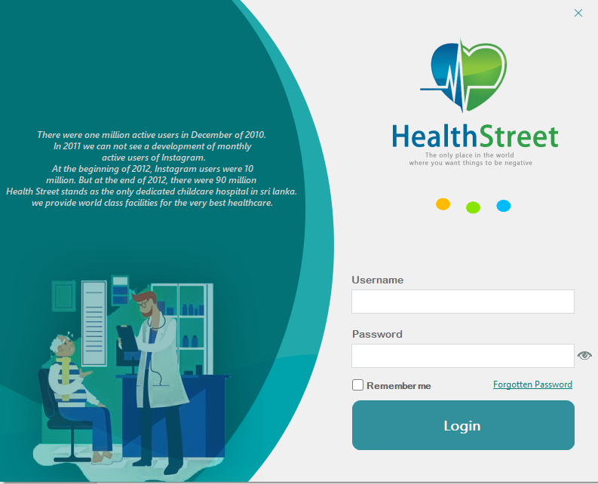

* **ADaddPatient Form-** This section is used to enter patient and patient guardian details. First Name, Middle Name, Surname, date of birth, reason and gender into patient. patient guardian details are name, Nic, Address, TP Number, Relationship, date and time.

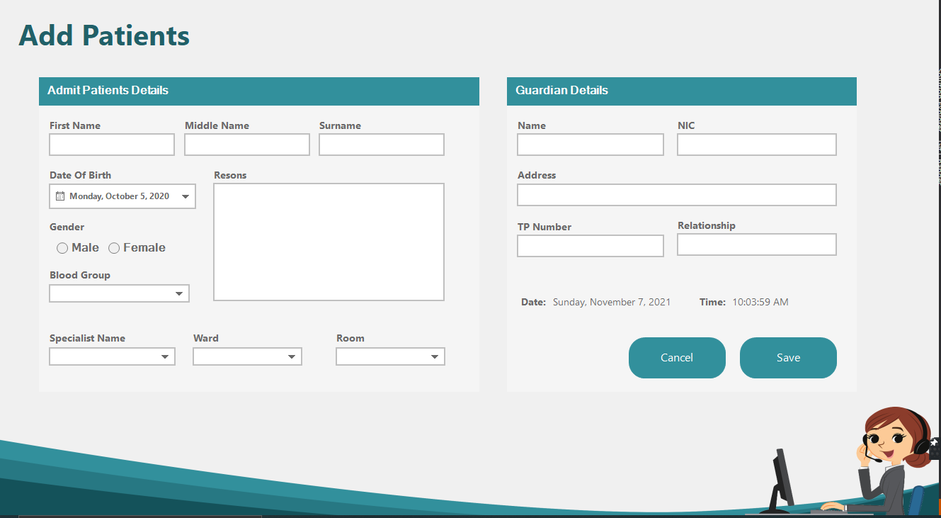

* **AddDash Form-** Patients admitted to the hospital by this section shows the in Patient id number, Patient first name , Patient middle name, patient surname, Gender , Date of birth, Age, Blood Group, Guardian NIC, Guardian Address and Guardian TP No in in admit patient in the hospital.

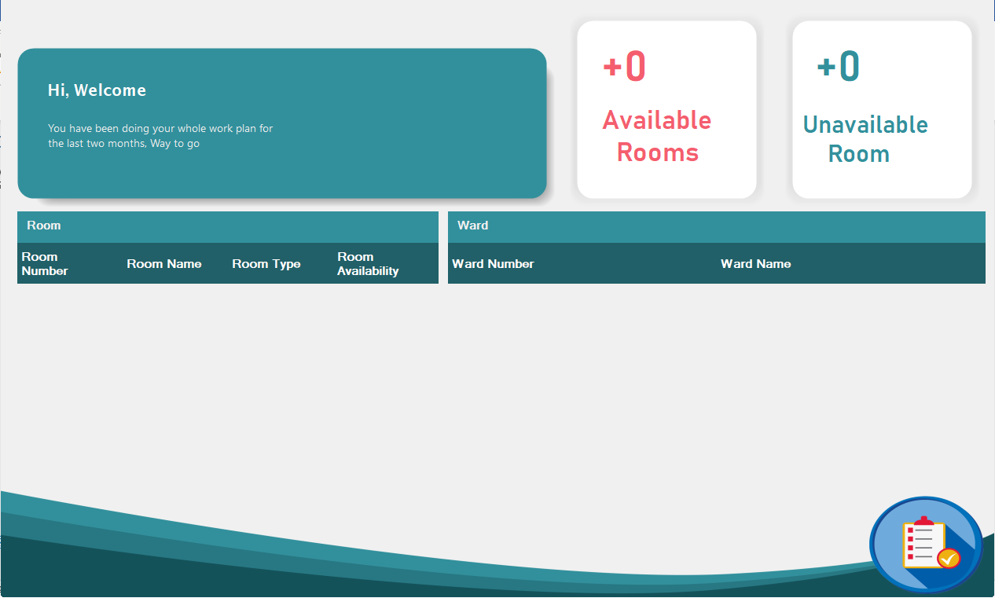

* **Add New Patient-** This section is used to add new patient. Add to Patient Name, guardian TP No, Guardian NIC, Age , reason. And add the patient’s guardians’ details. The details are Name, Nic, Address, TP Number, Relationship, Date, Time.

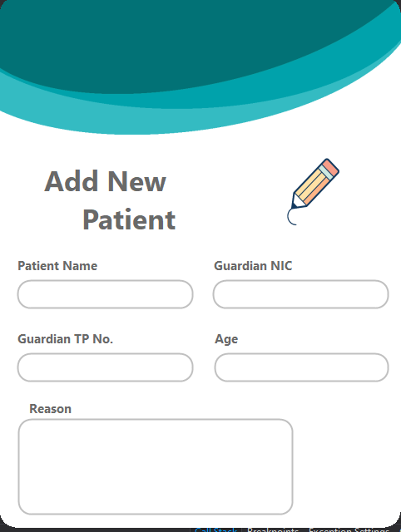

* **Customer Dashboard -** This section is used to show the invoice Number, Appointment Number, Consultant Name , Specialist Doctor id , Session Date , Patient Name, Contact Number , hospital fee.

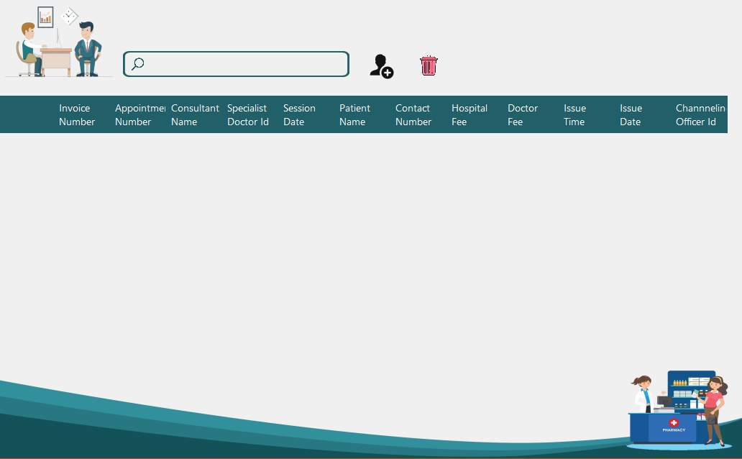

**Add Sample Inpatient –** This is used to add the x-rays to the system. x-rays are added by officers**.**

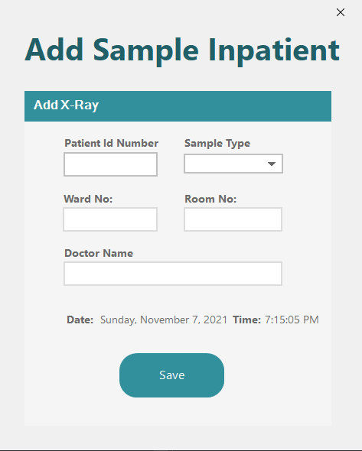

* **Add Customer *-*** This section shows add customer details. Details are Appointment Number, Patient Name, Session Date, specialist Name , Doctor fee , hospital fee , contact Number , Date , Time.

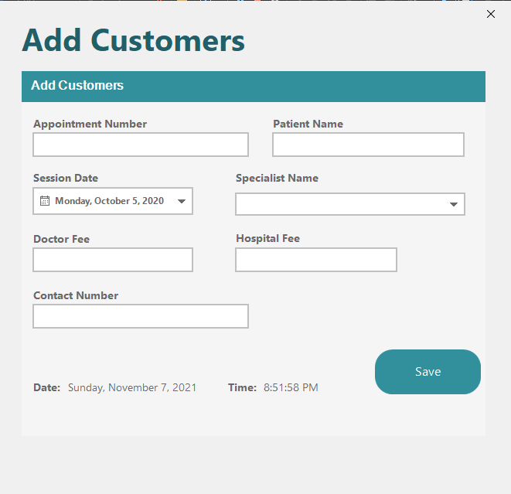

* **Room Dashboard** -This section Display the room details of the system.

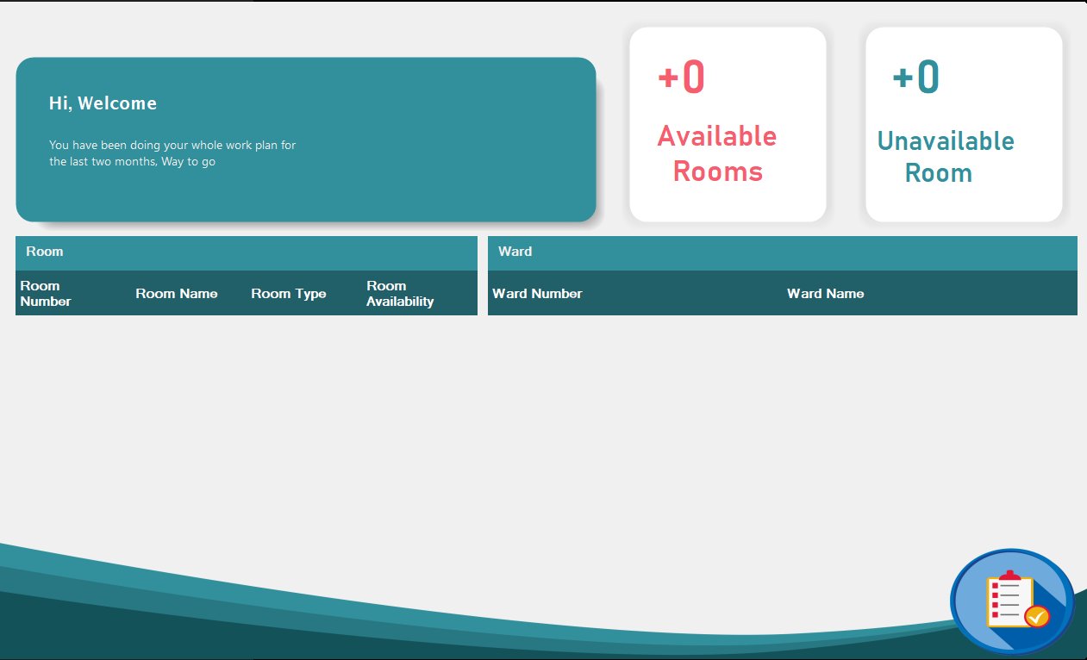

* Forget password- Customized details all login users. Details are first Name, Last name, G-mail, New Password, confirm Password.

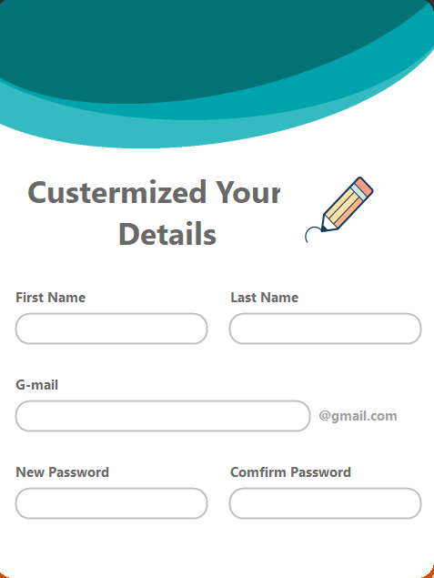

* **Channel Dashboard** – Display all details of the doctors and customers. Details are Special doctor id, Doctor Name, field, invoice Number, Appointment Number, Hospital fee, Doctor fee.

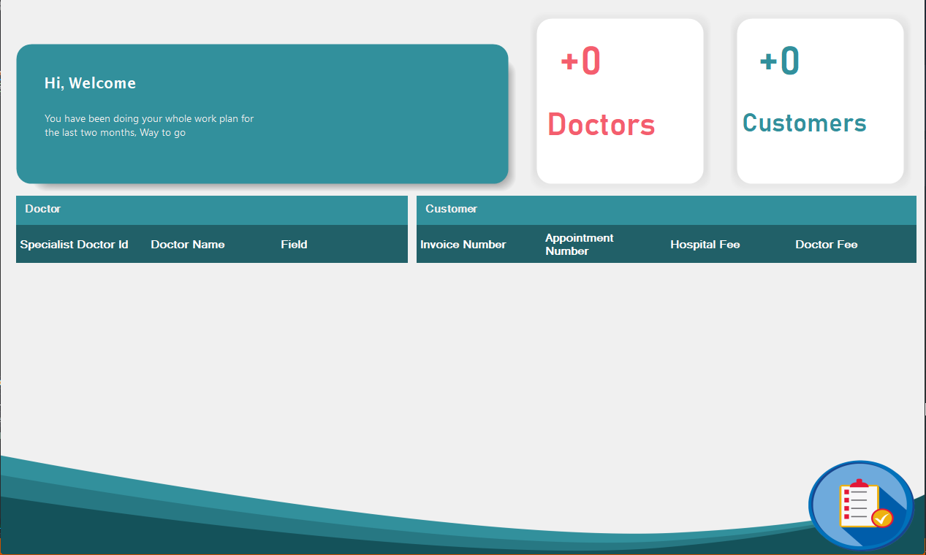

* **MessageQuestion Form** - This section use to Display the message of the yes or no.

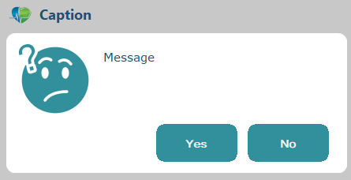

* **Doctor Dashboard-**display doctor in-Patient , out-Patient and appoinments.

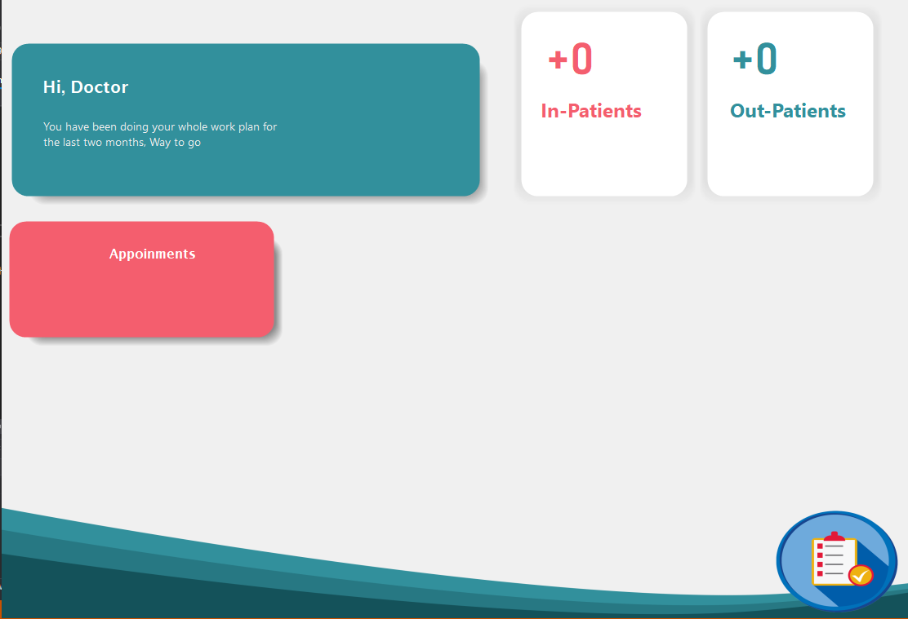

* **Doctor Inpatient** – Display and search in patient details.

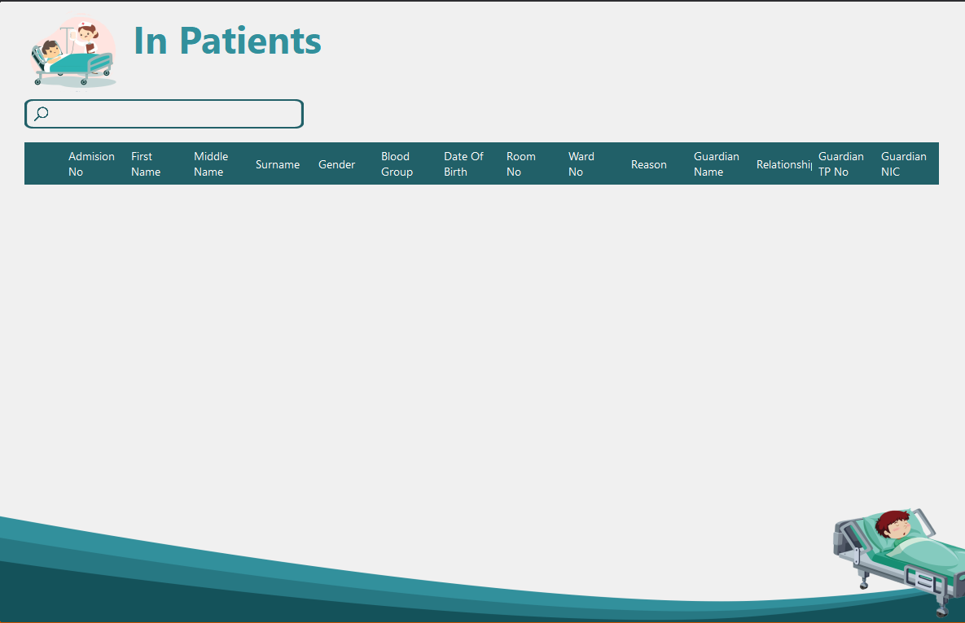

* **DctPatient Form**-This section use to display and search admit patients in the hospital.

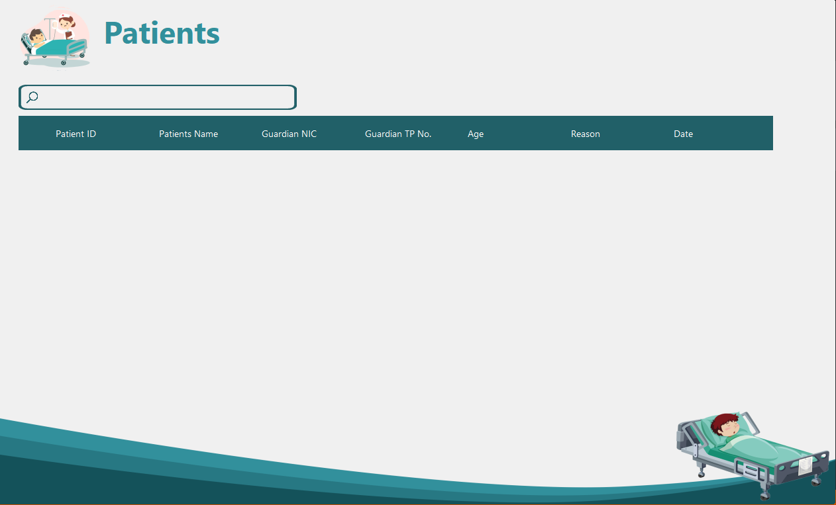

* 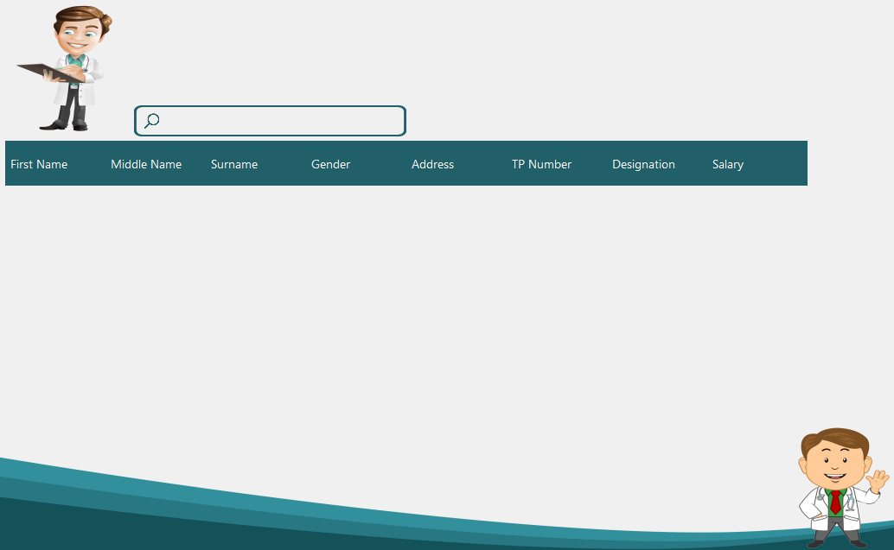**Doctor Form**-This section shows the details of the doctors working in the hospital. The details are First name, Middle Name, Surname, Gender, Address, TP Number, Designation, Salary.
* **Forgot Password Form-**This section use to change the password. Then enter the Gmail address and get code and reset your password.

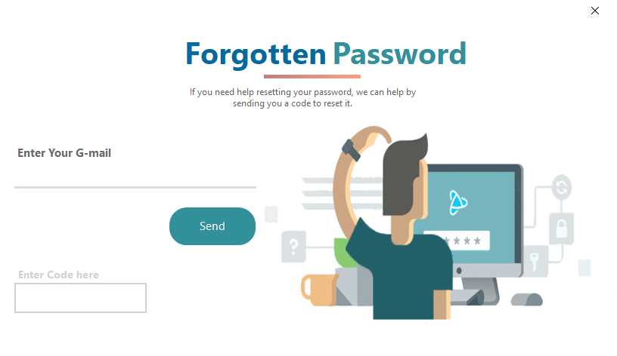

* **Guardian Form -** This section is used to show the Guardians details. There are Name, NIC, Address, TP Number , Relationship ,date and time.

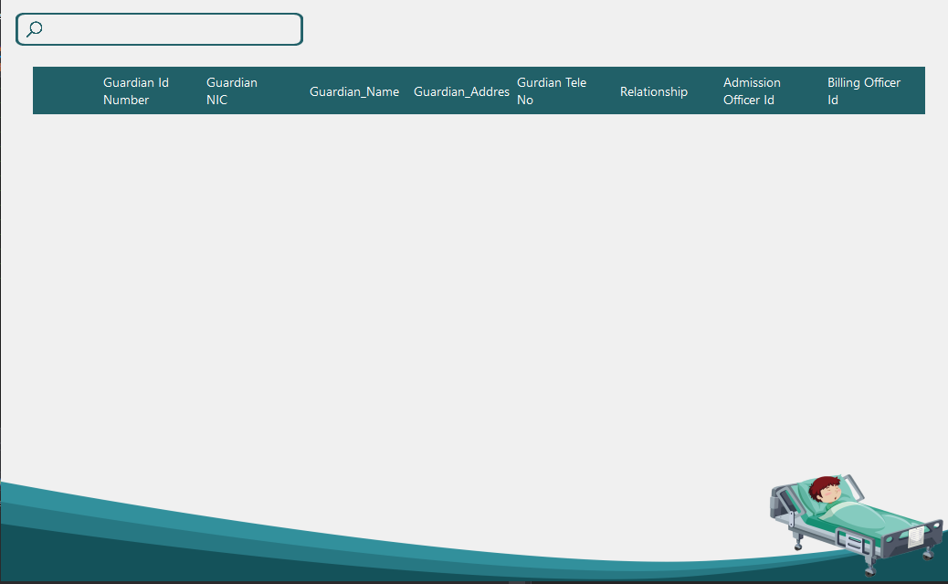

* **LabAdd Form –** This section is used to in the add to x-ray samples of the patient.

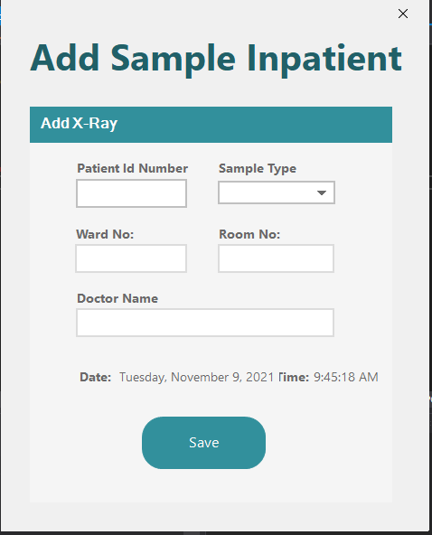

* **LabAddOut Form -** This section is used to in the out to x-ray samples of the patient.

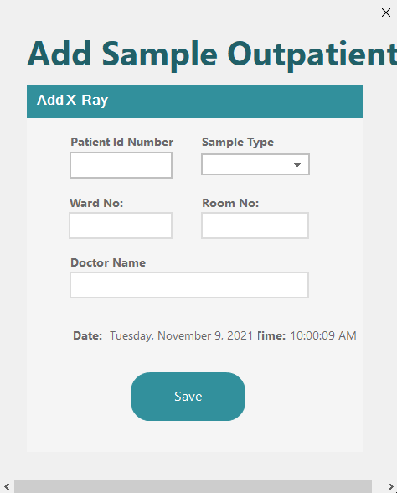

* **LabDash Form -** This section use to display the all details of lab. Display to the Staff analytics and Patient analytics.

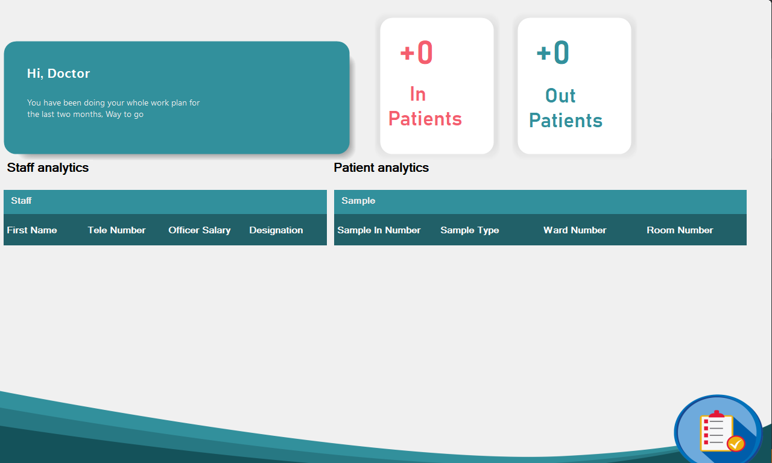

* **MessageError –** This section use to Display the message of the error.

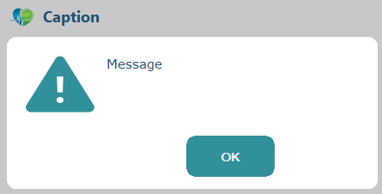

* **Laboratory Form** - This allows you to access the dashboard, samples, staff, and settings sections of the lab.

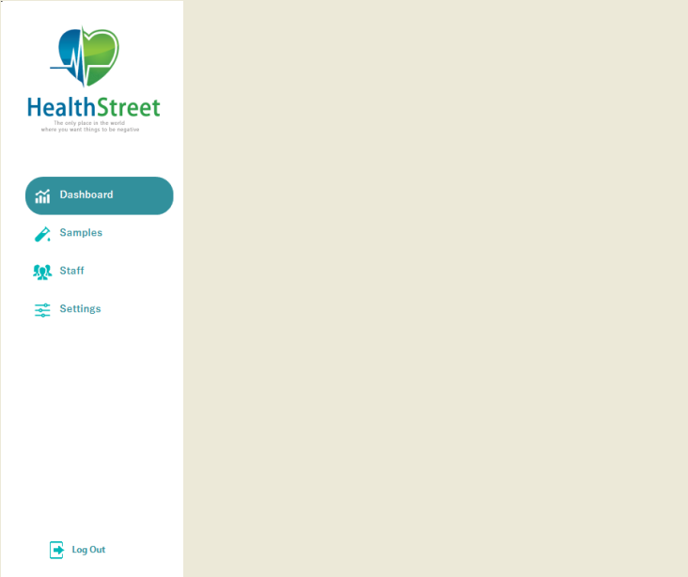

* 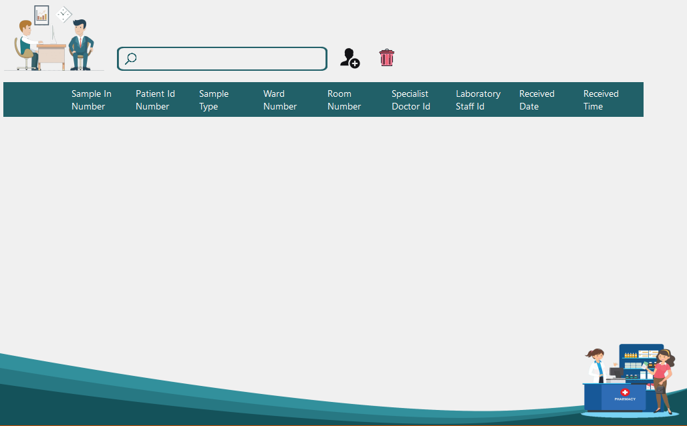**LabSmplInpatient Form –** This section use to display ,search , update , delete of the lab sample.
* **LabSmplOutpatient** - This section shows the full details obtained samples by the laboratories.

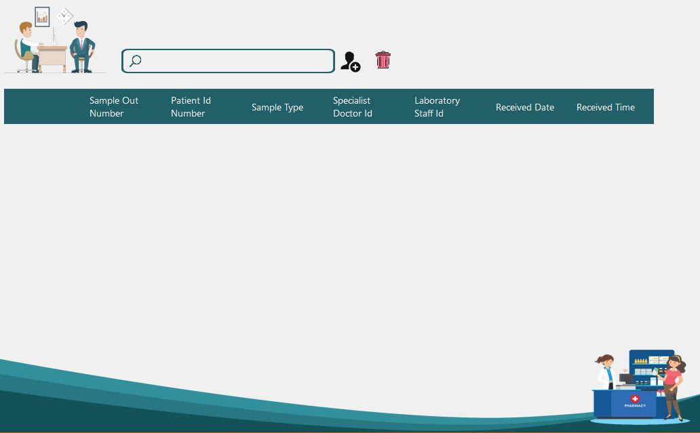

* **NewPassword Form -** This is used when changing the password.

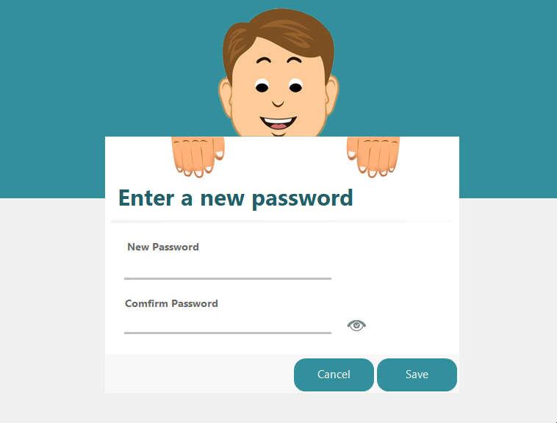

* **Officer frame –** This section is used to show the officer details. You can get the details by typing the officer id in the search bar.

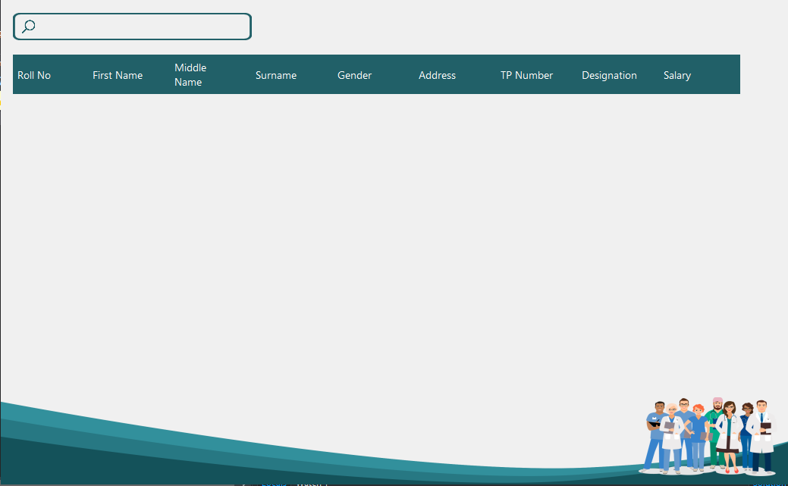

* **Organization frame –** This section is used to show the organization details. You can get the details by typing the organization id in the search bar.

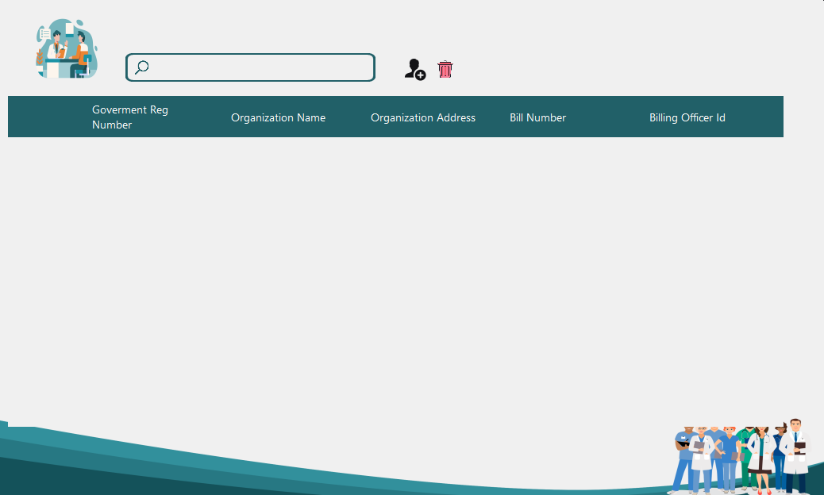

* 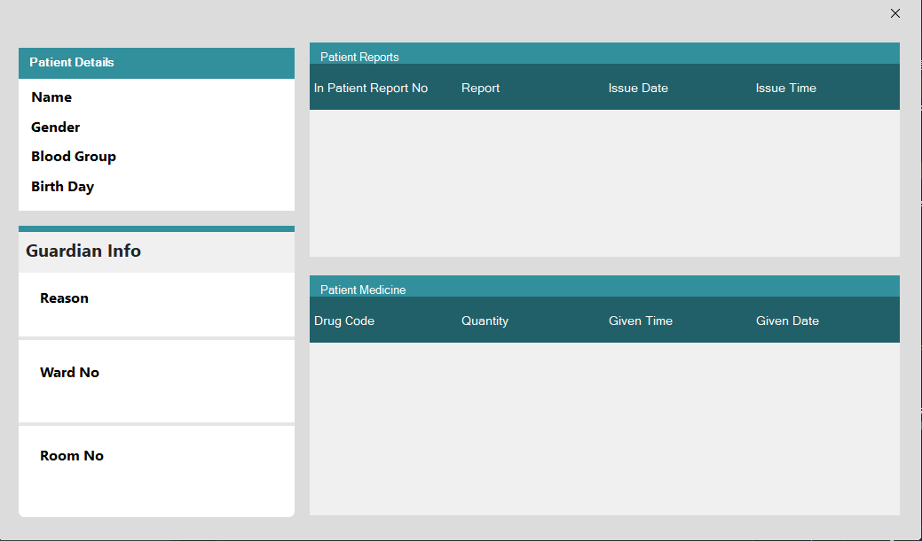**Patient Details frame –** This section is used to show the patient details and guardian information
* **Pharmacy frame –** This section is used to show the pharmacy dashboard, medicines, community and officer to access from. You can also change the setting.

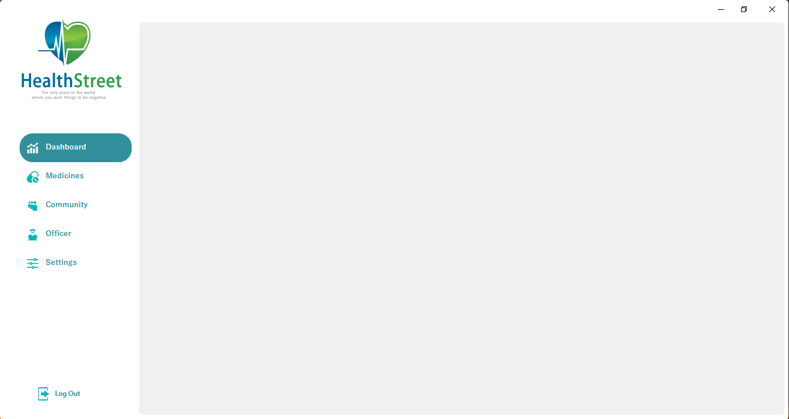

* **Pharmacy supplier add frame –** This section is used to add pharmacy supplier. Fill in the supplier name, manufacture company, manufacture company, manufacture register number and click save button.

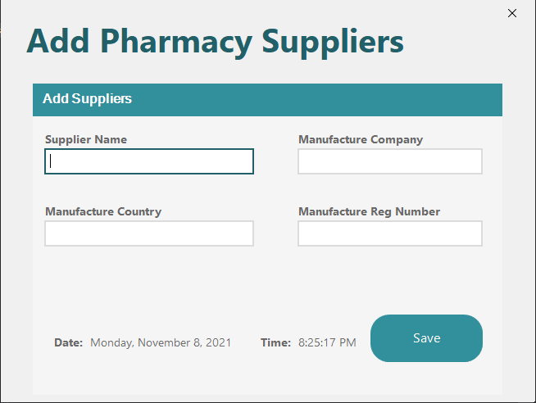

* **Pharmacy Customer Frame –** This section is used to show pharmacy customer details. You can get the details by typing the pharmacy customer id in the search bar.

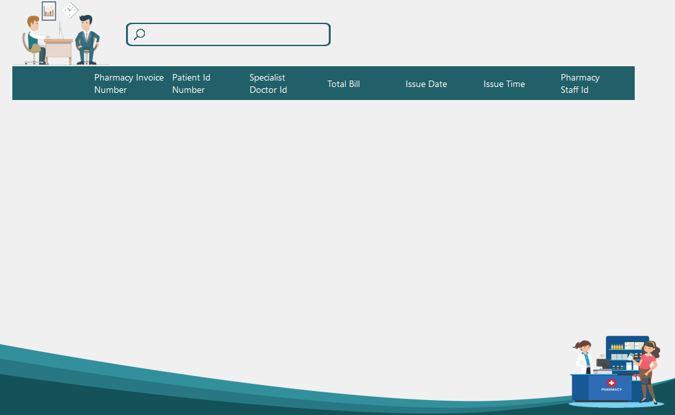

* **Pharmacy Medicine Frame –** This section is used to show pharmacy medicine details. You can get the details by typing the number of medicine in the search bar.

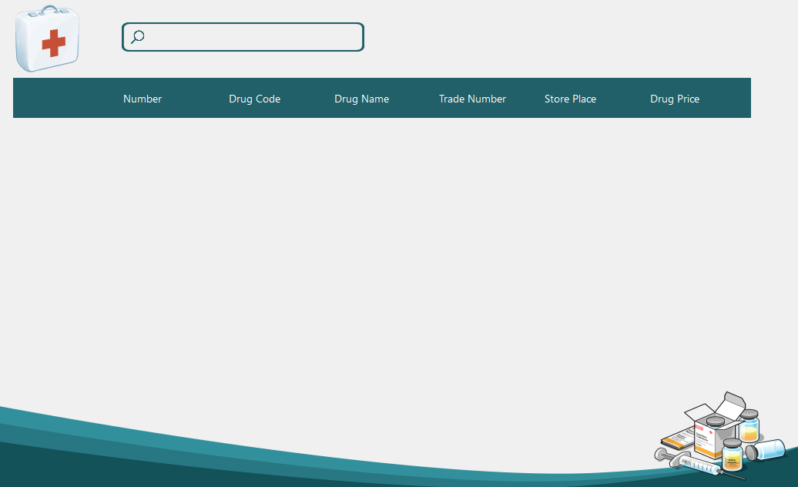

* **Add Pharmacy Medicines –** This section is used to add the medicines in a pharmacy. Fill in the Drug name, Trade name, Store place, Drug price and click save button

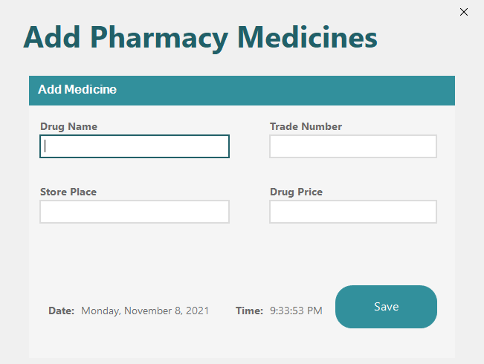

* **Pharmacy Supplier Frame –** This section is used to show pharmacy supplier details. You can get the details by typing the supplier Id in the search bar.

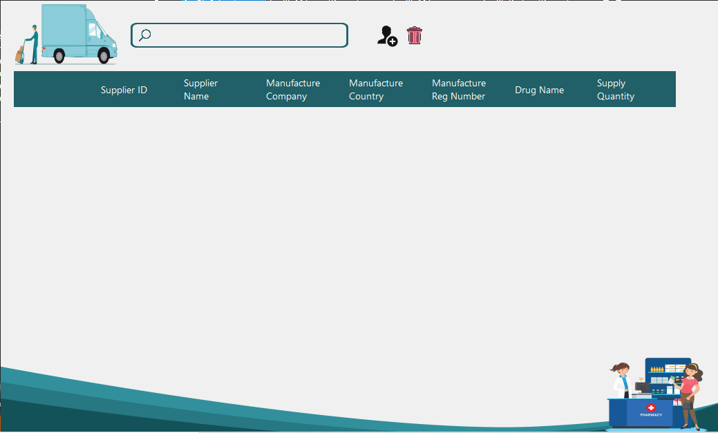

* **Add Scan Inpatient –** This section is used to add the scan inpatient. Fill in the addition number, patient name, ward no, room no, doctor name and click save button.

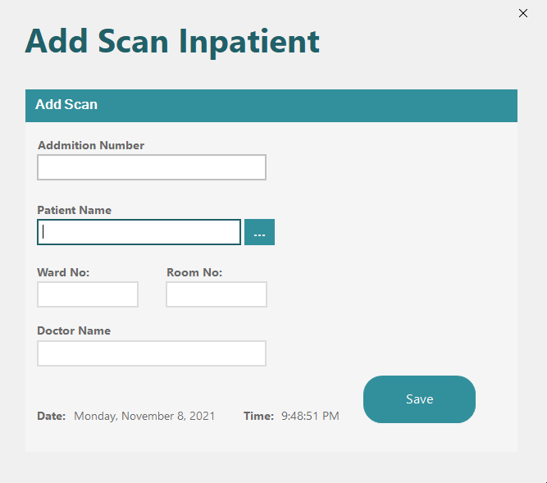

* **Add Scan Outpatient Frame -** This section is used to add the scan outpatient. Fill in the patient Id, x-ray, doctor name and click save button.

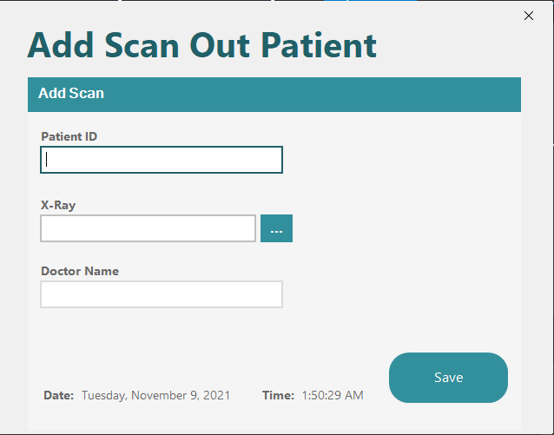

* **Scan Inpatient Frame –** This section is used to view scan inpatient details. You can get the details by typing the inpatient scan no in the search bar.

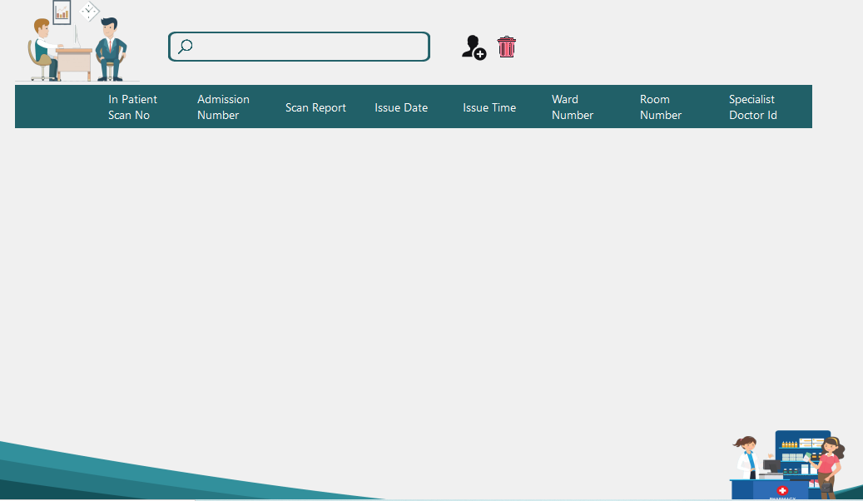

* 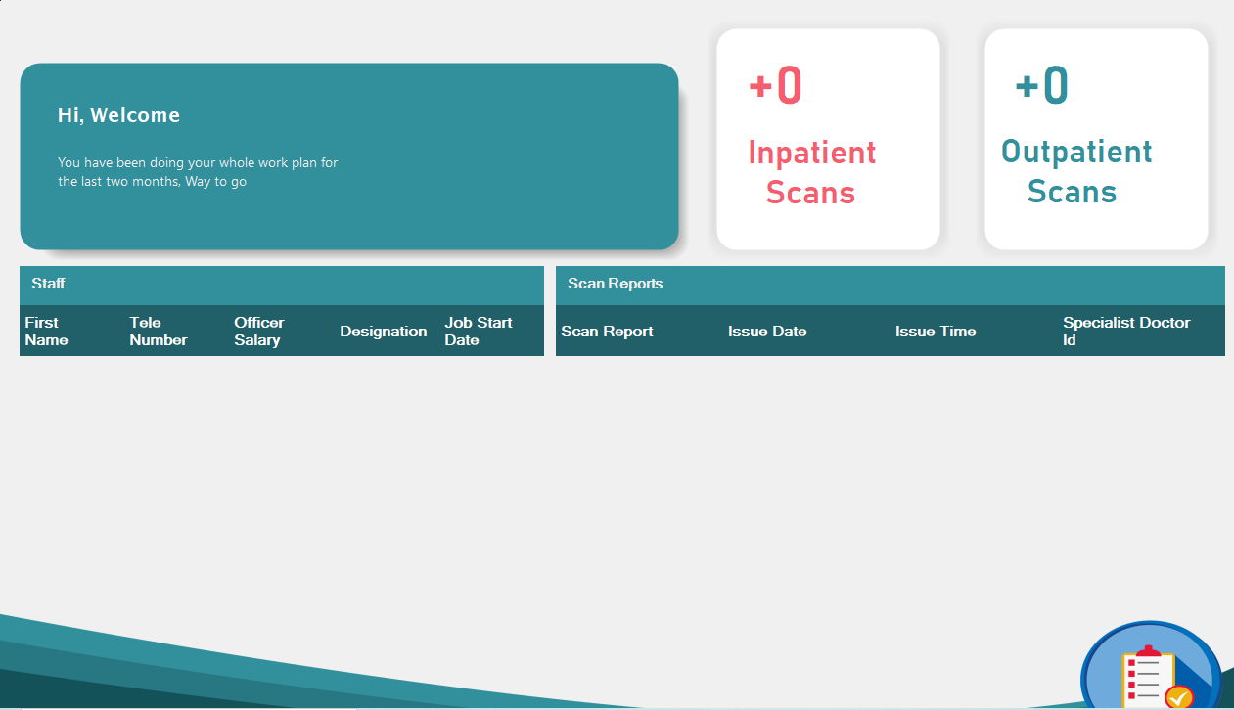**Scan Room Dashboard Frame –** This section is used to show number of Inpatient scan and outpatient scan. In addition to the details of the staff and the scan report.

* **Scan outpatient Frame –** This section is used to view scan outpatient details. You can get the details by typing the outpatient scan no in the search bar.

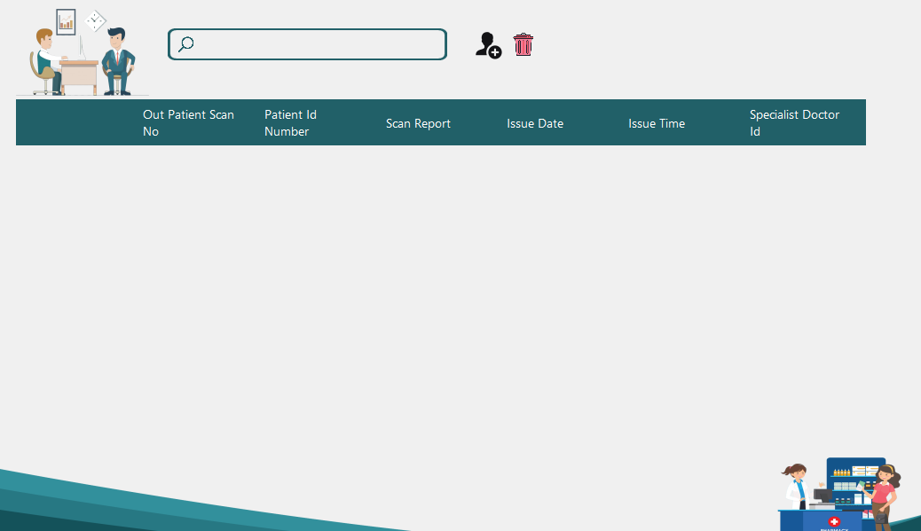

* **Scan Room Frame –** This section is used to show the dashboard, patient scans and staff. You can also change the setting.

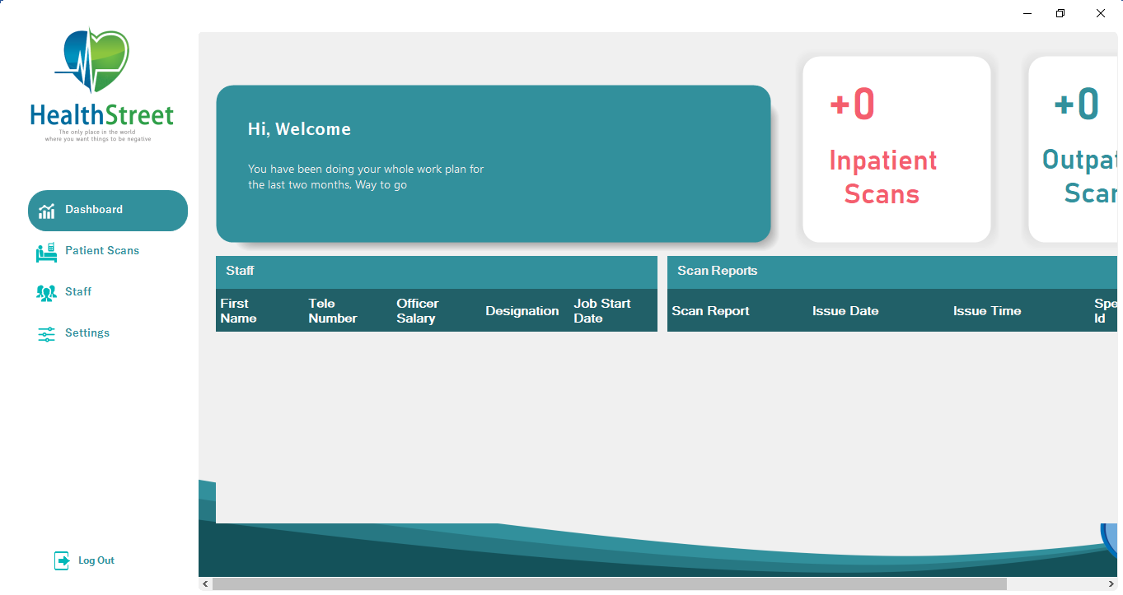

* 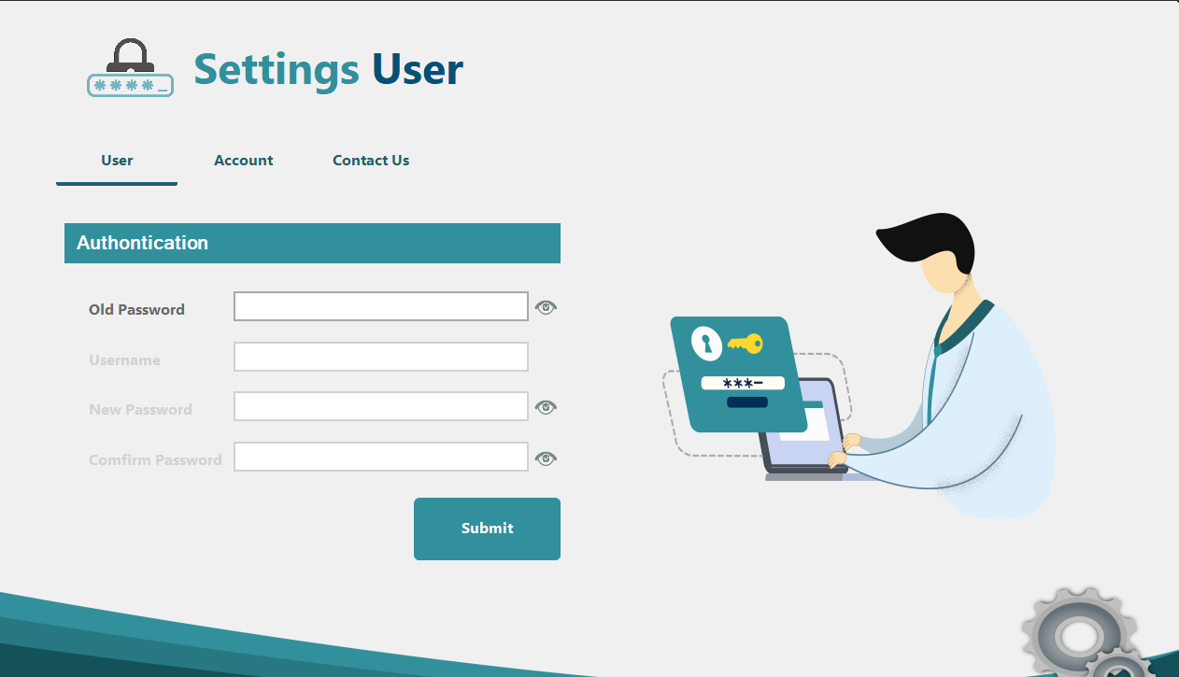**Setting Frame –** This section is used to change setting for user. The user setting is divided into 3 parts namely user, account and contact us. Here we can change the password and change the setting of the account.

* **Account Setting Frame –** This section is used to show the account details and you can go to the account edit setting frame by clicking the edit button

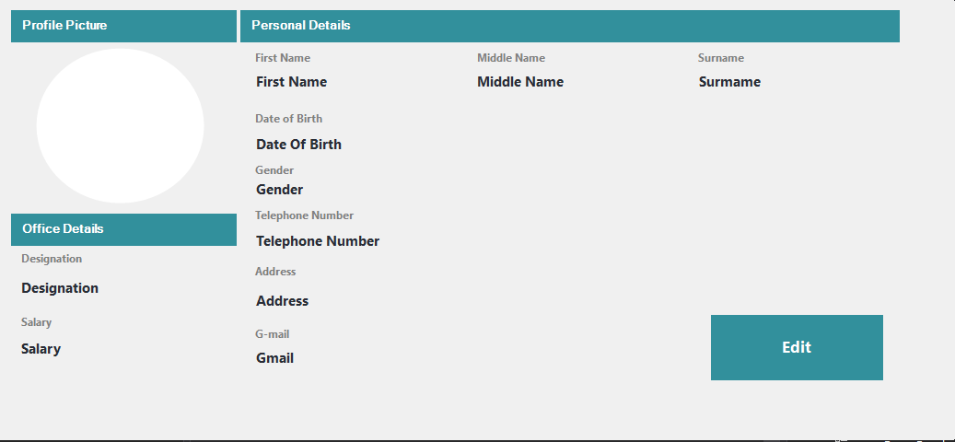

* **Account Edit Setting Frame –** This section is used to edit the account.

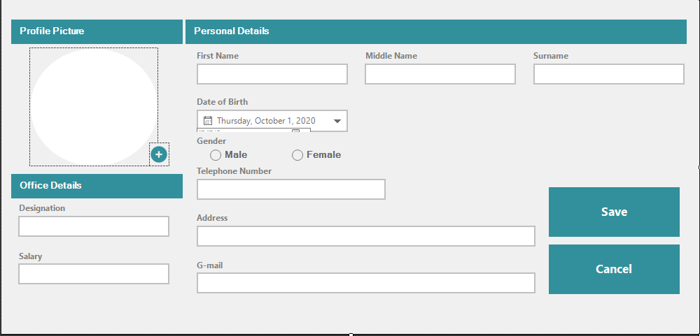

* **Setting Login Frame –** This section is used to change the password.

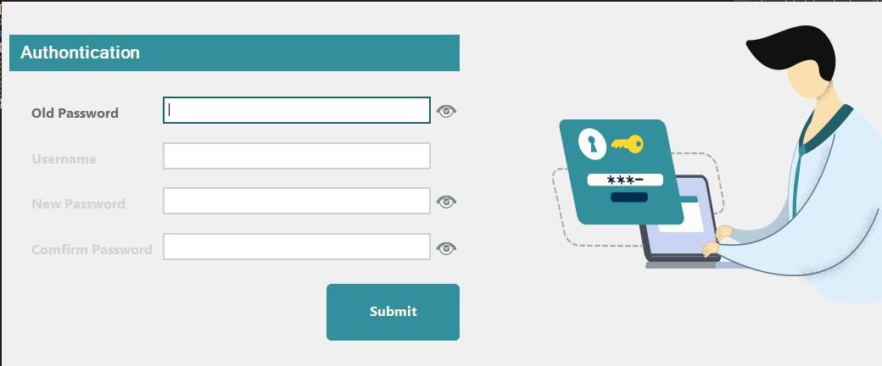

* **Ward Frame –** This section is use go to ward dashboard, staff, patients and room frames. You can also change the setting.

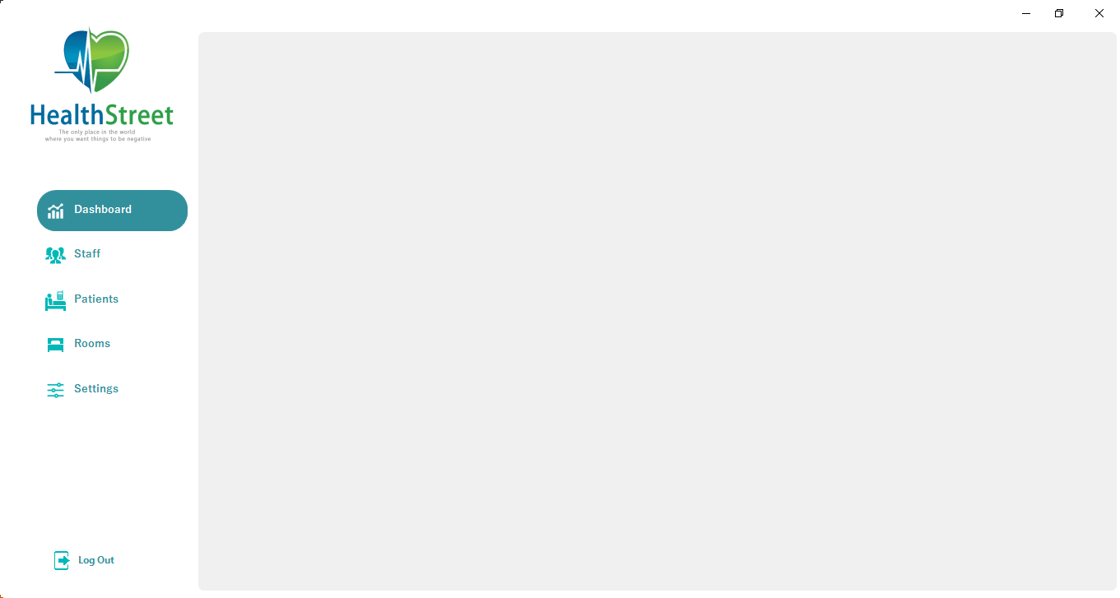

* **Ward Room Frame –** This section is used to show ward room details. You can get the details by typing the Room no in the search bar.

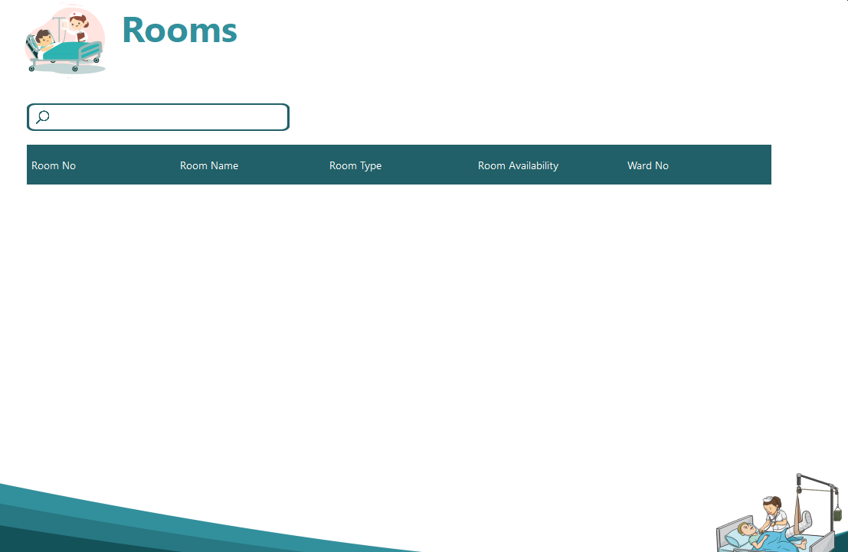

* **X-ray Frame –** This section is used to show the Dashboard, patients and staff. You can also change the setting.

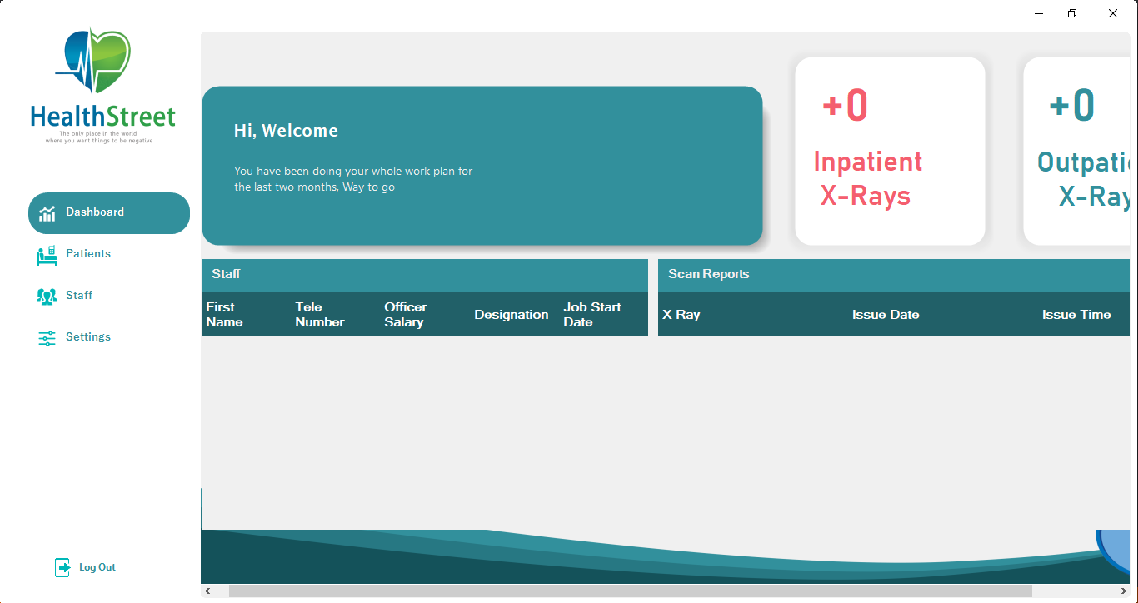

* **Add X-ray Inpatient Frame –** This section is used to add x-ray inpatient. Fill in the addition number, x-ray path, ward no, room no, doctor name and click save button.

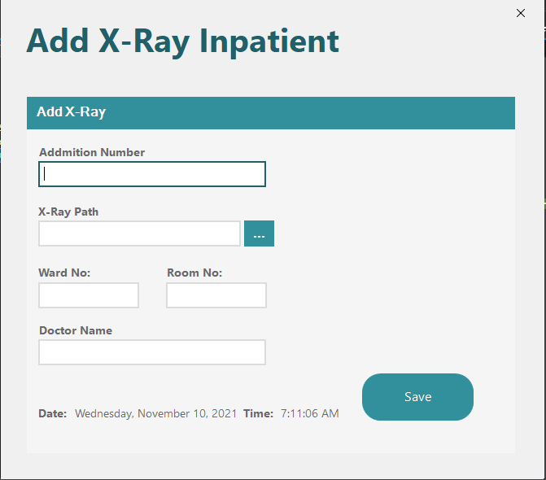

* **Add X-ray Outpatient Frame –** This section is used to add x-ray outpatient. Fill in the patient Id, x-ray and click save button.

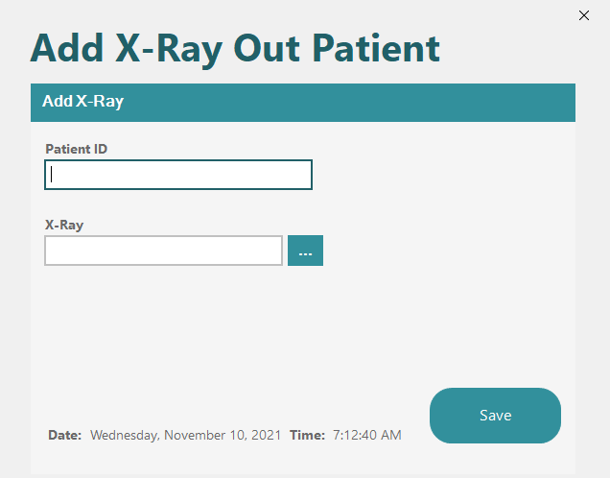

* **X-ray Dashboard Frame –** This section is used to show number of Inpatient x-ray and outpatient x-ray. In addition to the details of the staff and the scan report.

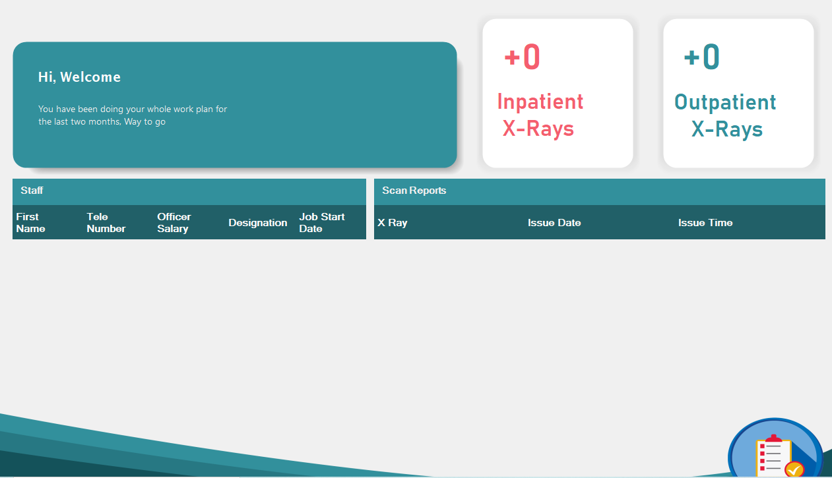

**X-ray Inpatient Frame –** This section is used to show inpatient x-ray details. You can get the details by typing the x-ray no in the search bar.

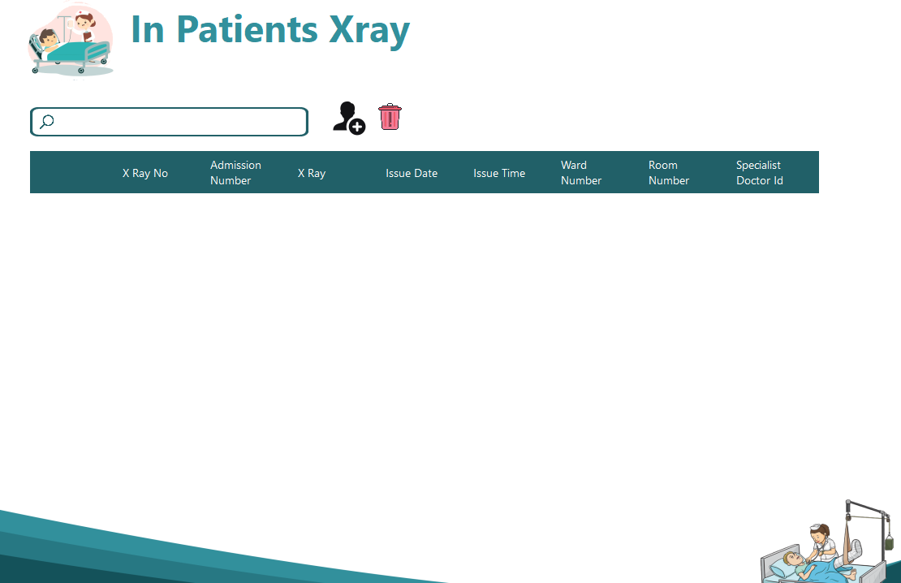

* **X-ray Outpatient Frame –** This section is used to show outpatient x-ray details. You can get the details by typing the x-ray no in the search bar.

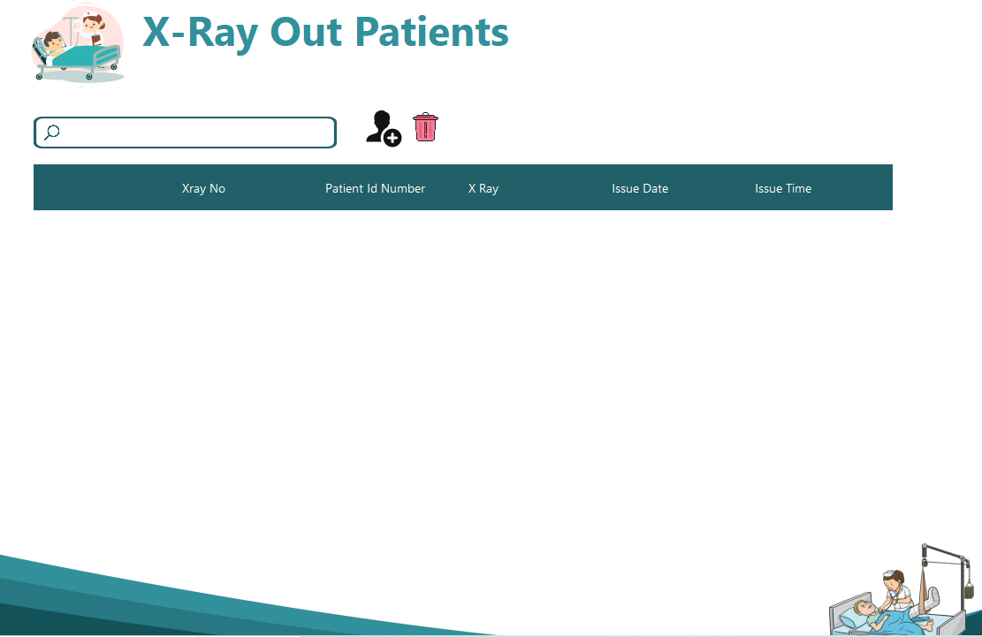

* **Parts of the Web**
* **Home Page -** This is the first page you will encounter when visiting the Health Streeth Hospital web site. This page will show any customer.



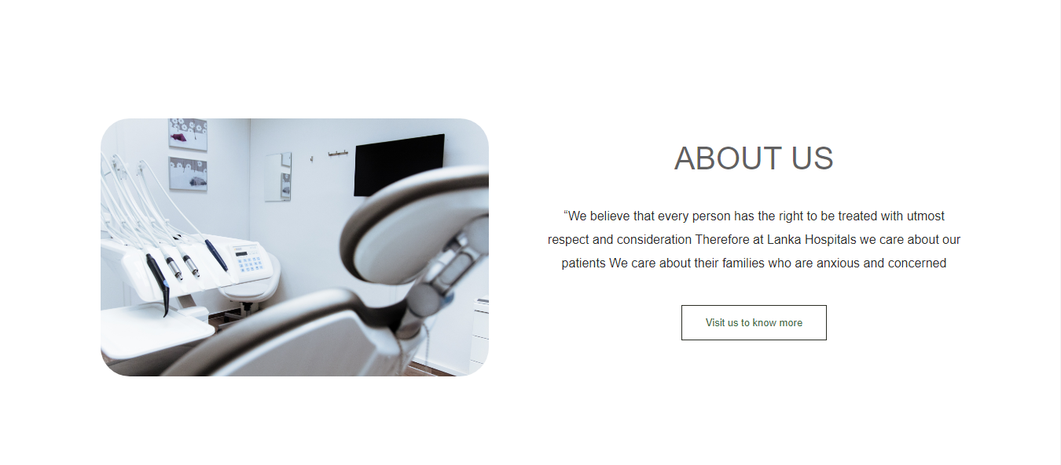

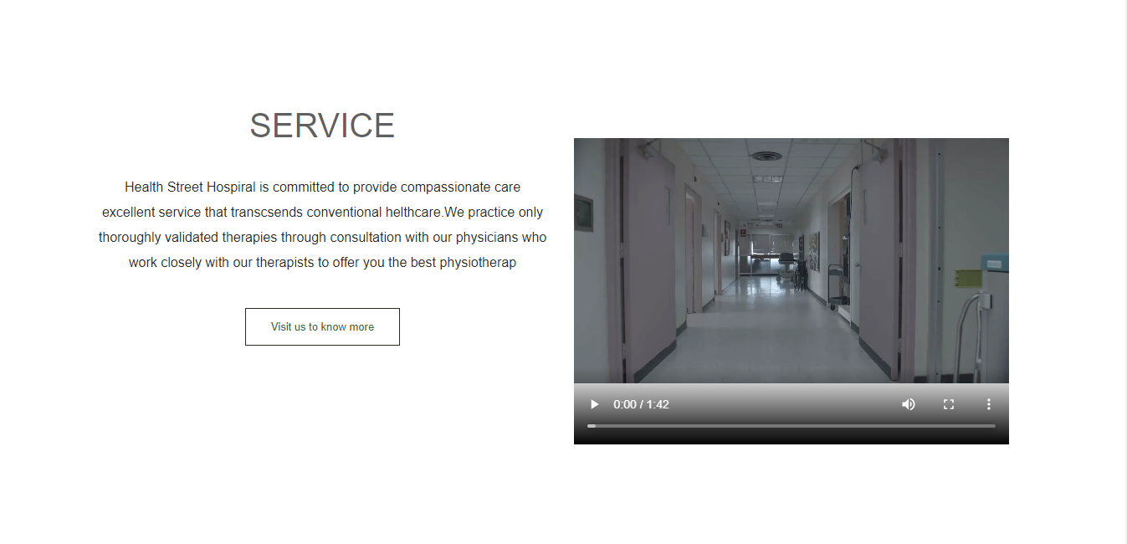

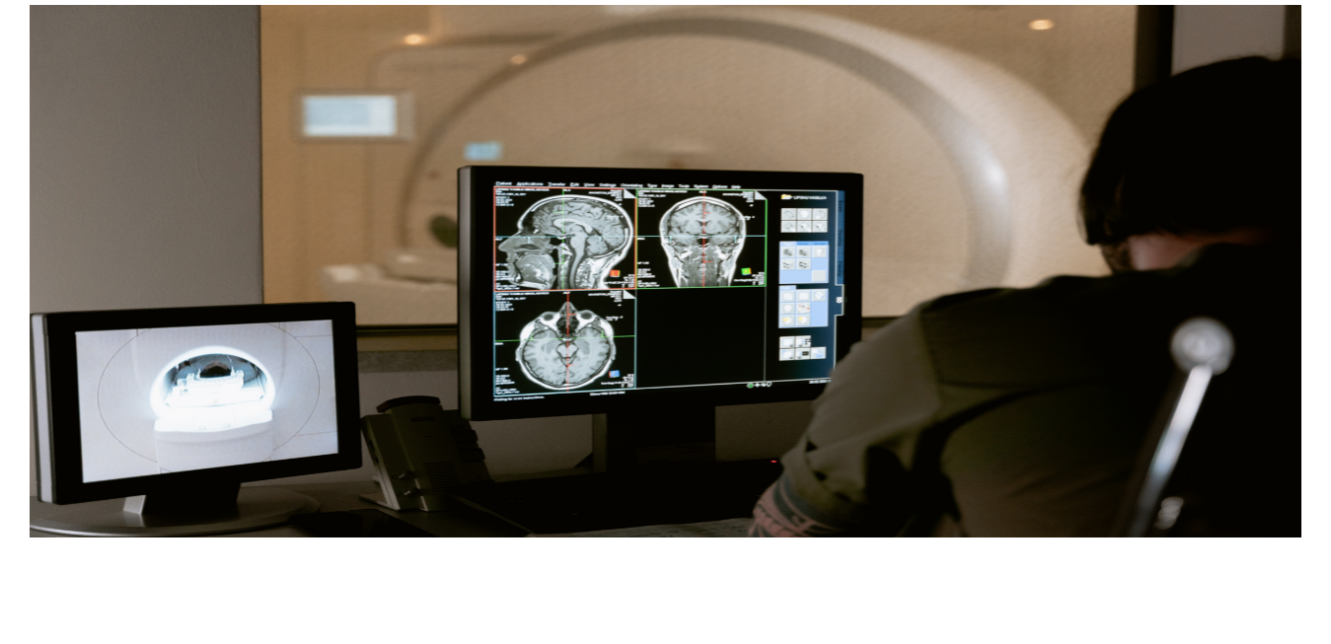

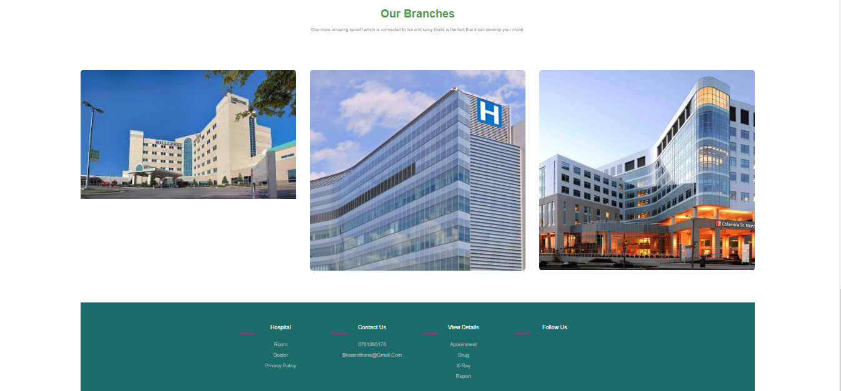

* **About us page** - This Page is used to show About us of the hospital.

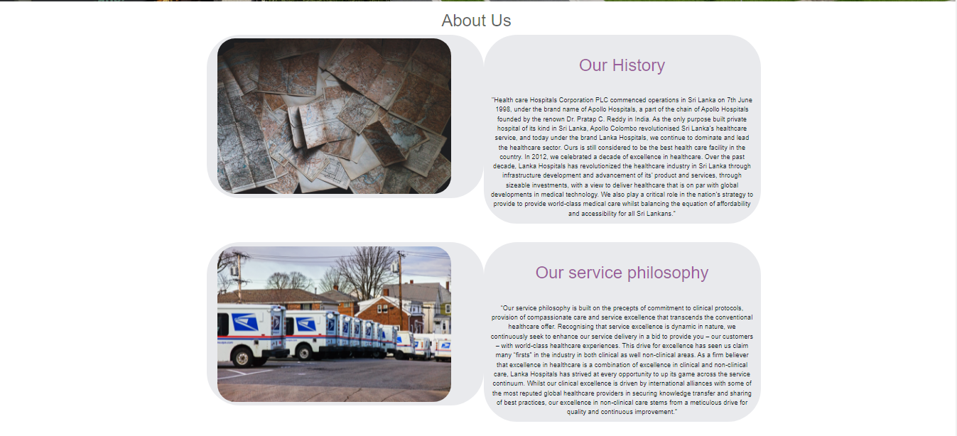

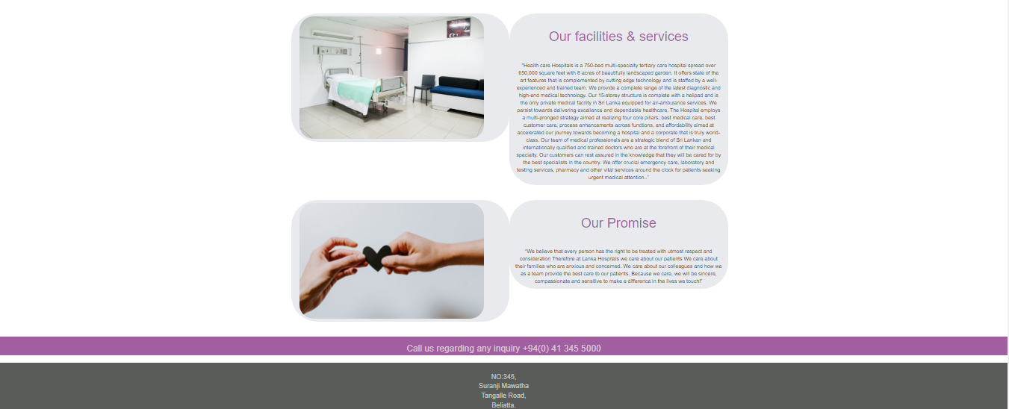

* **Sign Up New Account -** This is the part of the Customer registration Page**.**

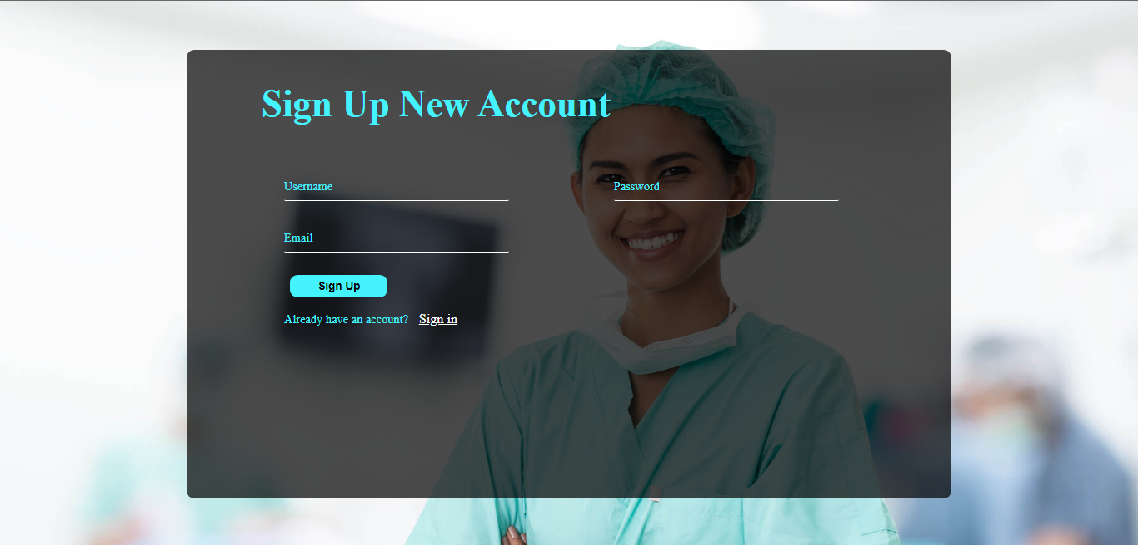

* **Login Page -** This is the login form that all registered users can access the system using their own username and password.

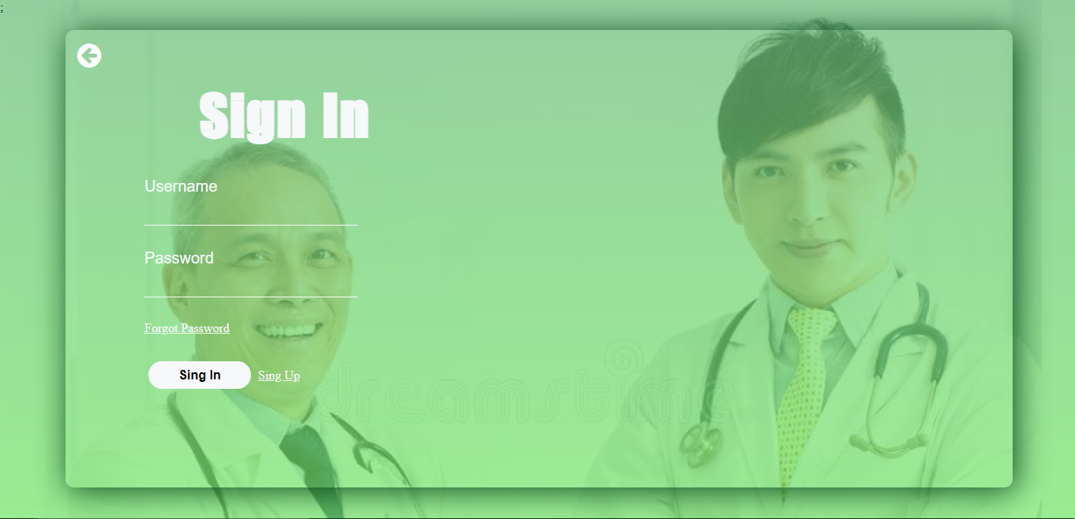

* **Book Appoinment Page** - You can use this page to enter Patient details and book appoinment.

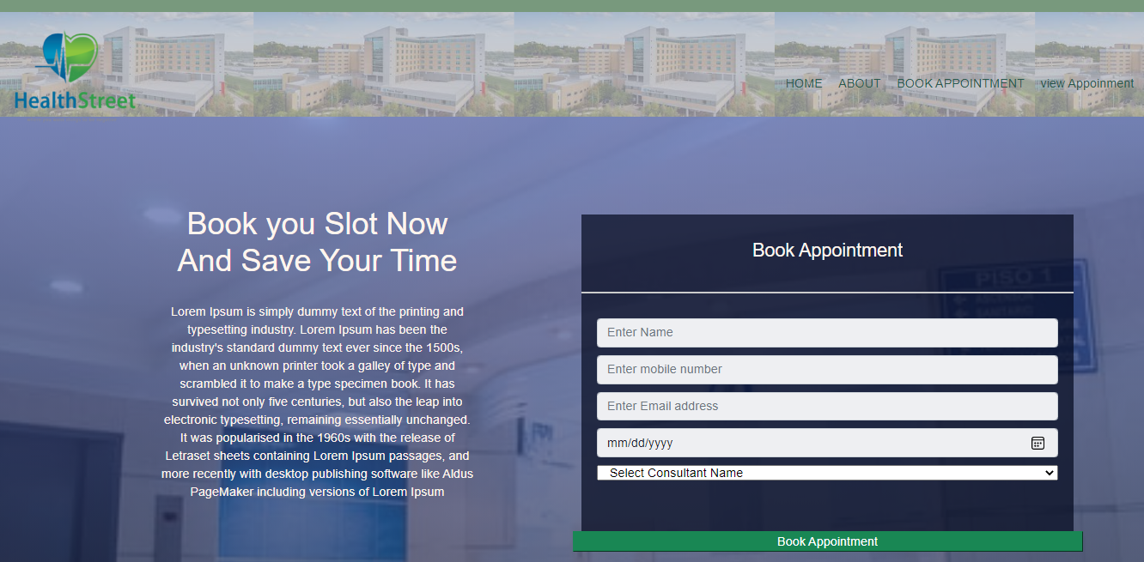

* 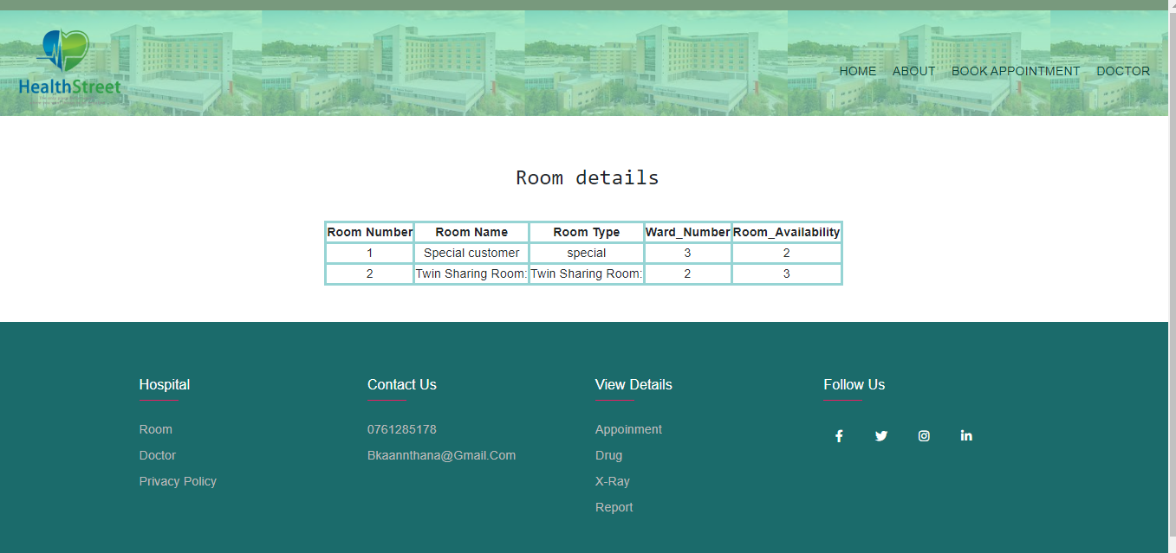**Room Details Page** –This page use to show the all rooms details in the hospital.
* **Doctor Details Page-** This page use to show the all Doctor details in the hospital

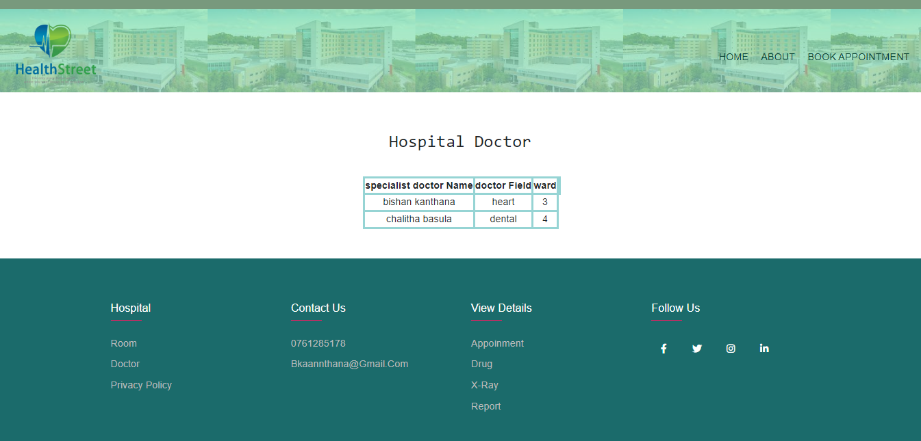

* **view appointment page** - This page use to show the all appoinment details in the hospital.

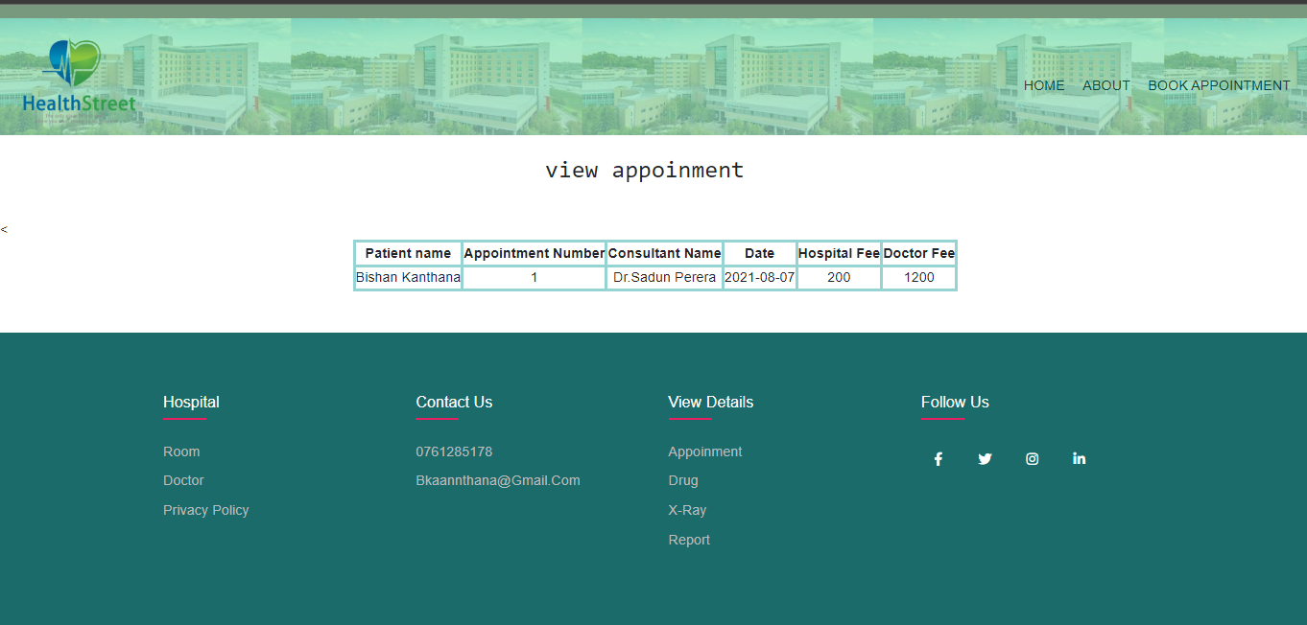

* **Search drug page -** This page use to search the all drugs in the hospital.

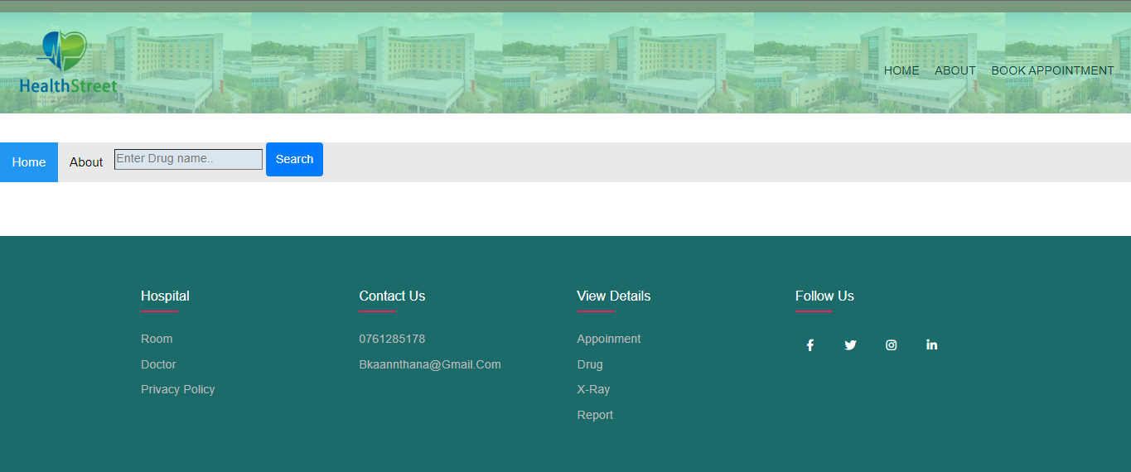

* **Drug menu page** - enter drug name then you can see drug name , number and price.

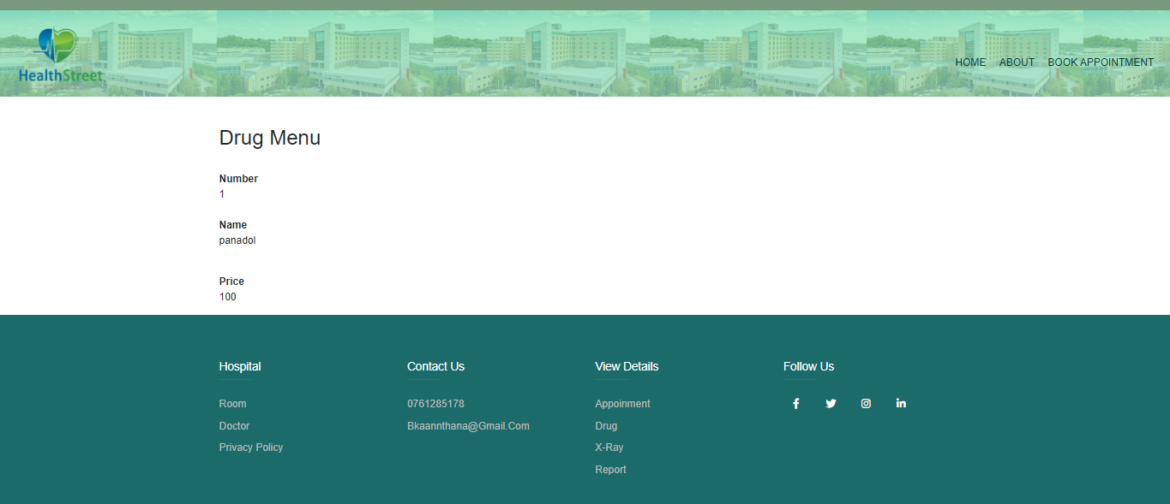

* **In_out Patient xray page -** This page use to select the in patient or out pateint of the xrays.

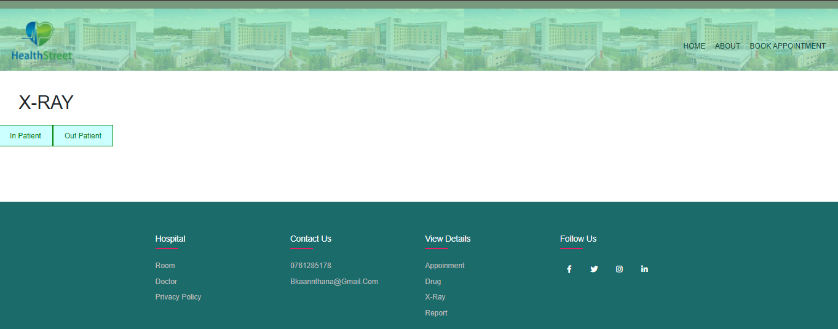

* 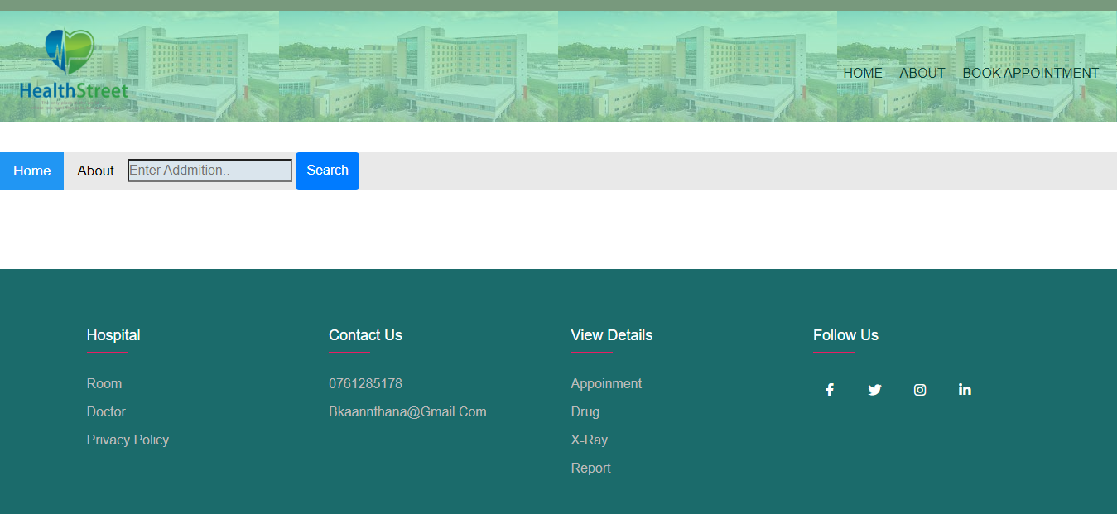**hospital in patient xray Search page -** This page use to search the all in patient xrays on hospital.
* **hospital in patient xray menu -** enter patient addmition number and then you can see addmition number, ward number, room number and xray photo.

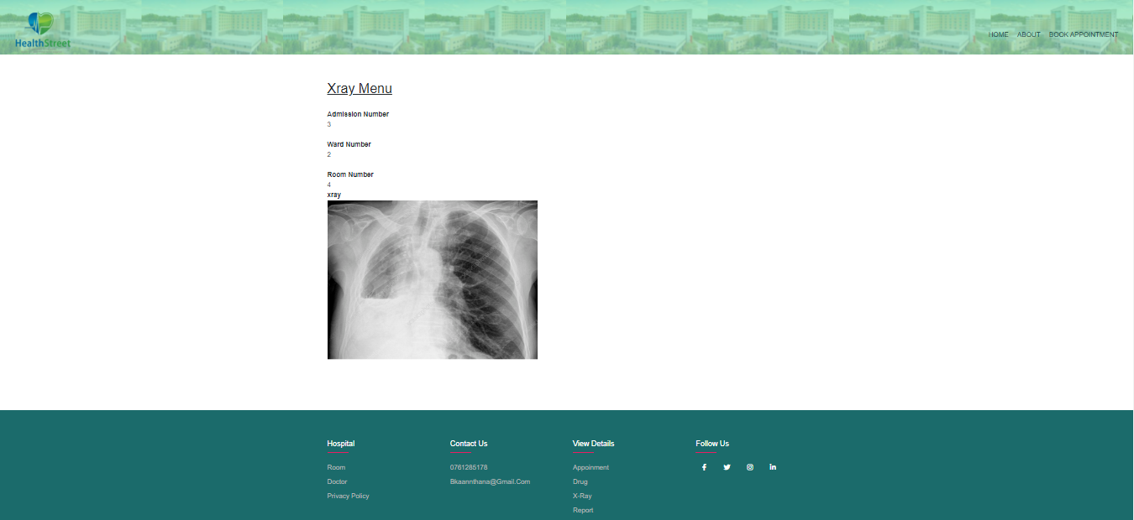

* **hospital out patient xray Search page -** This page use to search the all out patient xrays on hospital.
* 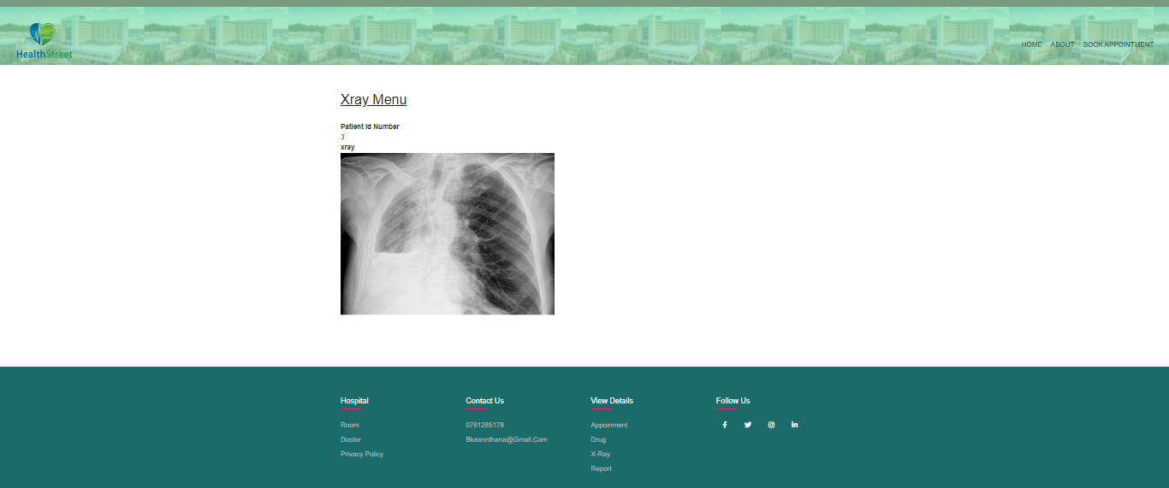**hospital out patient xray menu -** enter patient addmition number and then you can patient id number and xray photo.
* **In_out Patient report page -** This page use to select the in patient or out pateint of the reports.

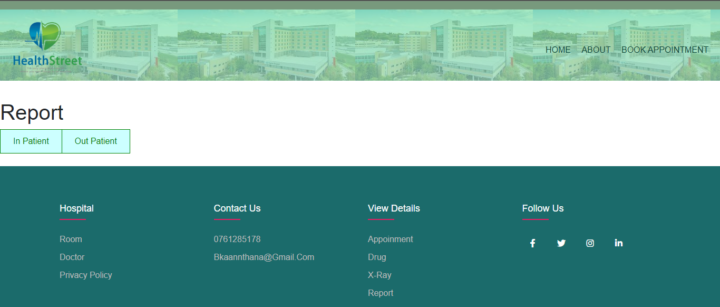

* **hospital in-patient reports Search page** - This page use to search the all in patient reports at hospital.
* **hospital in patient report menu -** enter patient addmition number and then you can patient addmition number and report photo.

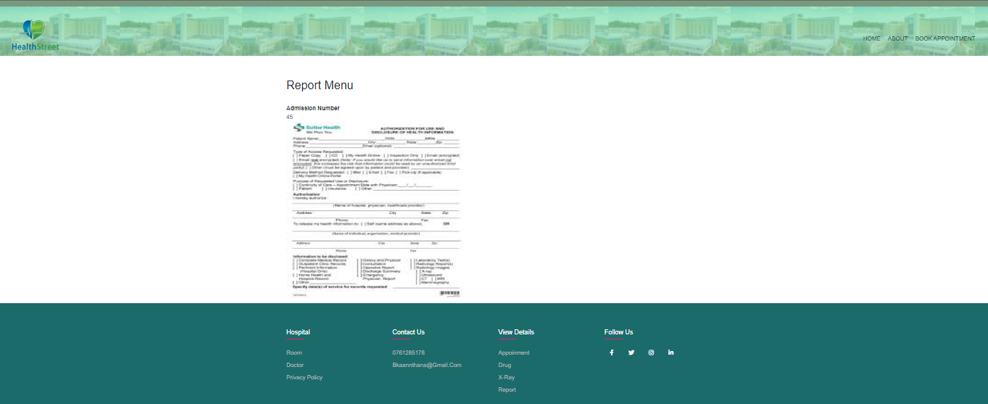

* **hospital out-patient reports Search page** - This page use to search the all out patient reports at hospital.

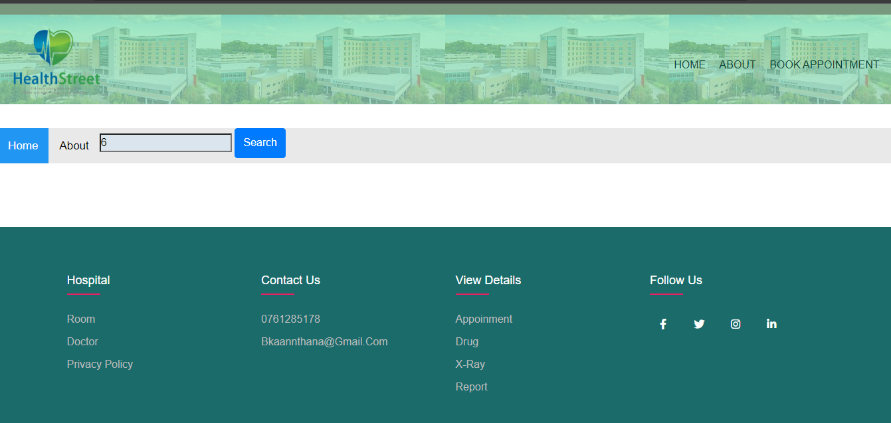

* 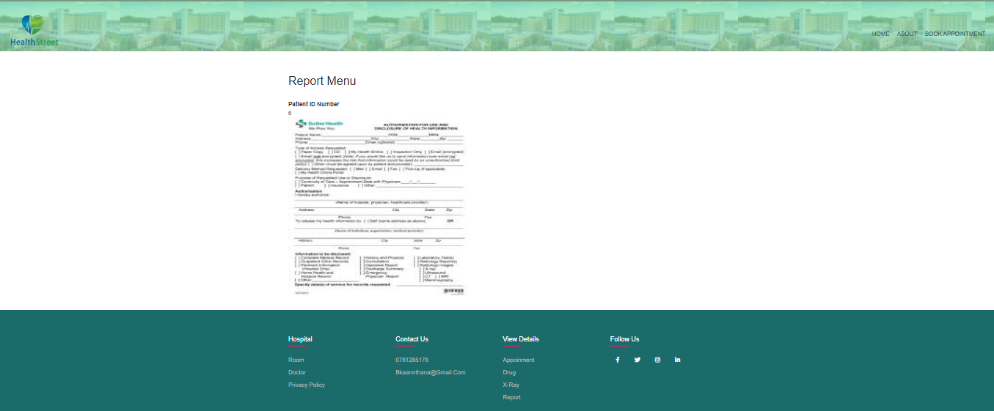**hospital out-patient report menu -** enter patient Id number and then you can see patient id number and report photo.

**Chapter 4**

**4. Conclusion**

We can reap many benefits through our "Hospital managemnet system". In particular, we will be able to eliminate all the disadvantages of the current Hospital system. By using our method they can minimize the loss of time and labor. We also hope that it will help reduce pollution. We store all important documents with proper security. All of the hospital's customers and staff can save valuable time by using our system. the employees working in the hospital can easily do their work We try to give an online Hospital enviromnment. We think we can do it. This is because with the current epidemic of covid-19 in the country, Customers who come to the hospital for services can get most of the services they need from home.

With the current epidemic of covid-19 in the country, we think that our innovative idea is the most suitable Hospital system for our country.